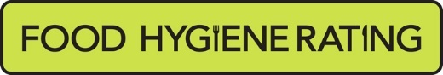  Food Hygiene Rating Scheme:  Request for a re-rating inspection |  | 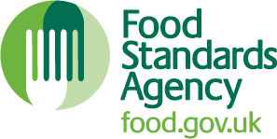

Notes for businesses:
- As the food business operator of the establishment you have a right to request at any time a visit for the purposes of re-rating under section 4 of the Food Hygiene Rating Act (Northern Ireland) 2016 provided that you have paid the £ 150 cost of the re-rating inspection in accordance with section 4(7) of The Food Hygiene Rating Act (Northern Ireland) 2016 and the following conditions are met:-
- You must wait until the end of the 21 days appeal period before you apply for a re-rating inspection
- Any appeal against the current food hygiene rating has been determined or abandoned:
- You must provide details of the improvements made to hygiene standards with your request, including supporting evidence where appropriate.
- The district council considers that you have provided sufficient evidence that the required improvements have been made.
- You must also be compliant with the Act. This means that you must display your current valid rating sticker. A re-rating inspection will not be carried out if you are found to be non-compliant and a £200 fixed penalty notice may be served for non-compliance.
- The district council officer will give you a ‘new’ food hygiene rating based on the level of compliance that is found at the time of the re-visit - you should be aware that your rating could go up, down or remain the same.
- The re-rating visit will take place within 3 months of the request being made and will usually be made without prior notification.

Business details
Food business operator/proprietor

Business name

Business addresses

Business tel. number |  | Business email

Inspection details
Date of inspection |  |  |  | Food hygiene rating given

Action taken
Please describe the remedial action you have taken with reference to the issues identified in the inspection letter/report provided to you by your district council with your score:
Compliance with food hygiene and safety procedures

Compliance with structural requirements

Confidence in management/control procedures

Please provide any other supplementary evidence (e.g. photographs, invoices, copies of relevant HACCP documentation etc.).

Signature
Name in capitals

Position |  | Date
Please now return this form to: ehealth@armaghbanbridgecraigavon.gov.uk
Or post to: Environmental Health Department, Armagh City Banbridge and Craigavon Borough Council,
[The Palace Demesne, Armagh, BT60 4EL] [Civic Building, Downshire Road, Banbridge, BT32 3JY]
[The Civic Centre, PO Box 66, Lakeview Road, Craigavon, BT64 1AL]

Instructions on Method of Payments

By Post – by making your cheque payable to Armagh City Banbridge and Craigavon Borough Council and sending it to the Environmental Health Department at the address overleaf. This form must be completed in full and accompany the payment. A receipt will be sent on request.

In Person – between 9.00 am and 5.00 pm on any day the office is open for business. Payment may be made by cash or any debit/credit card normally accepted by Council in accordance with their standard procedures. This form must be completed in full and accompany the payment. A receipt will be sent on request.

By Phone - ring the Environmental Health Department on 0330 0561 011. Payment may be made by any debit/credit card normally accepted by Council in accordance with their standard procedures. A receipt will be sent on request. This form must be completed in full and submitted to the Environmental Health Department, at the address overleaf.

Other Method/s – If you chose to pay the fee in cash by post, this must be sent registered post and proof of posting must be retained. If you require a receipt you must ask for one at the time of payment. If you are paying by post and require a receipt, you must provide a stamped addressed envelope. This form must be completed in full and accompany the payment.

