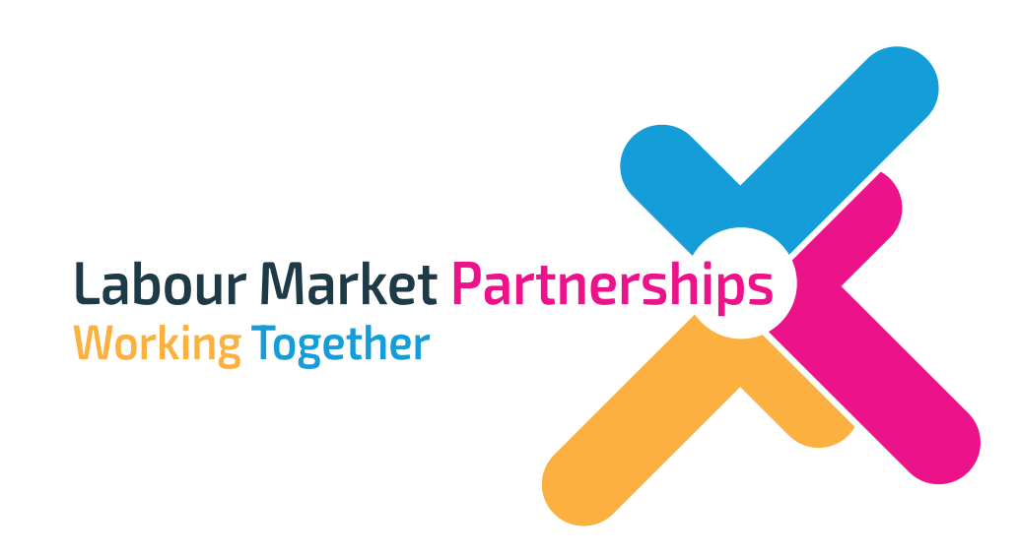

Armagh, Banbridge and Craigavon LABOUR MARKET PARTNERSHIP
Annual Report
2022/23

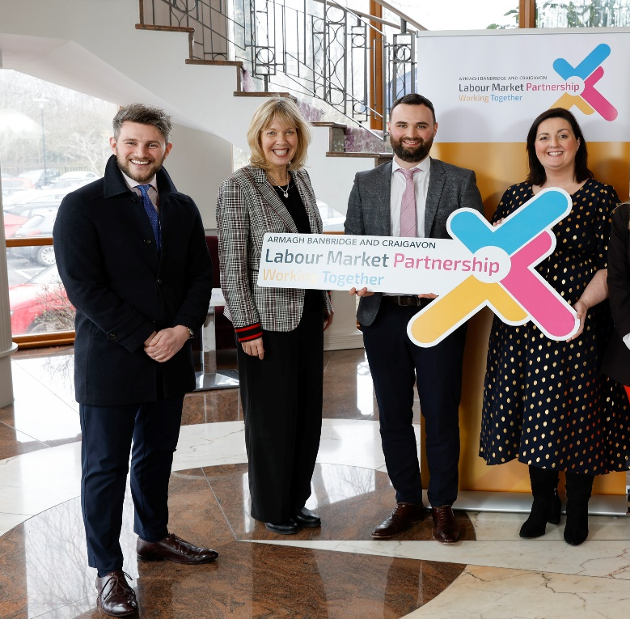

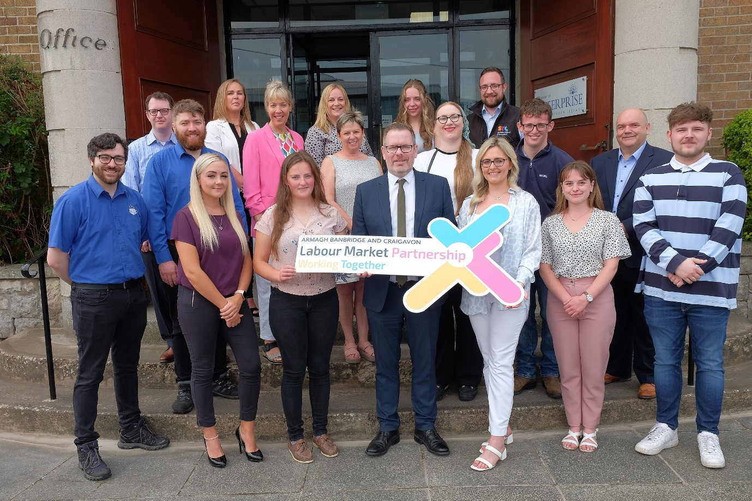

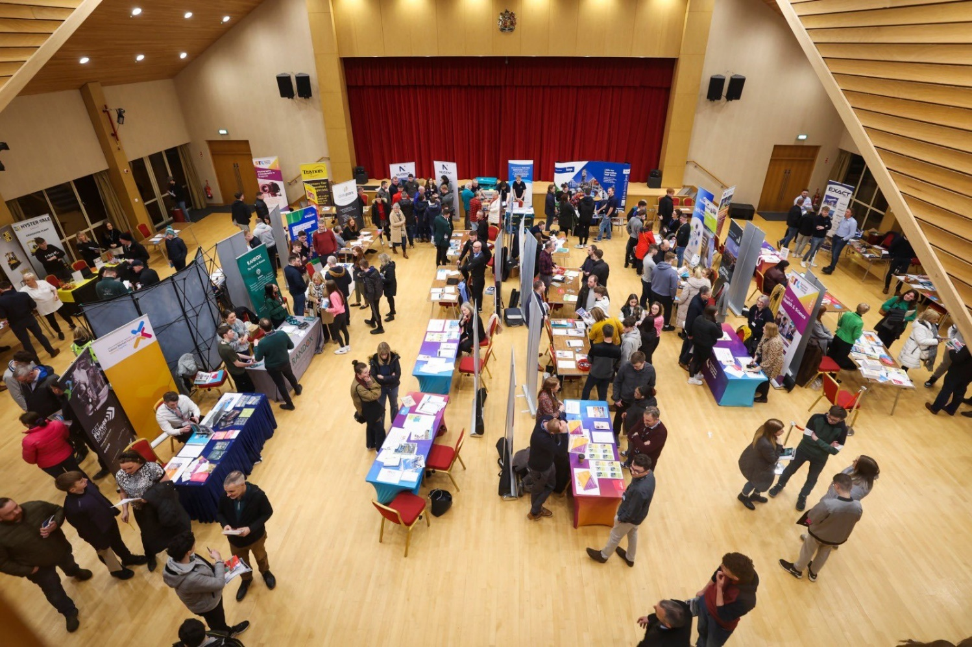

Contents Page
Chair and Vice Chair Foreword | Page 4 & 5
ABC Labour Market Partnership | Page 6
Membership | Page 7
Action Plan Report | Pages 8-13
Overview of projects/successes | Page 14
Financial Statement | Page 15 - 17

Nicola Wilson- LMP Chairperson Foreword
As Chair for the Labour Market Partnership in 2022-23, it gives me great pleasure to update on our first successful year through this annual review. I am delighted to have been part of this successful organisation, led by Armagh City Banbridge & Craigavon Borough Council in partnership with a wide range of local strategic partners. It is a testament to the great work of all our partners, who have shown great commitment to ensure that LMP delivers for all citizens across Armagh City, Banbridge & Craigavon Borough
On behalf of the LMP, I am pleased with the first-year achievements of the Labour Market Partnership, which has resulted to date in the following key outputs:
- 114 people supported to gain a new qualification.
- 150 people supported to gain paid employment.
- More than 200 people supported through sector specific employment programmes.
- More than 80 local employers participated on programmes.
- More than 1,7000 people attended Get Future Ready
At the heart of the ABC LMP, we continue to ensure that quality skills provision is driven by the demand for skills in the economy, leading to reduced economic inactivity. We are committed to ensure that all citizens in the Borough to have the necessary skills, support, and opportunities to succeed in the labour market, so everyone can make informed choices, have access to effective pathways, which will also see the economy benefitting from a resilient, agile and flexible workforce.
.
We look forward to the year ahead in 2023- 2024.
ABC LMP looks forward to the delivery of the 2023-2024 Action Plan for another successful collaborative programme. We will continue to develop our close working relationship with the Department for the Communities as key strategic partner and funder. We sincerely appreciate their continued investment in the Labour Market Partnership since its conception and for another year.
In summary, ABC LMP have used the last year to learn and adapt to what our strategic assessment has informed us, including that our Borough is falling behind the NI average when it comes to disability employment figures and economic inactivity amongst females. We will deliver on these issues to help address those differentials in the local employment market.
We will also continue to deliver our rapid response model for industry as it has proven very successful in helping to address skills gaps. Additionally, we have developed a number of important new innovative approaches, such as a reverse job fair for people with disabilities which will be a first in Northern Ireland.
We continue to recognise that a skilled flexible and resilient workforce is a key to the recovery and inclusive growth. We are committed to our vision for the Borough to be a place where all people can prosper, and businesses can flourish.

Tracy Rice- LMP Vice Chair 22-23 & Chair 23-24.
It gives me great pleasure to introduce this Annual Review of Armagh City, Banbridge and Craigavon Borough Council’s Labour Market Partnership (LMP) for 2022-23. The LMP has delivered a number of targeted activities to address the skills and employability challenges within the borough. I am proud of the long list of achievements that were realised in a short time frame including the rapid response employment academies in key sectors of engineering, construction, agri-food and hospitality and disability which has led to the creation of 56 jobs; the HGV academy which has saw 47 achieve the HGV license and 41 (to date) gain employment; the Enterprise Pathways programme which has delivered grants to 44 new start-up businesses; and finally the inaugural “Get Future Ready” initiative which encompassed a range of practical activities, events and the high profile conference to showcase the skills and employment opportunities in the borough.
The success of the LMP to date is down to the commitment and strong partnership working of all stakeholders involved. The partnership includes representatives from private and public sectors, employers, education, enterprise, economic development organisations, careers service, disability and community groups. The commitment from all partners has ensured the success of the LMP’s 2022-23 action plan to support the skills and employability agenda in the ABC borough.
As Chair of the LMP for 2023-24, I look forward to working with our partners to deliver on our ambitious action plan for the year ahead. We will strive to support our local businesses to address their recruitment challenges and we will work to provide opportunities for our citizens to access training to help them get a job, keep a job or get a better job. With the commitment of all involved, I am confident that we will overcome the challenges that lie ahead to deliver results for the people and the businesses with the borough.
Armagh Banbridge and Craigavon LABOUR MARKET PARTNERSHIP (LMP)
In February 2021, the Labour Market Partnership was established through funding from the Department of the Communities (DfC) in the Armagh City, Banbridge and Craigavon Borough (ABC) Council area. The ABC Labour Market Partnership (ABC LMP) undertook a strategic assessment of employability outcomes and local labour market conditions within the region to inform a locally focused Action Plan.
At the heart of the ABC LMP is the need to ensure that a quality skills provision is driven by demand for skills in the economy, leading to reduced unemployment. The aim is for residents in our borough to have the skills, information, support, and opportunities to succeed in the labour market so they can make informed choices, access effective pathways, and reach their full potential. Co-designed with a range of stakeholders, the ABC LMP aims to support the local economy with a resilient, agile, and flexible workforce.
ABC LMP use Outcomes Based Approach (OBA) to measure impact and improve accountability. Action Plan is completed using indicator and performance measure information; a project card template is used for each initiative and thematic report cards completed every quarter to ensure impact is measured and that the right projects are being delivered to meet identified needs. Each programme has specific measures that are reported against to gauge success and improvement for individuals and businesses within the borough.

Armagh Banbridge and Craigavon Labour Market Partnership Membership
Nicola Wilson
Elaine Cullen
Nicola Mahood
Ciaran Cunningham
Brenda Breen
Gillian McPherson
Stephen Fullerton
Mary Meehan
Harry Hamilton
Liam Burns
Joe Garvey
Laura Crilly
Catriona Regan
Sylvia Moorhead
Tracy Rice
Joanne McClelland
ABC Borough Council
ABC Borough Council
ABC Borough Council
Banbridge Enterprise Centre
Careers Service NI
Department for Communities
Invest NI
Manufacturing NI
NIFDA
NIUSE
Richmount Rural Community Association
Southern Health and Social Care Trust
Southern Regional College
Southern Regional College
Southern Regional College
TADA Rural Support Network

Annual Report
This Annual Report refers to the second full year of the ABC LMP and covers the funding period 1st April 2022 to 31st March 2023, although delivery of some projects has continued into 2023/24.
The projects developed/delivered (as appropriate) by the Partnership during 2022/23 period are set out in the following pages.
During the reporting period, ABC LMP implemented its Action Plan which includes the following three strategic priorities.

Strategic Priority 1 -
To form and successfully deliver the functions of the local Labour Market Partnership for the area
Theme 1- LMP formation
All members of the ABC LMP have remained committed to the partnership. Attendance at meetings is good and two-way communication between the LMP Secretariat and members is free-flowing and effective.
Some staff have been recruited to the ABC LMP which will support further development and growth of the partnership through training and other identified support.
The Action Plan has been submitted following the turning the curve exercise with the partnership.
Table of Key Outcomes – SP 1

How Much Did We Do?
Outcome |  | Performance Measure
10 |  | Meetings of the LMP
1 |  | Strategic Assessment /Research paper for 23-26 developed and Action Plan for 23-24 developed.
Comments
23-24 Action plan developed and submitted in February 2023
3 year strategic assessment developed with the Partnership.
How well did we do it?
Outcome |  |  | Performance Measure
152 |  |  | Attendance at meetings
Comments
10 LMP meetings.
Is anyone better off?
Outcome | Outcome |  |  | Performance Measure
16 | 100% |  |  | Increased Knowledge/understanding
Comments
All Partners reported an Increased knowledge/understanding of the LMP at a local/regional level.

Strategic Priority 2 -
To improve employability outcomes and/or labour market conditions locally
Enterprise Pathways- The Enterprise Pathway Programme is designed to promote the creation of new businesses by providing eligible individuals with tailored start-up advice, mentoring and financial support. Grants were administered to 44 participants who successfully completed the programme.
Rapid Response Programme- The Rapid Response Employment Programmes are designed to provide short, sharp interventions in areas of industry where demand exceeds supply. ABC RRP covers four areas of industry; Construction, Hospitality, Agri-Food and Advanced Manufacturing. A fifth RRP was added to provide and intervention into ABC’s Disability gap.
HGV Academy- Programme to address the current shortage of HGV drivers that will support people in gaining HGV license. This programme is ongoing and will be concluded in the end of December.
Get Future Ready Employability and Skills Week aimed to improve employability outcomes and/or labour market conditions locally by engaging unemployed people aged 16-24 and working with employers to create opportunities through a variety of engaging, interactive and creative events in an environment where everyone is supported and encouraged to explore a career locally. In doing so, the E&SW will help develop a skills pipeline which meets the needs of the local economy, with an overarching aim of ensuring higher numbers of 16-24 year olds enter into or stay in employment.
Table of Key Outcomes – SP 2
Enterprise Pathways
How Much Did We Do?
Outcome |  | Performance Measure
44 |  | Participants enrolled on LMP Programme
Number of participants leaving programme prior to completion: 0
Comments:
44 Participants enrolled with 44 grants administered.
How Well Did We Do It?
Outcome | Outcome |  | Performance Measure
44 | 100% |  | Participants presented ideas that were business ready
Comments
All participants had to have completed the go For It programme to be eligible and all, through mentoring and support, presented ideas that were business ready.
Is Anyone Better Off?
Comments
The 6 months sustained self employment measure is due to be gathered at the end of December 2023.

Rapid Response Programme
How Much Did We Do?
Outcome |  | Performance Measure
107 |  | Participants enrolled on LMP Programme
How well did we do it?
Outcome | Outcome | Performance Measure
98 | 95% | Complete Course
87 | 81% | Participants were satisfied they had the skills to apply for a job in a related area.
Comments
All programmes have been completed with targets being exceeded.

Is anyone better off?
Outcome | Outcome | Performance Measure
56 | 52% | Participants gaining new employment

HGV Academy
How Much Did We Do?
Outcome | Performance Measure
80 | Participants enrolled on LMP Programme
How Well Did We Do It?
Outcome | Performance Measure
47 | Obtain an HGV licence.
47 | Participants Complete Programme
48 | Were satisfied they had the skills to apply for a job in a related area.
Is Anyone Better Off?
Outcome | Performance Measure
52 | Participants gaining new employment
Comments
41 people were employed within the transport/logistics sector. 11 people were employed in unrelated sectors as a result of the employability training from the programme.

Get Future Ready Employability and Skills Week
How Much Did We Do?
Outcome |  | Performance Measure
1708 |  | Participants attending
119 |  | Organisations participating
How Well Did We Do It?
Outcome | Outcome | Performance Measure
629 | 98.9% | Attendees rated the events as good or excellent.
98 | 82.4% | Employers rated the events as good or excellent.
Is Anyone Better Off?
Outcome | Outcome | Performance Measure
622 | 97.8% | Attendees have a greater understanding
111 | 93.3% | Employers feel confident that participation in this event will help them secure future capacity and capability
Comments
Employers have given really positive feedback on the series of events across the month. The engagement from local employers with the LMP at the conference, apprenticeship event and employer visits have been a positive for the LMP- most employers have already signed up for future LMP events.

Strategic Priority 3 -
To promote and support delivery of existing employability or skills provision available either regionally or locally

Table of Key Outcomes – SP 3
How Much Did We Do?
Outcome |  | Performance Measure
1 |  | PR Strategy/Plan for 2022-23 is produced detailing the campaign
773 |  | Participants surveyed
How Well Did We Do It?
Outcome |  | Performance Measure
139195 |  | Views on social media
231 |  | Referrals to ENI programmes
Comments
Facebook Reach Engagement
109,046 219
Instagram Reach Engagement
2396 43

LinkedIn Impressions Reach
10,401 244

Twitter Impressions Engagement
17,352 542

TOTAL REACH ENGAGEMENT
139,195 1,120

Is Anyone Better Off?
Outcome | Outcome |  | Performance Measure
758 | 98% |  | Increased Knowledge/understanding
Comments
Ongoing communication throughout the year with staff and partners identified that the survey totals set were unachievable. This is something that has been relayed and learned from- as is evidenced in our 23-24 action plan.

Overview of Projects/Successes

From August 2023 in order to begin progressing the employment initiatives for the year. This allowed us to procurer deliver partners for our HGV, Enterprise Pathways and some of our Rapid Response Programmes. HGV got off to a slow start due to nationwide delays with the DVLA, but at the point of this report 40 previously unemployed/underemployed/at risk of redundancy participants have gained paid employment as a result of the academy, with up to 10 more anticipated by the end of December 2023.
The Enterprise Pathways programme was a real success for ABC LMP in 22-23. 44 young people (aged 30 or below) gained mentoring support & an up to £1,500 start up grant to begin their self-employed journey. 44 participants signed up to the programme and presented ideas that were business ready- all 44 participants received a start up grant and have begun their self-employed journey, the photo at the start of the report is of some of the participants who completed the programme at the celebration event. Our delivery partners for this programme, the x3 enterprise agencies in ABC, delivered excellent mentoring to each participant to support them to becoming self-employed. The funding from DfC was such a vital step for our young entrepreneurs who, for many, the £1,500 grant to start this journey removed their biggest barrier to self-employment. The funding from DfC has a proven record for delivering successful businesses in ABC as demonstrated by our 21-22 Enterprise Pathways programme- All 40 of the Participants on that programme were still successfully operating their businesses 6 months post programme completion- we hope this year’s participants are just as successful. Our Rapid Response Programme (RRP) targeted 5 sectors where demand was exceeding supply- we successful procured 4 delivery agents for: Agri-Food, Advanced Manufacturing, Hospitality & Construction. We later procured a small disability programme as the 5th RRP. The RRP were a real success and overachieved on every performance measure. 107 participants enrolled on the programme with 100 completing and gaining a qualification. 86 % of participants surveyed reported satisfaction with the programme with 56 people gaining employment.

We had a number of successful public facing events in 22-23, the highlights were our Big Apprenticeship event and employability and skills conference which we partnered with Southern Regional college to deliver. The apprenticeship event had more than 750 attendees- 250 surveys were completed with 98.9% of the surveyed attendees rating the event as good or excellent.

Financial Statement
An audit of LMP was completed in May/June 2022. The report concluded that overall, there is a satisfactory system of governance, risk management and control

Statement of Income & Expenditure
Armagh City, Banbridge and Craigavon Borough Council
Armagh, Banbridge and Craigavon Labour Market Partnership
Statement of Income & Expenditure
Year to 31 March 2023
 | Total Funding |  | Expenditure | Expenditure |  | Total
 |  |  | Charged | Accrued |  | Expenditure
Funding | £ |  | £ | £ |  | £
Funding from DfC (Administration) | 123,191.50 |  | 123,191.50 | 0.00 |  | 123,191.50
Funding from DfC (Operational) | 410,729.30 |  | 336,659.64 | 72,076.93 |  | 408,736.57
Funding from Department DfE
Contribution from Council | 0.00
Contributions from (Other Please state) | 0.00
Contributions from (Other Please state) | 0.00
 | 533,920.80 |  | 459,851.14 | 72,076.93 |  | 531,928.07
Payments | £ |  | £ | £ |  | £
Salaries | 118,141.50 |  | 121,314.18 |  |  | 121,314.18
Staff Costs | 2,000.00 |  | 92.30 |  |  | 92.30
Running Costs | 2,050.00 |  | 998.16 |  |  | 998.16
Training
Audit Fees | 1,000.00 |  | 786.86 |  |  | 786.86
Insurance
Total DfC Administration | 123,191.50 |  | 123,191.50 | 0.00 |  | 123,191.50
Strategic Priority 1 (Operational) | 45,764.85 |  | 45,764.85 | 0.00 |  | 45,764.85
Strategic Priority 2 (Operational) | 352,668.88 |  | 278,599.95 | 72,076.93 |  | 350,676.88
Strategic Priority 3 (Operational) | 12,295.57 |  | 12,294.84 | 0.00 |  | 12,294.84
Total DfC Operational | 410,729.30 |  | 336,659.64 | 72,076.93 |  | 408,736.57
Payments - Department XXXX (Admin)
Payments - Council Contribution (Admin)
Payments - (Other Please state) (Admin)
Payments - (Other Please state) (Admin)
Total Other (Admin) | 0.00 |  | 0.00 | 0.00 |  | 0.00
Payments - Department XXXX (Operational)
Payments - Council Contribution (Operational)
Payments - (Other Please state) (Operational)
Payments - (Other Please state) (Operational)
Total Other (Operational) | 0.00 |  | 0.00 | 0.00 |  | 0.00
 | 533,920.80 |  | 459,851.14 | 72,076.93 |  | 531,928.07
Certificate of Chief Executive
Subject to the central charges shown above properly reflecting actual costs Incurred by the Council on 'behalf of' the Labour Market Partnership. I am satisfied that the expenditure shown has been wholly, exclusively and necessarily incurred by the Council on the Labour Market Partnership and that the grant receivable is in accordance with the regulations and conditions applicable.
Roger Wilson |  |  |  | 26/04/2023
Chief Executive |  |  |  | Date

