District Electoral Areas
In 2008, the Northern Ireland Assembly approved the reform of Local Government. The change moved Local Government from 26 Districts to 11 new Districts, as well as making changes to the powers of Local Government. The new 11 Districts are made up of 80 District Electoral Areas, which form the basis for the electoral representation on councils.
Armagh City, Banbridge and Craigavon Borough is made up of seven District Electoral Areas as shown below: Armagh, Banbridge, Craigavon, Cusher, Lagan River, Lurgan and Portadown.

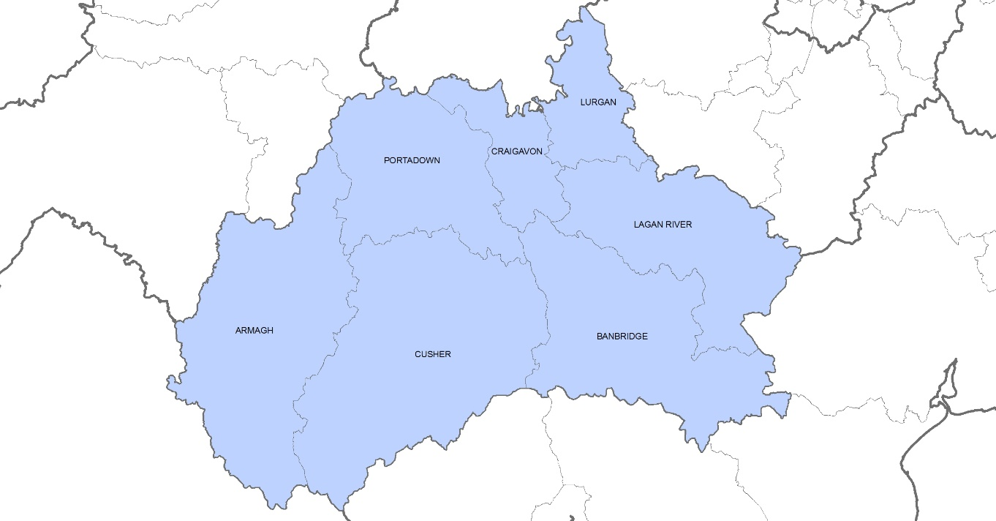Figure 1: District Electoral Areas within Armagh City, Banbridge and Craigavon Borough.

Census 2021
On Census Day 2021 the usual resident population of Armagh City, Banbridge and Craigavon Borough was 218,656. This accounted for 11.5% of the Northern Ireland population, the second largest council in terms of population after Belfast.
The largest district District Electoral Area (DEA) in the borough on Census Day in terms of population was Lurgan DEA with a usual resident population of approximately 38,198 (17.5% of the borough’s population). This was closely followed by Banbridge DEA with a population of 34,940 (16% of the borough’s population). The smallest DEA in the borough was Lagan River with a population of 24,803 (11.3% of the borough’s population).
There were 108,267 males (49.5%) and 110,388 females (50.5%) resident in the borough on Census Day 2021. The proportions of males and females were relatively similar across the seven DEAs in the borough.

DEA | Female | % | Male | % | Total
Armagh | 16,459 | 50.8% | 15,947 | 49.2% | 32,406
Banbridge | 17,758 | 50.8% | 17,182 | 49.2% | 34,940
Craigavon | 14,820 | 50.8% | 14,368 | 49.2% | 29,188
Cusher | 13,195 | 50.4% | 13,000 | 49.6% | 26,195
Lagan River | 12,472 | 50.3% | 12,331 | 49.7% | 24,803
Lurgan | 19,210 | 50.3% | 18,988 | 49.7% | 38,198
Portadown | 16,474 | 50.0% | 16,451 | 50.0% | 32,925
Table 1: Gender profile on Census Day 2021 in District Electoral Areas of Armagh City, Banbridge and Craigavon Borough. Source: Usual Resident Population –Sex – Table MS-A07. Census 2021, NISRA.

Figure 2: Census Day 2021 population for District Electoral Areas of Armagh City, Banbridge and Craigavon Borough. Source: Usual Resident Population –Sex – Table MS-A07. Census 2021, NISRA.
On Census Day 2021, the overall age profile of the borough showed that 22.1% were aged under 16, 29.7% were aged 16 to 39, 32.2% were aged 40 to 64 and 16% were aged 65 and over. Across the seven DEAs in the borough the age profiles were broadly similar to the borough overall.
Banbridge DEA and Lagan River DEA had higher proportions of those aged 40 to 64 than other age groups in their DEA. Craigavon DEA and Lurgan DEA had the highest proportion of those aged 16 to 39 (31.1%) while Cusher had the highest proportion of those aged 65 and over (17.3%)
District Electoral Area | 0-15 years | 16-39 years | 40-64 years | 65+ years | Total
Armagh | 7,364 | 9,612 | 10,062 | 5,367 | 32,405
Banbridge | 7,393 | 9,795 | 11,745 | 6,007 | 34,940
Craigavon | 6,902 | 9,068 | 9,170 | 4,048 | 29,188
Cusher | 5,848 | 7,371 | 8,451 | 4,525 | 26,195
Lagan River | 5,307 | 7,148 | 8,419 | 3,930 | 24,804
Lurgan | 8,275 | 11,881 | 12,244 | 5,797 | 38,197
Portadown | 7,153 | 10,002 | 10,456 | 5,316 | 32,927
Table 2: Age profile on Census Day 2021 for District Electoral Areas of Armagh City, Banbridge and Craigavon Borough. Source: Usual Resident Population – Age-4 categories – Census 2021, NISRA.
District Electoral Area | 0-15 years | 16-39 years | 40-64 years | 65+ years | Total
Armagh | 22.7% | 29.7% | 31.1% | 16.6% | 100.0%
Banbridge | 21.2% | 28.0% | 33.6% | 17.2% | 100.0%
Craigavon | 23.6% | 31.1% | 31.4% | 13.9% | 100.0%
Cusher | 22.3% | 28.1% | 32.3% | 17.3% | 100.0%
Lagan River | 21.4% | 28.8% | 33.9% | 15.8% | 100.0%
Lurgan | 21.7% | 31.1% | 32.1% | 15.2% | 100.0%
Portadown | 21.7% | 30.4% | 31.8% | 16.1% | 100.0%
Table 3: Age profile on Census Day 2021 for District Electoral Areas of Armagh City, Banbridge and Craigavon Borough. Source: Usual Resident Population – Age-4 categories – Census 2021, NISRA.

Figure 3: Age profile proportions on Census Day 2021 for District Electoral Areas of Armagh City, Banbridge and Craigavon Borough. Source: Usual Resident Population – Age-4 categories – Census 2021, NISRA.
Further information on District Electoral Areas from Census 2021 can be found via the following links:
Census 2021 main statistics demography tables – age and sex | Northern Ireland Statistics and Research Agency (nisra.gov.uk)

