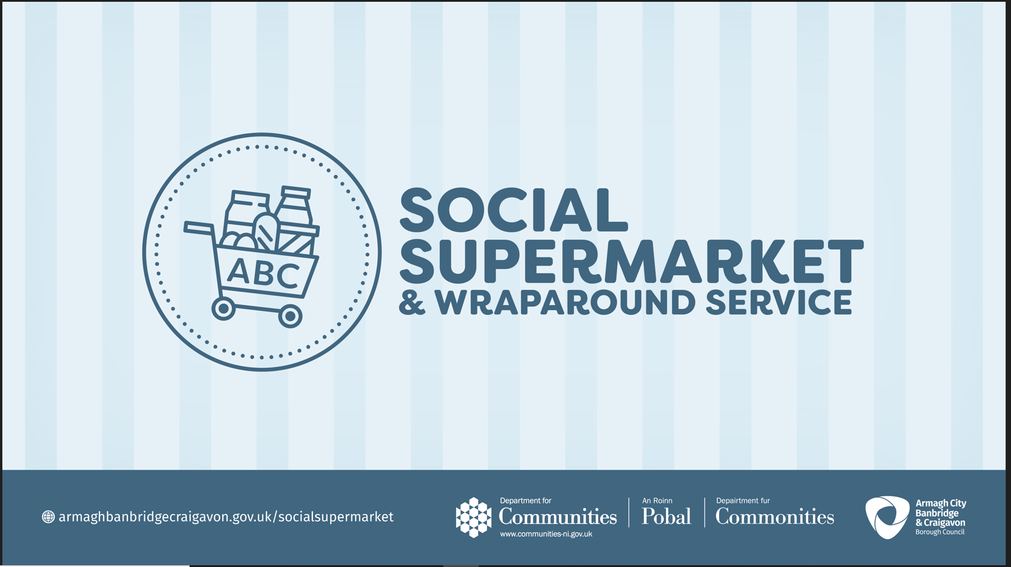

Armagh City, Banbridge and Craigavon Council Community Development Good Relations

**Expression of Interest (EoI) for ABC Community Organisations to share food produce with the established Food Provision Social Supermarket Partner** **through the Social Supermarket and Wraparound Service** **Grow to Give Pilot Project Grant 2023**

**(G2G 2023)**

**Scheme now open Tuesday 25 April and closes 12 noon on Tuesday 9 May 2023.**

|  |
| --- |
| **Introduction to Grant pages 1-6** |
|  |
| * **Background** |
| * **Eligibility Criteria** |
| * **Budget** |
| * **Procurement** |
| * **Training** |
| * **Management** |
| * **Timeline** |

**Background**

* In response to recommendations in the Welfare Reform Mitigations report[1] the Department for Communities has operated a Social Supermarket Pilot programme since October 2017. The aim of this programme has been to test the potential for the concept to tackle food poverty and its root causes. In addition to social supermarkets, as a response to the pandemic, the Department supported a number of food support interventions in 2020/21.
* The Armagh City, Banbridge and Craigavon Council (ABC Council) is committed to supporting and developing the ‘food and beyond’ support structure of the Social Supermarket Infrastructure.
* The Social Supermarket and Wraparound Service Model suggests a pathway through the financial distress journey by offering personal dignity, development and progression, addressing food insecurity and causes and greater access to sustainability of nutritional food and wraparound support services.
* Food, is an area that is requiring further support as we progress through the COVID 19 Recovery and the Cost of Living Crisis environment. This needed commitment is due to the recognised economic pressures as the government support scheme on offer changes and the cost of living spirals due to the ongoing challenges and the reaction to economic instability. This has left people facing stark choices in terms of essentials.

**Grow to Give Pilot Project Grant**

* The Social Supermarket and Wraparound Service **Grow to Give Pilot Project Grant 2023 (G2G 2023)** is designed to promote co-design and collaborative support of the community led approved environmental food supply chain network; by the growing/producing of products/available stock to be given into an established Food Provision Social Supermarket Partner being; 1.Armagh Foodbank, 2.The Storehouse Banbridge, 3.Craigavon Foodbank, 4.Via Wings Dromore, 5.ABC Food Hub, 6.St Vincent de Paul and 7.The Salvation Army.
* The Grow to Give Project is a flexible and responsive food intervention supply, to those most vulnerable in the Borough, through a maximum fund of £5000 to a minimum of 10 suitably qualified ABC Community Organisations who have obtained collaboration from the established Food Provision Social Supermarket Partner to co-create a food supply chain project and become a food producer partner.
* Council will seek to allocate a minimum of one award per Food Provision Social Supermarket Partner.
* The project encourages and is reflective of community ‘creative and adaptable’ food support alignments and other additional benefits with the established Food Provision Social Supermarket Partner.

**Grow to Give aligns to:**

* The linking of the existing ABC food provision structure and ABC community connections through the creation of a supply chain role
* Building skills in relation to environmental outputs
* Encouraging knowledge transfer for community led environmental food creation
* Delivering on the capacity of participants so that projects can be sustained after completion and therefore looking to create a future robust community led supply infrastructure.
* ABC Community Organisations who can meet the criteria of the project, **must seek collaboration** to be a Food Producer Partner, from the list of the seven *established Food Provision Social Supermarket Partners to offer a supply chain link.

*(*who are established because of over 7 years’ experience in the management of emergency food support, including Covid Response and Living Crisis engagement)*

**Eligibility Criteria**

**To be a Food Producer Partner:**

Suitable ABC Community Organisations must evidence:

* Be a constituted organisation.
* Have *written* *collaboration* from an eligible Food Provision Social Supermarket Partner. Be able to run the community project to encourage food production, sustainability, nutritional & wellbeing awareness, skills and structured collaboration supply networks for the benefit of their community group and the Food Provision Social Supermarket Partner end client, based on a *co-design project*
* To meet the needs of the ABC residents through preferred Projects such as, possibly on site or close to site, small vegetable patch, Micro Greens, Herbs, Fruit Trees/Bushes, Hydroponics (for limited outdoor space), Vertical Gardens, Apiaries (Bee Hives) and eco fuel (pine cones due to their beneficial energy use are permitted).
* Comply with Environmental Health Regulations to be able to offer a stock supply. Please see Appendix 1 Guidance Note - Advice on Supplying into a Food Bank.
* Have the capacity to offer up to 50% of stock to the aligned Food Provision Social Supermarket Partner under the necessary standards of Food and Environmental Health Legislation.
* Have Training in place. *(please refer to the training section*).
* Monitor and report on the value and outputs of the project funded by the grant. A final report will be required which includes:
  + Case Study,
  + Numbers of ABC residents supported through your project.
  + Number who benefited within your community organisation.
  + Number of products supplied and who benefited from them.
  + Sustainability and Development Outcomes achieved.

**Through the Grow to Give Project, Community Groups, who have co-operation, with the Food Provision Social Supermarket Partner will have access to the following:**

**Budget**

* Minimum of 10 suitably qualified ABC Community Organisations to receive a maximum fund of **£5000 available grant per eligible organisation** to support and build on the ABC existing Food Provision Social Supermarket structure in place.
* **Materials and equipment,** to support the development of an outside space and/or alternative space for the production of goods to supply to the **Food Provision Social Supermarket Partner** (See **Appendix 2** for suggested project equipment) which can be purchased from the maximum Grant Fund of £5000 per eligible organisation.
* **For guidance on the purchasing of materials and equipment please refer to the procurement information below.**

**Not In Scope**

* The funding is not available to provide direct payments to vulnerable people or labour costs.

**Procurement**

**Procurement Procedure**

The available grant is up to £5000 funding per eligible community organisation successful submitted project which includes an indicative budget. Value for money must be evidenced with **3** quotes and up to **2** cost comparisons relevant to indicative budget containing;

* The specification of goods required
* Company name & Address
* Organisational name & and Address
* Quantity
* Price
* Date
* Please note council reserves the right to extend the funding period due to changing circumstances and/or the availability of additional funding. Council also reserves the right to not proceed with the Funding Grant.
* One of the purposes of this Expression of Interest (EoI) process is to gather market intelligence regarding the likely budget requirement. Respondents should therefore include an indicative budget, with full breakdown of cost, within the Expression of Interest Response Template.
* To fulfil due diligence, responsibilities on behalf of the funders and programme partners, we must ensure that grant funding is being invested directly.
* A cost comparison (minimum of two comparative prices) for items under £1500 and three quotes per item over £1500.

**Training Mandatory Requirement**

**Project Awareness and Health and Safety Training** **Requirement:**

* ***Groups must participate in mandatory training (that can be provided by Council) or show evidence* in the form of** contracted training and certificates of leaders having a successful outcome in the following training;
  + - * 1. **First Aid Training**
        2. **Manual Handling Training**
        3. **Risk Assessment Training**
        4. **Safe Guarding**

*Please note that attendance at this training is mandatory by* ***two*** *members of your group if the organisation* ***cannot*** *provide evidence of this required standard being in place. The Training will be offered by* council and must take place before the project can begin.

**Management**

**Project Management and Governance**

* A dedicated project contact is expected to be nominated, who will act as the main point of contact to council. It will be a requirement of any future offering that the project contact will have the necessary authority to take decisions, at all times, and deal directly with all matters relating to this project to ensure any issues which may arise are resolved in a timely manner.

**Evidence and Publicity**

* Successful applicants will be required to produce evidence in the end of project/ post reporting of the outcomes of the funded project. Due to the project including planting and growing of produce the timeline of reporting will be relevant to harvesting.
* All publicity relating to funding will require prior approval from the funder DFC and Council.

**Role and Purpose of the projects key element of Co-Design/ Co-Create**

is being established to:

* Consider place-based approaches that builds on the existing structure and the potential of partnerships in ABC.
* Sharing with a **Food Provision Social Supermarket Partner** will include co-operation and planning of the project.

**Timeline**

**Funding to be spent by 30 June 2023 with programme delivery in the Armagh City, Banbridge and Craigavon Borough between the estimated date range of 17 May 2023 and 16 September 2023 (due to the seasonal aspect of the project this date range might vary). Reporting to be submitted by 31 October 2023.**

**Deadline for receipt of submitted application forms is 12 Noon Tuesday 9 May 2023.**

|  |
| --- |
| Submission to include –  Icon 2 Application Form |

**With letters of offer to be issued by Wednesday 17 May 2023 and all mandatory training to take place before project can start.**

**It is noted that due to the seasonal aspect of the project reporting will be ongoing.**

**Date Range**

|  |  |
| --- | --- |
| **Description** | **Date / time** |
| Advertised EoI | Tuesday 25 April |
| Deadline for receipt of EoI | Tuesday 12 noon 9 May |
| Assessment | Thursday 11 May and Friday 12 May 2023 |
| Successful/non successful Correspondence | Monday 15 May 2023 |
| Letter of Offer | Wednesday 17 May |
| Monitoring and monthly reporting (including case studies) | Ongoing ( project may include various phases; planting, growing, harvesting, producing and end user support) |

1. [Welfare Reform Mitigations Working Group Report (executiveoffice-ni.gov.uk)](https://www.executiveoffice-ni.gov.uk/sites/default/files/publications/ofmdfm/welfare-reform-mitigations-working-group-report.pdf)