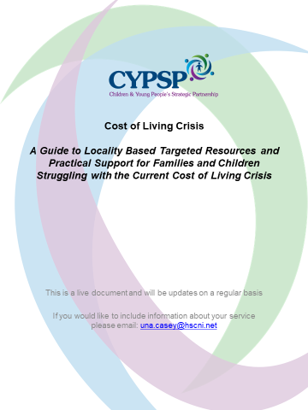
Organisation/Service Name
Service offered to support families with cost of living
What is available:
(Food, Fuel, clothing, financial support, uniforms, PE kits, Warm Places etc.)
How to access:
(phone, email, referral process etc.)
is there a waiting list?
Is there an expected response time? How long is this?
Further Information:
(e.g. time frame of provision/availability etc.)
Area Covered

