When you receive the link from the council officer it will take you to the following screen.
https://daera.outsystemsenterprise.com/RBDGS/StartPage
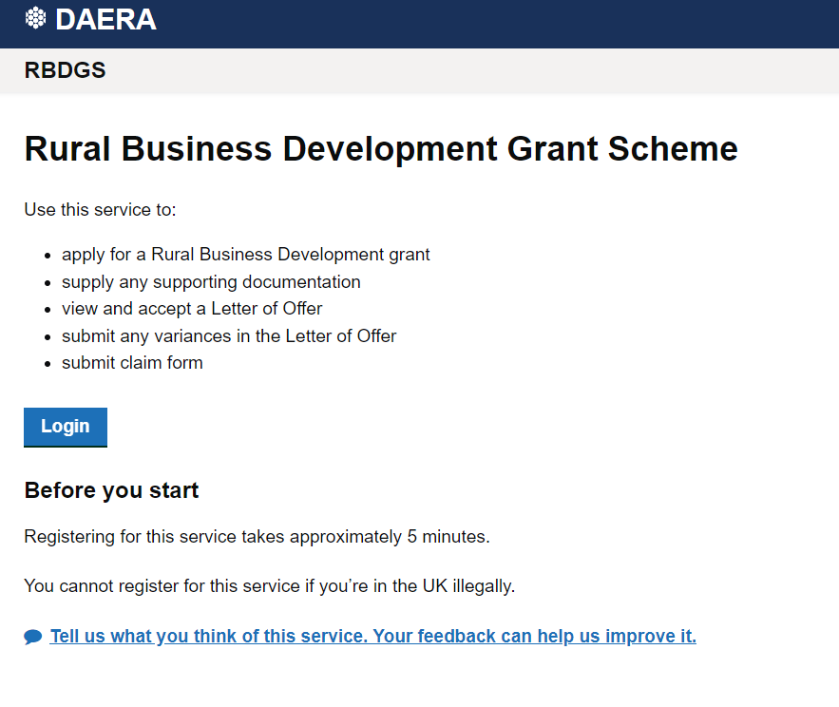
Clicking log in will take you to the DAERA secure log in site, you can log in or register with either option.
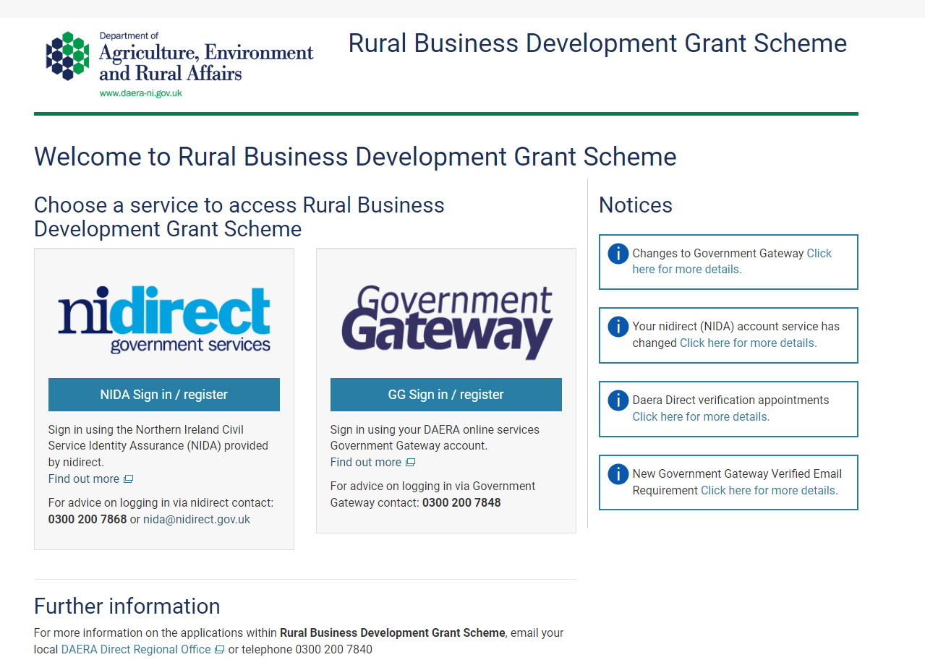
For this example, I will use NI Direct as this is used by all citizens.
Clicking Sign in / Register will take you here:
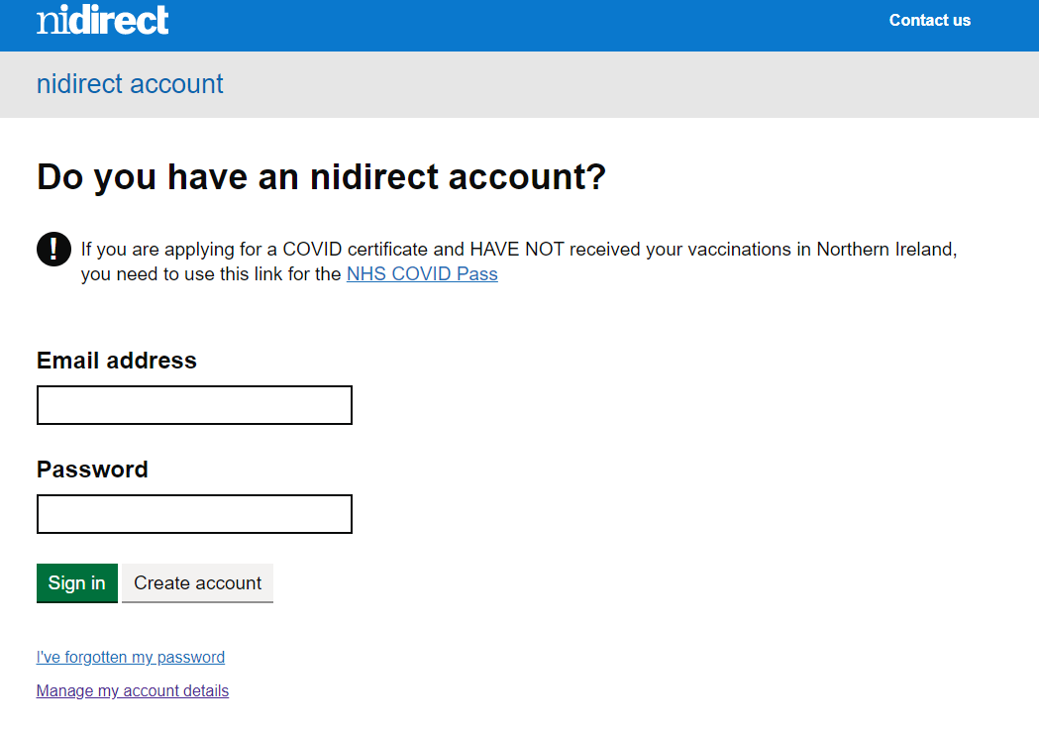
Most citizens will have an NI Direct account, if not you can “create account”.
You will require an email address to do this:
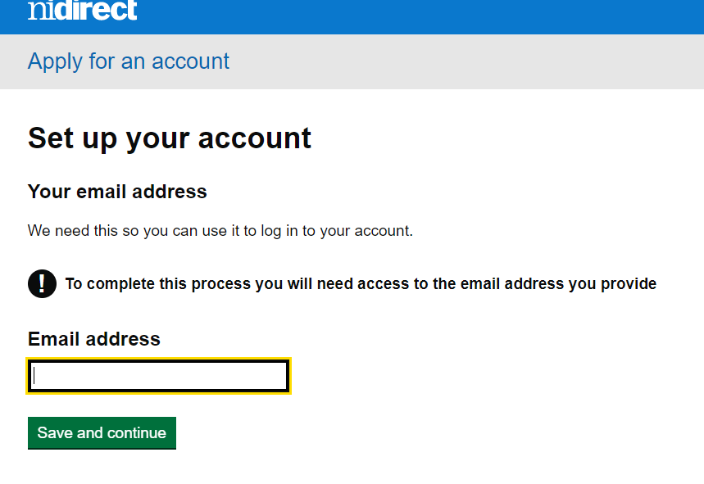
Below are the steps required to complete the NI Direct registration: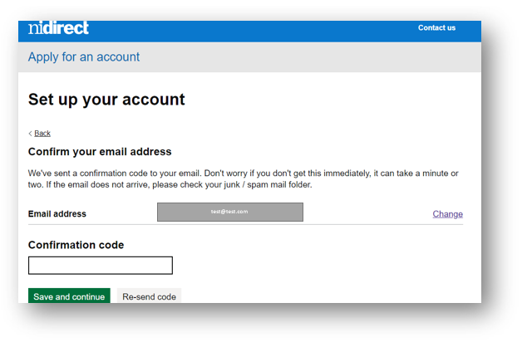
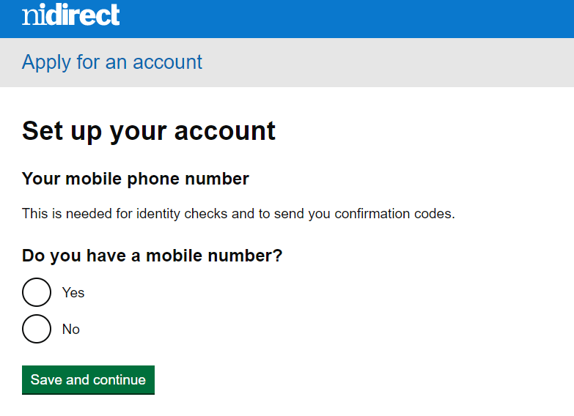

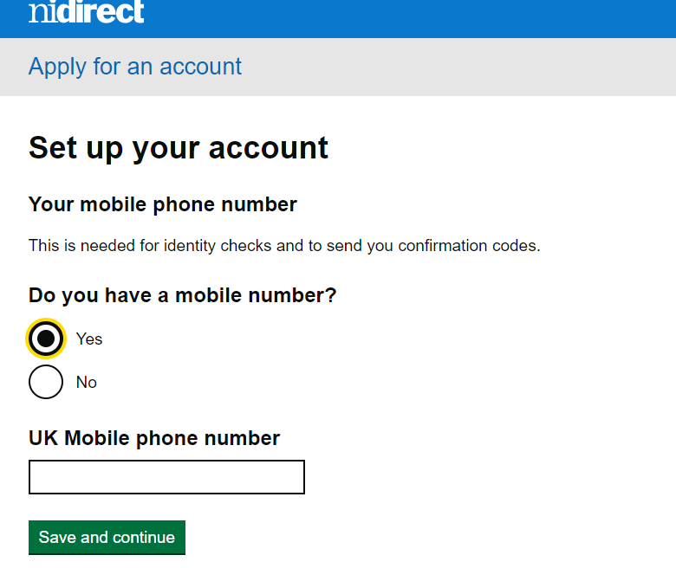
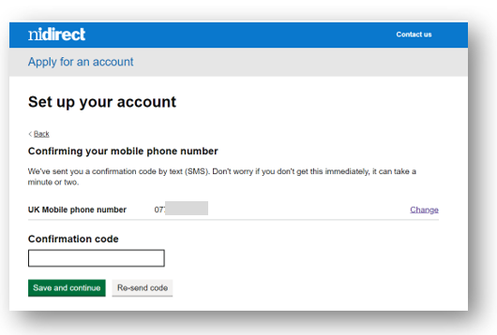

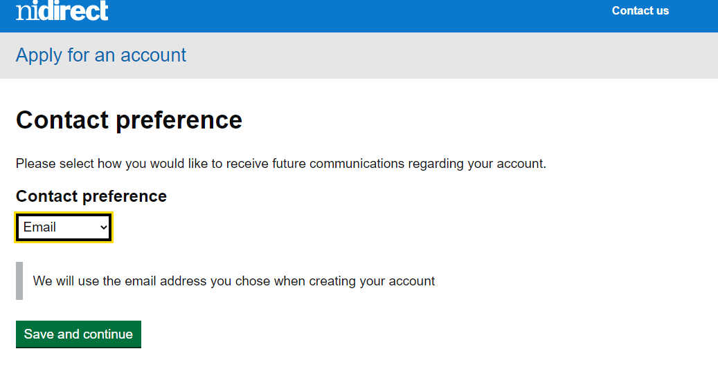
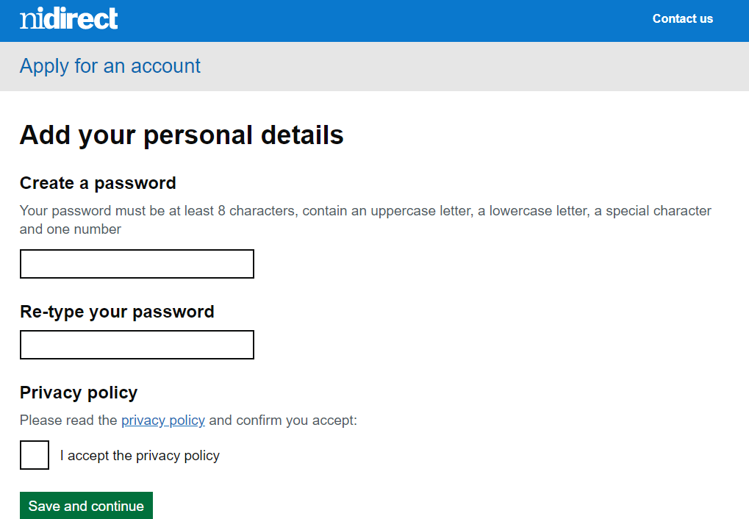
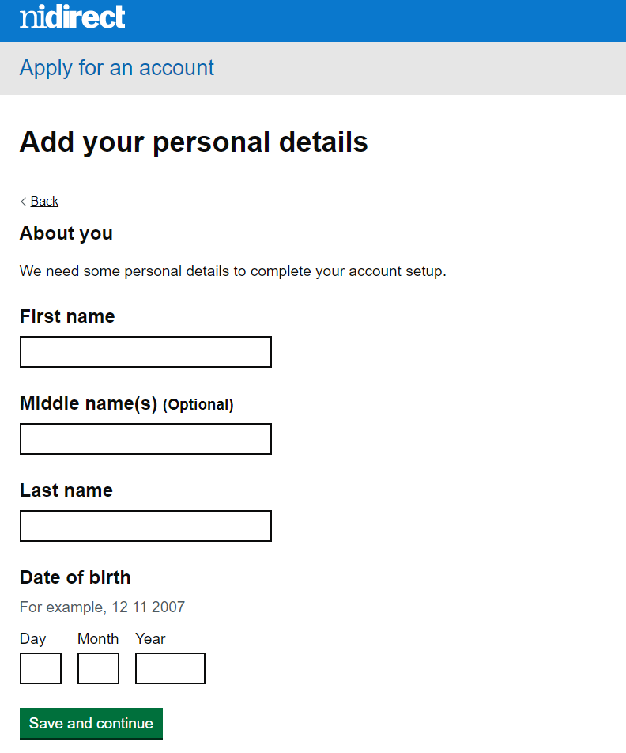
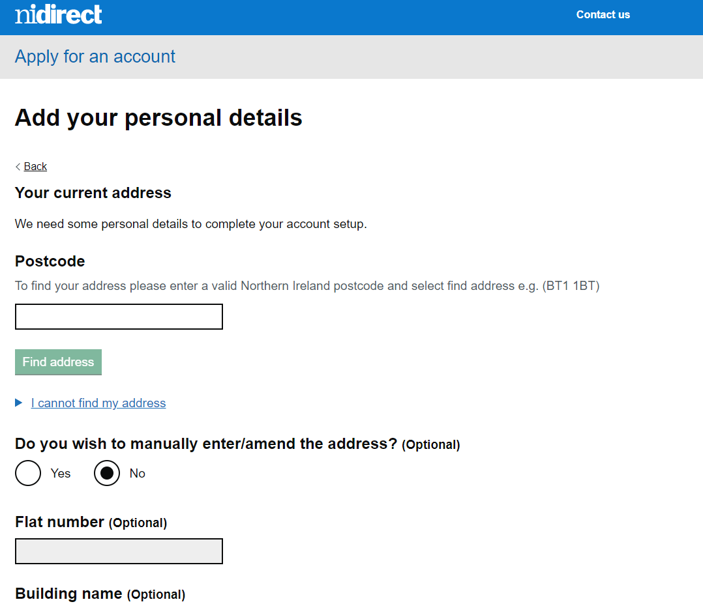
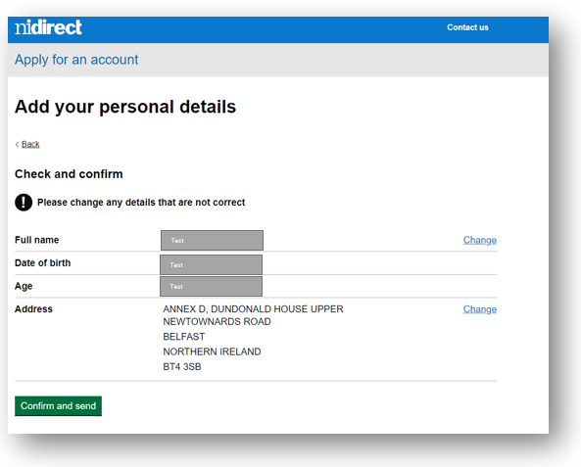

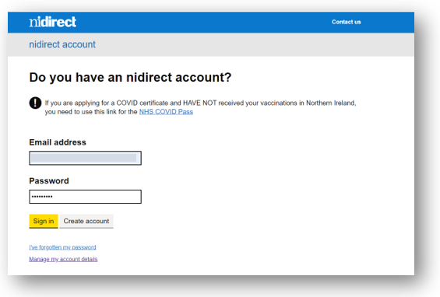
Once the information is complete it will take you back to the above log in screen where you can enter in your newly formed NI Direct account, and it will direct you to the application screen where you can create a new application:
