District Electoral Areas
In 2008, the Northern Ireland Assembly approved the reform of Local Government. The change moved Local Government from 26 Districts to 11 new Districts, as well as making changes to the powers of Local Government. The new 11 Districts are made up of 80 District Electoral Areas, which form the basis for the electoral representation on councils.
Armagh City, Banbridge and Craigavon Borough is made up of seven District Electoral Areas as shown below: Armagh, Banbridge, Craigavon, Cusher, Lagan River, Lurgan and Portadown.

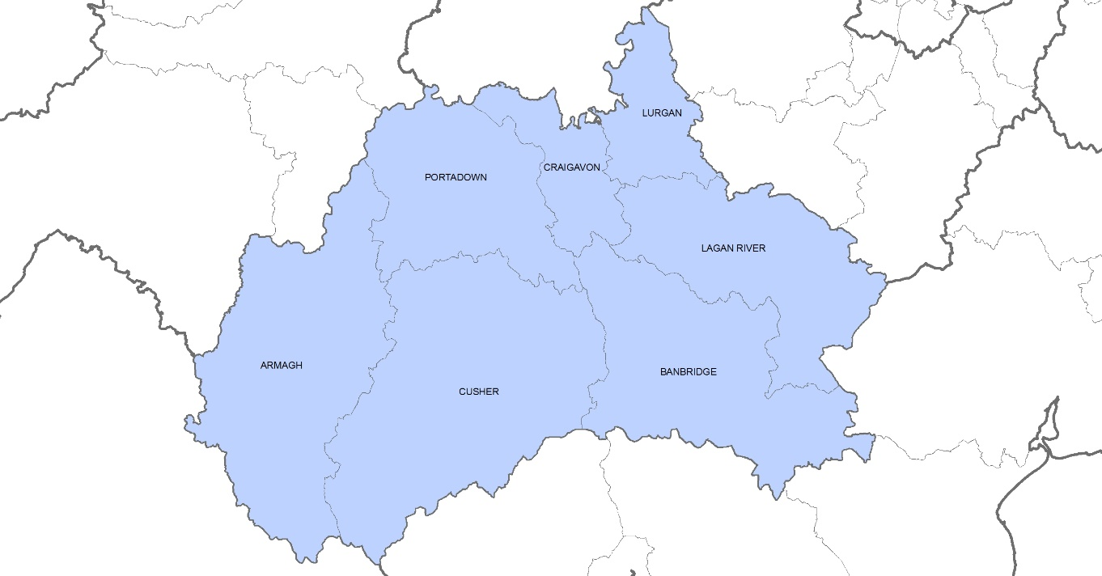Figure 1: District Electoral Areas within Armagh City, Banbridge and Craigavon Borough.

Census 2011
On Census Day 2011 the usual resident population of Armagh City, Banbridge and Craigavon Borough was 199,693. This accounted for 11.0% of the Northern Ireland population, the second largest council in terms of population after Belfast.
The largest district District Electoral Area (DEA) in the borough on Census Day in terms of population was Lurgan DEA with a usual resident population of 34,939 (17.5% of the borough’s population). This was closely followed by Banbridge DEA with a population of 33,419 (16.7% of the borough’s population). The smallest DEA in the borough was Lagan River with a population of 22,991 (11.5% of the borough’s population).
There were 98,713 males (49.4%) and 100,980 females (50.6%) resident in the borough on Census Day 2011. The proportions of males and females were relatively similar across the seven DEAs in the borough. Craigavon DEA had the highest proportion of females with 51.0%.

DEA | Male | % | Female | % | Total
Armagh | 14,953 | 49.4% | 15,333 | 50.6% | 30,286
Banbridge | 16,465 | 49.3% | 16,954 | 50.7% | 33,419
Craigavon | 12,399 | 49.0% | 12,888 | 51.0% | 25,287
Cusher | 11,645 | 50.0% | 11,633 | 50.0% | 23,278
Lagan River | 11,498 | 50.0% | 11,493 | 50.0% | 22,991
Lurgan | 17,228 | 49.3% | 17,711 | 50.7% | 34,939
Portadown | 14,525 | 49.3% | 14,968 | 50.7% | 29,493
Table 1: Gender profile on Census Day 2011 in District Electoral Areas of Armagh City, Banbridge and Craigavon Borough. Source: Usual Resident Population – KS101NI (administrative geographies), Census 2011, NISRA.

Figure 2: Census Day 2011 population for District Electoral Areas of Armagh City, Banbridge and Craigavon Borough. Source: Usual Resident Population – KS101NI (administrative geographies), Census 2011, NISRA.

On Census Day 2011, the overall age profile of the borough showed that 22.1% were aged under 16, 32.8% were aged 16 to 39, 31.2% were aged 40 to 64 and 13.8% were aged 65 and over. Across the seven DEAs in the borough the age profiles were broadly similar to the borough overall.
Banbridge DEA and Lagan River DEA had higher proportions of those aged 40 to 64 than other age groups in their DEA. Craigavon DEA had the highest proportion of those aged 16 to 39 (34.9%) while Portadown had the highest proportion of those aged 65 and over (15.0%)

Age Group | Armagh | Banbridge | Craigavon | Cusher | Lagan River | Lurgan | Portadown
0 – 15 years | 6,609 | 7,349 | 5,941 | 5,248 | 5,226 | 7,606 | 6,227
16 – 39 years | 10,072 | 10,622 | 8,820 | 7,377 | 7,243 | 11,536 | 9,802
40 – 64 years | 9,319 | 10,746 | 7,683 | 7,375 | 7,470 | 10,768 | 9,027
65 and over | 4,286 | 4,702 | 2,843 | 3,278 | 3,052 | 5,029 | 4,437
Total | 30,286 | 33,419 | 25,287 | 23,278 | 22,991 | 34,939 | 29,493
Table 2: Age profile on Census Day 2011 for District Electoral Areas of Armagh City, Banbridge and Craigavon Borough. Source: Age Structure – KS102NI (administrative geographies) and Table CT0246NI – Usually Resident Population by 5 Year Age Bands by Sex, Census 2011, NISRA.
Age Group | Armagh | Banbridge | Craigavon | Cusher | Lagan River | Lurgan | Portadown
0 – 15 years | 21.8% | 22.0% | 23.5% | 22.5% | 22.7% | 21.8% | 21.1%
16 – 39 years | 33.3% | 31.8% | 34.9% | 31.7% | 31.5% | 33.0% | 33.2%
40 – 64 years | 30.8% | 32.2% | 30.4% | 31.7% | 32.5% | 30.8% | 30.6%
65 and over | 14.2% | 14.1% | 11.2% | 14.1% | 13.3% | 14.4% | 15.0%
Total | 100.0% | 100.0% | 100.0% | 100.0% | 100.0% | 100.0% | 100.0%

Table 3: Age profile on Census Day 2011 for District Electoral Areas of Armagh City, Banbridge and Craigavon Borough. Source: Age Structure – KS102NI (administrative geographies) and Table CT0246NI – Usually Resident Population by 5 Year Age Bands by Sex, Census 2011, NISRA.

Figure 3: Age profile proportions on Census Day 2011 for District Electoral Areas of Armagh City, Banbridge and Craigavon Borough. Source: Age Structure – KS102NI (administrative geographies) and Table CT0246NI – Usually Resident Population by 5 Year Age Bands by Sex, Census 2011, NISRA.

Mid-Year Population Estimates
It was estimated that at the 30th June 2020 the population of Armagh City, Banbridge and Craigavon Borough was 217,232 of which 49.75% were male and 50.25% female. Mid-year estimates for the DEAs show similar age profiles as the borough overall. Lagan River and Portadown are the only DEAs in the borough to have more males than females although Portadown is closer to a 50:50 split. Please note DEA totals will not add to the population of the borough due to different methodologies used for estimating populations at various geographic levels.
Lurgan DEA is the largest DEA in the borough in terms of population, accounting for 17.3% of the borough’s population followed by Banbridge (16.1% of borough’s population). The smallest DEA in the borough is Lagan River with a population of approximately 24,360 (11.2% of the borough’s population). Lurgan DEA is the second highest populated DEA in Northern Ireland after Botanic DEA (Belfast Council).
DEA | Male | % | Female | % | Total
Armagh | 16,140 | 49.8% | 16,260 | 50.2% | 32,400
Banbridge | 17,240 | 49.3% | 17,710 | 50.7% | 34,940
Craigavon | 14,270 | 49.4% | 14,640 | 50.6% | 28,910
Cusher | 12,930 | 49.9% | 12,990 | 50.1% | 25,910
Lagan River | 12,210 | 50.1% | 12,150 | 49.9% | 24,360
Lurgan | 18,730 | 49.8% | 18,890 | 50.2% | 37,620
Portadown | 16,360 | 50.0% | 16,320 | 49.9% | 32,690
Table 4: 2020 gender profile of District Electoral Areas in Armagh City, Banbridge and Craigavon Borough. Source: 2020 Mid-Year Population Estimates, NISRA. Please note estimates are rounded to the nearest ten and therefore may not sum to totals. Rounding for estimates at this geographic level is independent and as such figures may not add to higher geography totals.

Figure 4: 2020 population estimates of District Electoral Areas in Armagh City, Banbridge and Craigavon Borough. Source: 2020 Mid-Year Population Estimates, NISRA. Please note estimates are rounded to the nearest ten and therefore may not sum to totals. Rounding for estimates at this geographic level is independent and as such figures may not add to higher geography totals.
Between mid-2011 and mid-2020 three of the top five DEAs in Northern Ireland with the greatest increase in number of people were in Armagh City, Banbridge and Craigavon Borough. Portadown DEA increased by around 3,180, Craigavon by around 3,180 and Lurgan by around 3,070.
 | 2011 | 2012 | 2013 | 2014 | 2015 | 2016 | 2017 | 2018 | 2019 | 2020
Armagh | 29,960 | 30,160 | 30,350 | 30,550 | 30,780 | 31,180 | 31,510 | 31,920 | 32,240 | 32,400
Banbridge | 33,090 | 33,290 | 33,370 | 33,600 | 33,860 | 34,160 | 34,380 | 34,680 | 34,970 | 34,940
Craigavon | 25,730 | 26,040 | 26,270 | 26,650 | 26,950 | 27,400 | 27,840 | 28,260 | 28,680 | 28,910
Cusher | 24,360 | 24,630 | 24,720 | 24,850 | 24,930 | 25,130 | 25,410 | 25,580 | 25,830 | 25,910
Lagan River | 22,720 | 22,990 | 23,230 | 23,420 | 23,610 | 23,810 | 23,910 | 24,100 | 24,300 | 24,360
Lurgan | 34,550 | 34,890 | 35,150 | 35,430 | 35,850 | 36,280 | 36,500 | 36,980 | 37,360 | 37,620
Portadown | 29,510 | 30,010 | 30,260 | 30,840 | 31,430 | 31,890 | 31,970 | 32,160 | 32,410 | 32,690
Table 5: Population estimates of District Electoral Areas in Armagh City, Banbridge and Craigavon Borough 2011 to 2020. Source: Mid-Year Population Estimates, NISRA. Please note estimates are rounded to the nearest ten and therefore may not sum to totals. Rounding for estimates at this geographic level is independent and as such figures may not add to higher geography totals.
The age profile of the borough overall at 30th June 2020 showed 22.5% were aged under 16, 29.9% were aged 16 to 39, 31.9% were aged 40 to 64 and 15.7% were 65 and over.
Cusher DEA has the highest proportion of those aged 65 and over (16.7%) in the borough. Craigavon DEA has the highest proportion of children (those aged under 16) in the borough with 24.0%.
Lurgan DEA has the 2nd highest proportion of children of all DEAs in Northern Ireland.
Age Group | Armagh | Banbridge | Craigavon | Cusher | Lagan River | Lurgan | Portadown
0 – 15 years | 7,590 | 7,520 | 6,930 | 5,860 | 5,300 | 8,280 | 7,290
16 – 39 years | 9,610 | 10,010 | 9,060 | 7,360 | 7,010 | 11,630 | 10,130
40 – 64 years | 9,960 | 11,590 | 8,960 | 8,360 | 8,250 | 11,930 | 10,060
65 and over | 5,230 | 5,810 | 3,950 | 4,330 | 3,800 | 5,780 | 5,210
Total | 32,400 | 34,940 | 28,910 | 25,910 | 24,360 | 37,620 | 32,690
Table 6: 2020 age profile of District Electoral Areas in Armagh City, Banbridge and Craigavon Borough. Source: 2020 Mid-Year Population Estimates, NISRA. Please note estimates are rounded to the nearest ten and therefore may not sum to totals. Rounding for estimates at this geographic level is independent and as such figures may not add to higher geography totals.

Age Group | Armagh | Banbridge | Craigavon | Cusher | Lagan River | Lurgan | Portadown
0 – 15 years | 23.4% | 21.5% | 24.0% | 22.6% | 21.8% | 22.0% | 22.3%
16 – 39 years | 29.7% | 28.6% | 31.3% | 28.4% | 28.8% | 30.9% | 31.0%
40 – 64 years | 30.7% | 33.2% | 31.0% | 32.3% | 33.9% | 31.7% | 30.8%
65 and over | 16.1% | 16.6% | 13.7% | 16.7% | 15.6% | 15.4% | 15.9%
Total | 100.0% | 100.0% | 100.0% | 100.0% | 100.0% | 100.0% | 100.0%
Table 7: 2020 age profile of District Electoral Areas in Armagh City, Banbridge and Craigavon Borough. Source: 2020 Mid-Year Population Estimates, NISRA. Please note estimates are rounded to the nearest ten and therefore may not sum to totals. Rounding for estimates at this geographic level is independent and as such figures may not add to higher geography totals.

Figure 5: 2020 age profile of District Electoral Areas in Armagh City, Banbridge and Craigavon Borough. Source: 2020 Mid-Year Population Estimates, NISRA. Please note estimates are rounded to the nearest ten and therefore may not sum to totals. Rounding for estimates at this geographic level is independent and as such figures may not add to higher geography totals.

Further information on District Electoral Areas can be found via the following links:
https://www.ninis2.nisra.gov.uk/public/AreaProfileDEA.aspx
https://www.nisra.gov.uk/publications/2020-mid-year-population-estimates-small-areas

