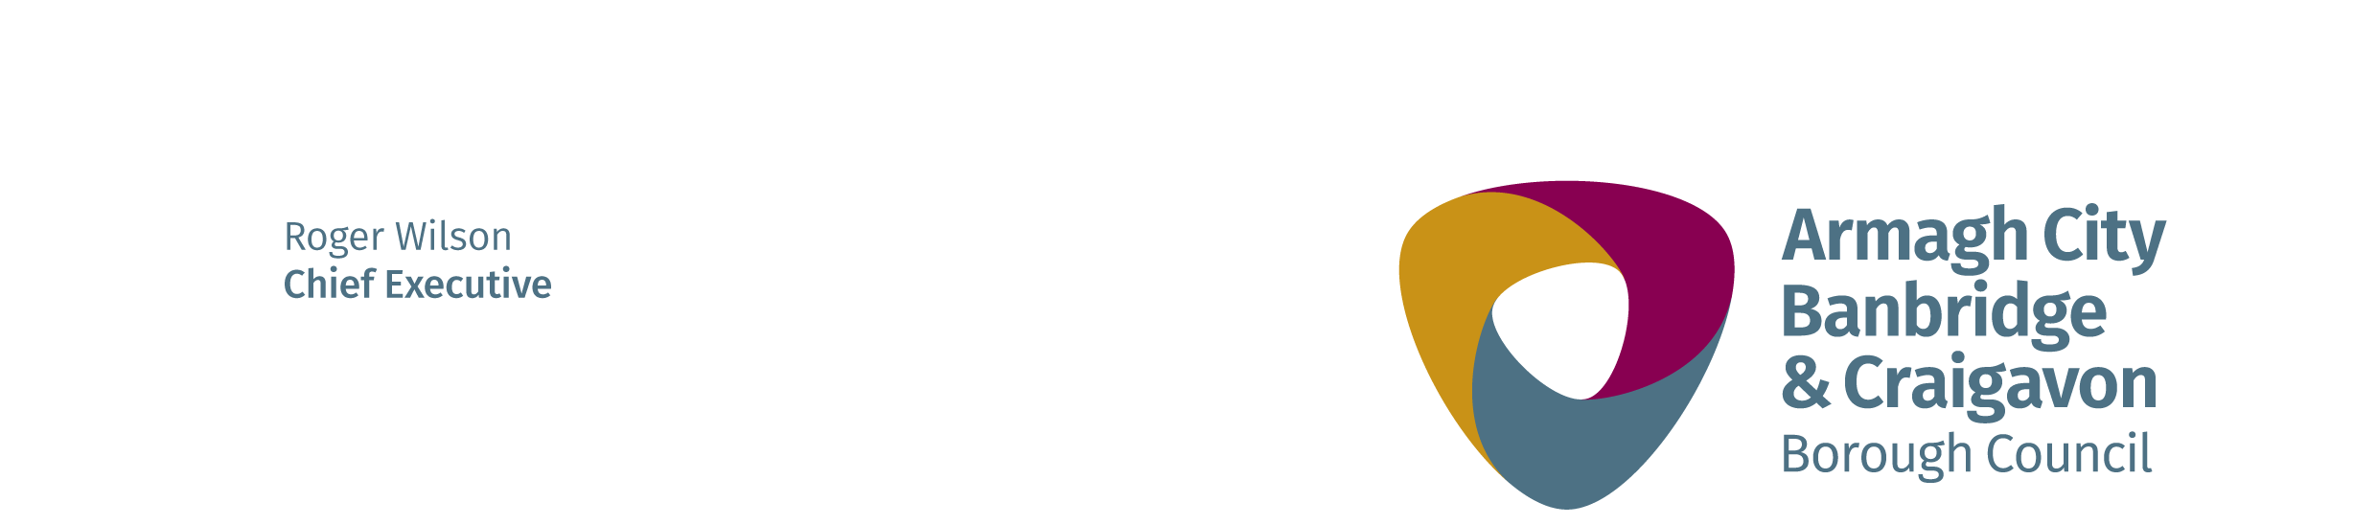
JOB DESCRIPTION

Post: Leisure and Climbing Wall Attendant 26th March 2021

Directorate: People

Department: Health and Recreation

Location: Gilford Community Centre

Reports to: Duty Manager

Salary:

Hours:

Duration: Permanent

All employees are expected to model the Customer Care behaviours of “Serve Passionately, Engage Positively and Deliver Consistently.”

job purpose:

Committing to the one-team ethos, you will be flexible and collaborative and you will actively support all colleagues and other activities necessary to deliver the service objectives.

At your site, you will uphold all safety standards and procedures, ensuring that all areas are properly organised and equipped meaning that all customers have a safe and enjoyable experience.

main Duties and Responsibilities:

- Maintain constant surveillance of the site and customers’ behaviour and act appropriately to ensure the safety of all users.

- Adhere to all NOPs, EAPs, control measures, safe systems of work and standards.

- Remain fully conversant with all emergency procedures and take part in emergency situations, providing emergency care as required.

- Conduct inspection and cleaning duties, keep records up-to-date and fix or promptly report faults to ensure that all areas of the site are clean, tidy, and hygienic and facilities and equipment are fit for a safe and enjoyable customer experience.

- Conduct effective set up/take down tasks to ensure facilities and equipment are prepared for a safe and enjoyable customer experience throughout the site.

- Provide support, guidance and encouragement to gym users on how to use equipment, ensuring a safe and enjoyable fitness session, providing customer inductions, exercise programmes and instruction on all aspects of fitness and gym equipment.

- Provide safe instruction and supervision for all Climbing Wall customers in compliance with required standards and procedures.

- Assess climbers and approve climber’s competence as appropriate.

- Conduct all required Climbing Wall equipment checks and maintenance in compliance with all regulations, national governing bodies or manufacturer’s guidelines.

- Assist with activity programmes as required.

- Make all customers feel welcome and comfortable and ensure that they are benefiting from the services provided in the Gym/Centre and assist with all forms of customer communications.

- Ensure that all customers are fully informed with respect to the facilities, services, products and prices available to them and promote and/or sell all products and activities within the site and within the Leisure Services portfolio.

- Conduct exit interviews/surveys with leaving members to understand issues around customer retention.

- Carry out reception duties and assist with administration, financial and cash handling duties for the effective operation of the site.

- Conduct facility tours as required.

- Be flexible and collaborative and actively support all colleagues and other activities or processes which impact on the performance of the Centre.

