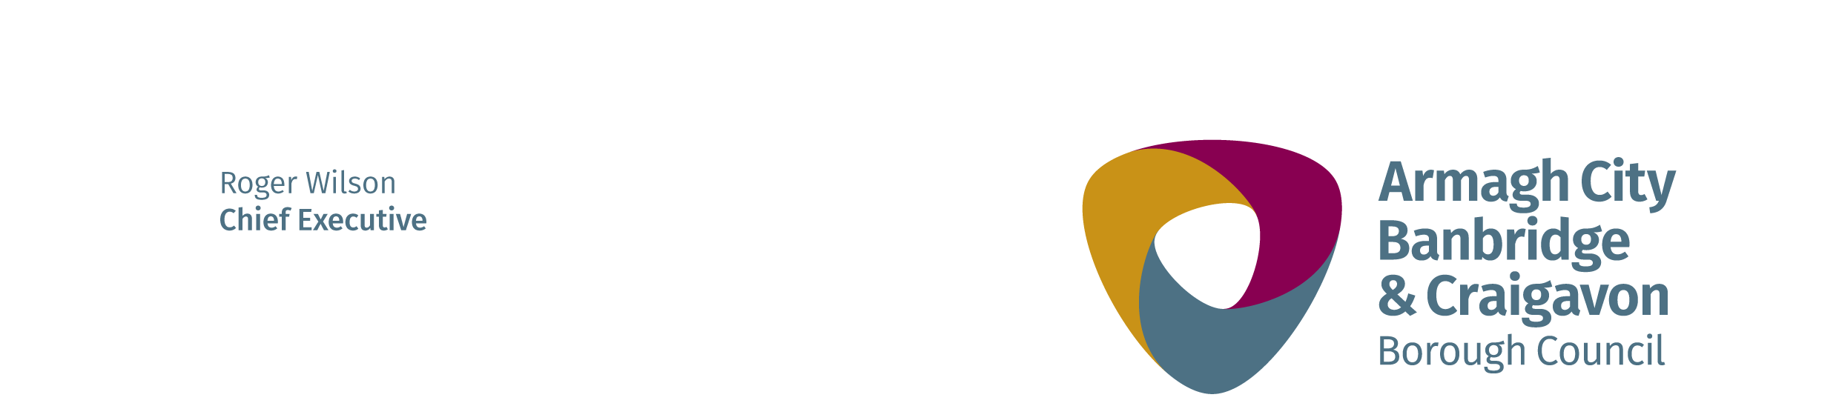
JOB DESCRIPTION

Post: Operations Manager 26th March 2021

Directorate: People

Department: Health and Recreation

Location: TBC

Reports to: Indoor Leisure Manager

Salary:

Hours: 37 hours per week

Duration: Permanent

All employees are expected to model the Customer Care behaviours of “Serve Passionately, Engage Positively and Deliver Consistently.”

job purpose:

Committing to the one-team ethos, you will be flexible and collaborative and you will actively support all colleagues and other activities necessary to deliver the service objectives.

As an Operations Manager, you will be responsible for leading the team in the delivery of an excellent customer experience. You will engage positively with staff and customers, understanding and meeting their needs as appropriate.

You are responsible for the management of an agreed business unit and for the achievement of financial targets and the operational performance of the Centres, the leadership of the teams and the delivery of the agreed Service Plan.

main Duties and Responsibilities:

- Manage the agreed service area, ensuring the effective and efficient use of staff in operating, developing and promoting the facilities.
- Recruit, lead and develop staff to ensure that they and any employees for which they are responsible:
- Effectively manage their teams, positively contributing to wellbeing and high levels of employee engagement;
- Implement and review appropriate training and development programmes for employees to ensure sufficient skills, capacity and knowledge within the service.
- Operate within Council policies and procedures;
- Deliver services in the most efficient and equitable manner and in accordance with Council governance and financial regulations;
- Efficiently and effectively manage available resources;
- Deliver their agreed performance targets;
- Work in a corporate and collaborative way with other services and departments.

- Ensure that staffing requirements meet the changing needs of the service.

- Promote communication that is clear, effective and transparent at all levels both inside and outside of SLLC.

- Ensure that the business unit is managed to a high standard against agreed performance targets.

- Manage the service area to ensure a culture of continuous improvement.

- Develop a Service Plan to achieve financial and performance targets, with appropriate linkage to budget processes and other plans
- Ensure that, within the service area, all Normal Operating Procedures and Operating Standards, Emergency Action Plans, Technical Operating Procedures (equipment and plant operating instructions) and health and safety systems (risk assessments, etc.) are compliant with Council policy and regulatory standards and that effective checks and records are in place.

- Implement health & safety and safeguarding systems within the Centres.

- Ensure that SLAs are managed for the interests of the service area.

- Actively participate in marketing/sales plans to maximise the Centres’ usage and income.

- Promote and/or sell all products and activities within the Centres and within the Leisure Services portfolio.

- Work with leadership team to identify and implement cultural change necessary to ensure the Centres’ success.

- Be flexible and collaborative and actively support all colleagues and other activities or processes which impact on the performance of the Centres.

