JOB DESCRIPTION

Post: Gymnastics Level 2 Coach 26th March 2021

Directorate: People

Department: Health and Recreation

Location: All sites

Reports to: Duty Manager

Salary:

Hours:
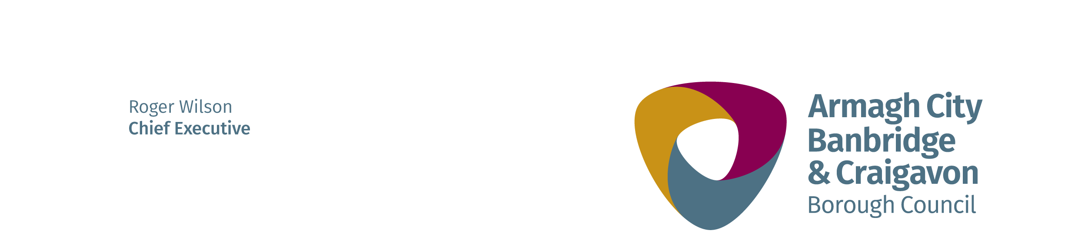
Duration: Permanent

All employees are expected to model the Customer Care behaviours of “Serve Passionately, Engage Positively and Deliver Consistently.”

job purpose:

Committing to the one-team ethos, you will be flexible and collaborative and you will actively support all colleagues and other activities necessary to deliver the service objectives.

As a qualified Level 2 Gymnastics Coach, you will assist with the planning, implementation and delivery of Recreational Gymnastics programmes in line with British Gymnastics and Gymnastics Northern Ireland guidelines. You will coach and develop participants, as permitted by your qualification, in accordance with Council policies and procedures.

main Duties and Responsibilities:

- Assist with the planning and implementation of the Gymnastics Programme in line with British/NI Gymnastics guidelines.

- Coach participants, as permitted by your qualification, ensuring adherence to systems that promote best practice.

- Erect and dismantle equipment and liaise with the operational staff/managers to ensure that equipment set-up reflects the focus of the session and report any issues/defects.

- Assist with administration, record-keeping and communication with parents/students.

- Assist the other coaches and managers/supervisors.

- Assist in guiding and training all lower level or less experienced instructors or coaches.

- Ensure compliance with all Council and British Gymnastics Health and Safety, Safeguarding and Equal Opportunity policies and Codes of Conduct.

- Be flexible and collaborative and actively support all colleagues and other activities or processes, which impact on the performance of the Centre.

