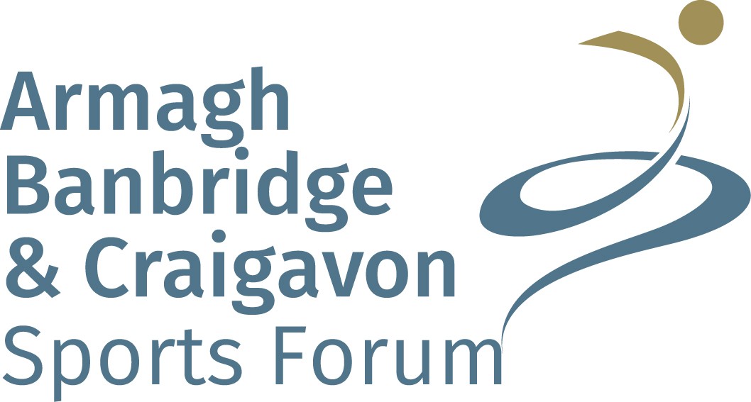
Dxc
Sports Bursary Scheme
Criteria & Application Form

CRITERIA

Purpose:

To facilitate the further development of aspiring athletes who reside in the Armagh City, Banbridge and Craigavon Borough Council area and who have the ability and potential to bring credit to the borough with success at Provincial level or higher. The sports bursaries are for athletes who have the potential to compete and achieve success at a very high level within their sport.

Criteria:

Those athletes of proven ability whose ranking is judged against, Irish, British, European and World standards and indicates significant potential to compete with credit at international level or with distinction in British and Irish Championships.

Budget:

The Sports Forum will allocate a budget for each level of award i.e. Development and Ambassador. It should be noted that not all individuals who meet the criteria will necessarily receive awards due to the limited finance available for distribution. The Sports Forum will only consider awarding bursaries when funds are available to do so.

Eligibility:

- Applicants must reside within the Armagh City, Banbridge and Craigavon Borough Council area.
- Applicants must be affiliated to the Armagh, Banbridge and Craigavon Sports Forum as an individual or through their club.
- Applicants must be involved in an amateur capacity and be affiliated, either individually or by club, to a Sport Northern Ireland, Sport Ireland or UK Sport recognised Governing Body.
- Applicants must be aged 12 and over at the closing date of application.
- Applications received after the closing date or not fully completed will not be considered.
- For individuals who are involved in team sports, applications must be made on an individual basis and supporting documentation from the Governing Body must be made on the individual needs and potential of this person.
- Recipients must report the result of their targeted event to the Sports Forum by email/letter.
- Recipients who do not submit a report to the Sports Forum on their achievements (through email/letter) will not be considered for a future award.

Awards:

Development Awards:

Applications for Development Awards will be considered from the following criteria:

- Athletes who are a member of a provincial/national squad and/or have a high ranking in Ulster/NI/Ireland and are trying to reach the next level by committing to a programme of training/competition outside their normal practice and normally outside Northern Ireland (Please provide a Governing Body selection letter as evidence that you are a member of a provincial/national squad and a copy of a 6 month training programme).

- Athletes who have an improving competitive record (Please attach details of improving competition record over a 2 year period).

- The potential to achieve podium finishes in your chosen sport and the potential to represent Northern Ireland/Ireland/Great Britain at international events. (Details to be provided in Governing Body Letter of Support)

- The awards recognise that competitors face heavy financial demands as they strive for sporting success. Please detail costs that you incur by taking part in your sport at a provincial/national level. (Please attach a spreadsheet/table stating the financial demands that you have incurred within the last 12 months)

- Please attach a Personal Statement on why you feel you should be awarded a Sports Bursary and how it could benefit your sporting career (max 200 words)

Ambassador Awards:

Ambassador Awards will be selected using the following criteria:

- Athletes who can be regarded as outstanding examples of Northern Ireland Sportsmen or Sportswomen. (Details of this to be provided in Governing Body Letter of Support )

- The awards recognise that top competitors face heavy financial demands as they strive for sporting excellence and therefore athletes should be of a high international standard in their chosen sport. (Please attach a spreadsheet/table stating the financial demands that you have incurred within the last 12 months)

- Applications may be considered from individuals who have competed at Senior Olympic, Paralympic, World, European or Commonwealth level. (Please attach evidence that you have competed at such competitions).

- Applicants who are trying to reach an Elite level of competition by committing to a programme of training/competition outside their normal practice and normally outside Northern Ireland (Please provide a copy of a 6 month training programme).

- Athletes who have an improving competitive record (Please attach details of improving competition record over a 2 year period).

- Ambassador awards are selected at the discretion of the Sports Forum and the recipient should be a sporting role model providing inspiration to the next generation of athletes. (Details of this to be provided in Governing Body Letter of Support & Personal Statement)

- Please attach a Personal Statement on why you feel you should be awarded a Sports Bursary and how it could benefit your sporting career (max 200 words)

- Recipients are required to attend council functions as special guests to discuss how the Sports Bursary they received has benefited their sporting career. (Confirmation of this to be stated in your Personal Statement)

Procedure:
- Applications should be submitted on the approved application form and must be completed in full, legible, preferably typed or printed in black ink.

- Applications must be signed by the individual, or if under 18 the parent/guardian.

- Applications must be accompanied by Governing Body Letter of Support, spreadsheet/table of financial demands, ranking lists, improving competition record over a 2 year period, 6 month training programme & personal statement.

- The Governing Body must submit written comment in support of applications. During assessment, these written comments will be weighted and if insufficient information is provided by the Governing Body, this may have a detrimental impact on the Bursary that might be awarded to you. (The Governing Body comments should indicate the applicant’s ability, potential to achieve selection for future competitions & that you have been identified for potential future representation at higher levels within your chosen sport. It should also specify the athlete’s need for this Bursary and details of the athlete’s commitment in relation to the criteria.)

- The Governing Body representative must also sign the completed application. (Electronic Governing Body signature will be accepted at this time)

- All decisions are made at the sole discretion of the Armagh, Banbridge and Craigavon Sports Forum.

APPLICATION FORM

- What level of bursary are you applying for:

Development

Ambassador

- Name: __________________________________________ Date of Birth:________________________

Address: ____________________________________________________________________________

Town: ___________________________________________ Postcode: __________________________

Tel. No. (H): ____________________________ _________Tel. No. (M): ________________________

Email: ______________________________________________________________________________

* If the Athlete is under 18 please provide contact details of parent/guardian.

- Name of Club/School:________________________________________________________________

- Sport Represented: ___________________________________________________________________

- Governing Body: _____________________________________________________________________

- Governing Body Contact Name:
_______________________________________________________

Address: ___________________________________________________________________________

Town: _____________________________________________Postcode: ________________________

Tel. No. (W): _______________________________________Tel. No. (M): ______________________

Email: _____________________________________________________________________________

- Please attach details of your target competition that you have been or are aiming to be selected for by your Governing Body. Please include details such as, competition name, level, date, venue and details of additional training that you have undertaken. (Details of this needs to be stated in your Personal Statement, also your ability in achieving competition selection needs to be stated in your Governing Body Letter of Support)

- A letter of support from your Governing Body should also be attached. During assessment, these written comments will be weighted and if insufficient information is provided by the Governing Body, this may have a detrimental impact on the Bursary that might be awarded to you. (The Governing Body comments should indicate the applicant’s ability, potential to achieve selection for future competitions & that you have been identified for potential future representation at higher levels within your chosen sport. It should also specify the athlete’s need for this Bursary and details of the athlete’s commitment in relation to the criteria.)

- Have you applied for, or are you in receipt of funding from other sources, such as Sport NI, Sport Ireland, UK Sport, your Sport’s Governing Body, or similar in respect of the application being applied for?

Yes No

If yes, please give details below:

Organisation | Details | £

- Please attach approximate annual costings for competing in your sport i.e. memberships, entry fees, equipment, kit, player contributions, transport, mileage and other.

- Please attach an improving competitive record (Please attach details of improving competition record over a 2 year period).

- Please attach a copy of a 6 month training programme that you have under taken to reach selection & your target competition.

- Please attach a Personal Statement on why you feel you should be awarded a Sports Bursary and how it could benefit your sporting career (max 200 words)

Declaration
I have read and understood the Sports Bursary Criteria and certify that the information submitted is accurate to the best of my knowledge and belief.

Signed: ______________________________ (Applicant) Date: ________________

Signed: ______________________________ (Governing Body Representative) Date: ________________
(Electronic signature will be accepted)

At Armagh, Banbridge and Craigavon Sports Forum we are committed to protecting your privacy. The General Data Protection Regulation gives you more control over how your personal information is used.

If you require any further information, our privacy notice is available on the Armagh, Banbridge & Craigavon Borough Council website or by request.
____________________________________________________________________________________

Checklist

Please return this application ensuring that you have ticked ALL of the boxes below. Please note that applications without all requested documentation will NOT be assessed.

- Application completed in full
- Application signed by Individual
- Application signed by Governing Body (Electronic signature will be accepted at this time)
- Letter of support from your Governing Body. During assessment, these written comments will be weighted and if insufficient information is provided by the Governing Body, this may have a detrimental impact on the Bursary that might be awarded to you. (The Governing Body comments should indicate the applicant’s ability, potential to achieve selection for future competitions and future representation at higher levels within your chosen sport. It should also specify the athlete’s need for this Bursary and details of the athlete’s commitment in relation to the selected criteria.)

- A 6 month in-season training programme
- Competition record over a 2 year period
- Ranking list to include number of competitors
- Annual Costings
- Personal statement (200 words max)
- Previous Sports Bursary recipients should include an identified target competition report
(Recipients who received a Sports Bursary last year and have yet to submit their report on their achievements at their identified target competitions with not be eligible for a Sports Bursary this year.)

* APPLICANTS NEED TO SHOW THIS APPLICATION FORM TO THEIR GOVERNING BODY REPRESENTATIVE TO ENSURE THAT THEIR LETTER OF SUPPORT FOR THIS BURSARY INCLUDES ALL THE NECESSARY DETAILS.*

Completed applications should be returned to:
Armagh, Banbridge and Craigavon Sports Forum
C/o Sports Development Assistant
Lough Neagh Discovery Centre
Oxford Island
Lurgan
Co. Armagh
BT66 6NJ

Applications will close on Monday 4th January 2021 at 5pm

PLEASE NOTE THAT INCOMPLETE APPLICATIONS WILL NOT BE ASSESSED

Assessment Timeline

- Submission of Application & all supporting documents before Monday 4th January 2021

- Assessment period with Armagh Banbridge & Craigavon Sports Forum start of February 2021

- Acknowledgment if your application has been successful or unsuccessful end of February 2021

- Awarding the ABC Sports Forum Bursary’s in March 2021

