STAFF COPY
Frequently asked Questions and Answers
HR
Question | Answer
When will we have the new JDs for SLLC | These were consulted on in December. They have now been evaluated and been agreed. They are on the Leisure Matters webpage
When will posts be harmonised across SLLC/Indoor leisure | Harmonisation will be a corporate project and a timescale has not yet been set. New JDs will be in place once SLLC opens. These JDs will also be used as a starting point for a new structure in Indoor Leisure to be consulted on and implemented later in 2020
How will the posts in SLLC be filled? | Most posts will be filled by assimilation. Where there are vacancies these will be advertised first internally and then externally if not filled. All posts will be filled using the usual ABC processes.
Seconded positions – will staff have to return to their substantive post | Each job will be considered and all circumstances considered e.g. accrued rights
Contracted staff – will they have to compete for a post. | To be determined
VR Scheme – when will this be operational | April 2020
Rotas / Family friendly issues – when will this be considered | These issues will be considered after the rotas have been released
Uniform – Will there be a new uniform to distinguish leisure staff from other Council employees | This is under consideration
Can the yellow and red lifeguard uniform be re-introduced | This is under consideration
Can a skin be provided for those taking classes in the water | This will be considered
Name badges – will these have to be worn | This will be considered
Paid breaks – will this continue | There will be no change made to terms and conditions
Will terms and conditions remain the same | There will be no change made to terms and conditions
What will the breaks be when on shift | There will be no change made to terms and conditions
Is there a shift hand over period | To be determined
Will over time and enhancements remain | There will be no change made to terms and conditions
Will I have to clock in/out | To be determined
Will I have both wet and dry duties if working in SLLC | Yes, staff will be expected to work in all areas of the building
Can Fitness Advisers be given a training gear allowance? | To be determined
Will there be any team building days to allow staff to get to know each other? | Yes, there is an extensive training programme organised for the 3 Craigavon teams and water sports centre moving to SLLC
During the transition from the centre closures until SLLC opens, will there be restrictions on staff taking holidays? | There is no change to way that leave requests are currently with, but we will ask all staff to bear in mind the needs of the service
When will the staff started being trained for the new booking system? | As soon as possible; the system is already built for SLLC
Still no structure for satellite sites - when will these be available | The staff structures for smaller sites in Indoor Leisure are not changing as part of current transformation project
No job descriptions for satellite sites – when will these be available | If there are any changes to JDs this will be later in the year
Within Banbridge area we have a shift allowance of 3% ,10% etc. dependent when we work evenings /weekends is that the same in the other areas or will this change | There will be no change made to terms and conditions
Acting up: is there a job description /interview process for this post | This is being considered and a JD will be made available
When the C/Avon centres start to close and if one remains open who will staff this facility. | The staff who have asked for redundancy will be asked to stay on to allow the last facility to remain open
If staff decide to take redundancy when will they be able to leave post | Once SLLC has been opened

Policy and Procedures
Question | Answer
Family Friendly Policy – will this be reviewed | This policy will be reviewed as part of the process when considered rotas/posts.
Safeguarding – training will be required | This will be carried out before SLLC opens and will continue as scheduled in the other facilities.
Clothing policy in Gym/Building – will this be introduced e.g. to make gyms spaces neutral …. Not allow anyone to wear football tops etc. | This issue is being considered
Block Bookings – is a new policy required for SLLC | A new policy will need to be considered for the whole of Indoor leisure
Lifestyle policy – will this simply continue for all Council staff being allowed to use Gym & Swim free & £10.00 for classes | This policy has been ratified by Council and will continue
Exclusion policy – Staff training is required | This will be carried out before SLLC opens and will continue as scheduled in the other facilities
Customer Care policy – staff refresher | This will be carried out before SLLC opens and will continue as scheduled in the other facilities
Is there a mission/vision statement | This issue will be looked at by a working group made up of management, unions and staff
Discounts/charity use of buildings | A new policy is being worked on

Prices
Question | Answer
What DD payments are available to customers | DD payments will include all memberships and swimming lessons. See Appendix 2
Can you pay on line and if so what products | Customers will be able to pay for memberships, swimming lessons and classes. Birthday parties/hall/room bookings will then be considered once all activity programmes are agreed.
Is there a change in pay as you go prices | There are some small changes being made to PAYG prices – these will be distributed to staff as part of the training process
Legacy discounts – will these continue | These are being investigated at the moment and will be addressed once analysis is complete.
Price of birthday party packages | This is still to be completed.
Concessions – what are they | Concessions are available for : refer to Appendix 3  Over 60’s,  Students,  Those in receipt of benefits,  Disability users,  Junior threshold currently 17 & under  Free Swim for under 5, over 60 and Disability users

Membership
When can you buy a membership | May 2020
What memberships are available | Membership all sites gym/classes , Membership specific sites gym/classes , swimming only, health & beauty suite + gym/classes, Junior membership, terms of family membership still to be agreed
Will there be a gap in membership if C/Avon building close to make way for SLLC | There will be a gap in membership when the C/Avon buildings close and the new building opens – see below
Can we freeze memberships | Yes, memberships can be frozen if the customer requests this but they will not be able to use any of the centres whilst their membership is frozen
Will I have to do an induction in each gym | One induction will need to be carried out as all gym equipment Is the same across all of the gyms in the Borough
Is there a family membership | This is still being considered
Is there a junior membership | There is a junior membership that can be paid for by DD
Gap in membership when a building closes until SLLC opens – compensation? | Customers have the choice to either retain their membership and have use of all the other facilities across the borough for a £10 reduction on the their monthly rate or to freeze their membership until SLLC opens.
What will happen to my Cash monthly/annual membership when my centre closes? | This will be frozen if the customer requests this or alternatively a refund can be given
Will I be able to use one of the other centres including Banbridge , Dromore, Gilford and Armagh when my centre closes? | Yes, it is anticipated that customer will be offered the use of another centre of their choice
Can I freeze my membership when my centre closes until SLLC opens without any penalty | Yes you can freeze your membership  There will be no penalty
My membership currently includes use of the Health Suite will there be a package which includes use of Health suite in SLLC | Yes,there will be a membership that includes use of the health & beauty suite
How long will Waves be closed before SLLC is open | There will be an 8 week gap until SLLC is open
If I take out a new yearly membership will it be carried forward and if the Pool is closed for 6weeks can I get an extension on my membership if I don’t want to use other council facilities. | Customers have the choice to either retain their membership and have use of all the other facilities across the borough for a £10 reduction on the their monthly rate or to freeze their membership until SLLC opens.
Gap in membership when a building closes until SLLC opens – compensation. | Customers have the choice to either retain their membership and have use of all the other facilities across the borough for a £10 reduction on the their monthly rate or to freeze their membership until SLLC opens.

Migration
Question | Answer
When will the buildings close  Waves  CLC  Cascades | Waves closes Sat 20th June  Craigavon closes Sat 4th July  Cascades closes Fri 14th August
Why is Waves closing 1st ? | Waves is the oldest of the 3 and is in the poorest condition
Why not keep CLC open rather than Cascades as it it more central? | CLC has the smallest pool and we want to be able to continue with a swim programme up until SLLC opens. Cascades provides the best opportunity for this
Why is there such a long gap between Waves/CLC closing and SLLC opening? | We need to properly train the staff on all the new systems and operating procedures before SLLC can open. Some of this can be done prior to handover of the building to ABC and we want to start this asap, but some has to wait until we are on-site. Also July is a very busy holiday period so some staff will be on leave and unavailable for training
Why close the centres over the summer holidays when people want to use the leisure centres? | We need to properly train staff on all the systems and operating procedures before SLLC can open. The building will be handed over to ABC on 3rd July; and we want to open it to the public asap after that. This means that the other centres have to close to release staff for training.
When will SLLC open | Saturday 15th August
What will happen to the buildings being closed | They will be secured. The Council is currently considering options
Can any of the equipment in the buildings closing be purchased | Any equipment that may be able to be sold will have to go to public auction; an inventory is been done at the moment in the C/Avon centres
Is there anything in the building that needs to be retained | Plaque’s – detailed opening dates
Last days of old buildings – any ideas to mark this occasion? | We will provide an opportunity to celebrate the buildings before they close. Suggestions for what form this might take would be welcomed eg Staff/public encouraged to bring in old photos

SLLC building - General
Question | Answer
What is the opening and closing times of SLLC | Please see Appendix 1
Car parking - how many available spaces | There are 360 available spaces
How many disability parking spaces are available | 28 spaces are available
Can staff park on site | Yes, staff will be able to park on site
Staff room – what will be in the staff room | There will be a kitchen facility, changing rooms, lockers etc/
Will there be products for sale in reception e.g. swim costumes etc. | Yes, there will be products for sale in reception
Booths to book classes etc. | Yes, there will be booths to swipe in and out so that customers do not have to go to reception
Will staff get a discount in the cafe | This will be determined when the service has been procured.
Who will be running the café | A social enterprise company is being considered at the moment
Will there be security in the building – during the day or over night | The type of security is to be determined
Locker provision – will I have a personal locker | There will be no personal lockers available; staff will be expected to bring clothes etc…. with them when they are on shift
CCTV – is there provision | Yes, there is CCTV provision in SLLC
Opening and closing times | Opening and closing times for SLLC, BLC and OLC have been distributed at the staff engagement session and on the leisure matters page
Guide dog / service dog in the building | Yes, guide and service dogs will be allowed in to the new SLLC building as it he case across the Borough – the procedure for this need to be considered
Will be applying for a Disability excellence award for SLLC | Council will be going forward for a disability excellence award for SLLC once it opens
Are there any changing places available in the SLLC building | There are 2 changing places available in the SLLC building – one in wet and one dry
Are there public toilets available | Public toilets are available in the SLLC building in the reception area
Will we have recycling bins | Recycling bins will be available
Will there be an alcohol licence | This is being considered for SLLC
Will there be free wi-fi for customers | Yes
Will there be a cleaning service in the building during the day or after hours | Cleaning will take place during the open periods. Any cleaning outside of opening hours is to be determined
Will there be a bus service to transport people from the town centres of Lurgan & Portadown to SLLC. If so will it run regularly each day and cover the opening and closing times of SLLC? | There is a bus service that runs from each of the town centres past SLLC. We will work with Translink to identify any gaps in service. See Appendix 4
Is there a buggy park available | Yes, a buggy park is available in SLLC
Will there be re-newable energy source for the building | A roof-mounted (photovoltaic) system;  This system is a grid connected PV installation comprising of a roof mounted array of thirty panels with a total area of 6m x 11m

Soft play
Question | Answer
Opening times of soft play | These are still to be agreed
Can the soft play be booked exclusively for a birthday party | Yes, although prices are still to be determined
Is there an age limit for the soft play area | This is still to be agreed
Will this area need to be supervised by staff | No staff will not supervise this area

Sensory Room
Question | Answer
Who can use the sensory room | Anyone that feels that their child needs calmed down or need time out as this is a quiet space
Will the sensory be open at all times | The sensory room will be available during opening hours
Is there a charge for using the room | No

SLLC building - Wet side
General queries

Will over 60’s still get free swimming during public swim times | Yes, this will continue
Is there village style changing rooms available | There are village style changing rooms that serves 50mt, 20mt and leisure water
What is the disability access to the pools | There is a pool pod available at the 50mt pool  Pool hoist 20 mt pool
Is there family changing rooms available | There are 5 family rooms available
Adult to child ratio when swimming | This will remain unchanged.
Can swimming lessons be paid for by DD ? | Yes, this option will be available and those children in the swimming lessons will be able to swim free during public swim times
Swimming lesson prices | The swimming lesson prices will have a concession price for those parents who fall in to these categories.

Leisure Water
Opening hours of leisure water | Please see appendix:
Age for using leisure water | The leisure water will be able to be used by children up the age of 8.
What will the rotation of lifeguards look like | NOP’s are being determined at the moment and this will be clarified at a later date.
How may lifeguards will be required in the leisure water | NOP’s are being determined at the moment and this will be clarified at a later date.
Can the leisure water be booked exclusively for a birthday party | This is still to be clarified.

Health suite
Is there an Age limit for using the Health & beauty suite | This is still to be clarified.
Will the health & beauty suite be able to be booked for a private party e.g. hen parties … will alcohol be available | Yes, this will be available for private functions.
Will robes be made available for users | Yes
Will customer be able to use the health suite after a swim | Yes, but they have to pay for this option or have a membership to do so
Is there a max number of users allowed in the health suite | NOP’s are being determined at the moment and this will be clarified at a later date

50 mt Pool
How many booms are there in this pool | There are two booms, one that traverses from the right hand side to the left and the other rises from the pool deck;  - The traversing boom effectively forms the right hand side pool wall and, as such, when it moves to the left there is no reduction to the 50m pool length;  - When the rising boom is deployed it effectively reduces pool length by the width of the boom and that’s circa 600mm/800mm
Total wet changing capacity | 119 people
What will the rotation of lifeguards look like | NOP’s are being determined at the moment and this will be clarified at a later date
How may lifeguards will be required | NOP’s are being determined at the moment and this will be clarified at a later date
Adult swim camp- will it be 50m or 25m allocation, Full pool, can it be 6am start?, and what will be Lifeguard allocation? | The SLLC building will open at 6am for public swimming.  NOP’s are being determined at the moment and this will be clarified at a later date
Junior Swim Camp – can the time be 6-7pm at the latest | The programme of activities for SLLC is being looked at the moment – this will be taking in to consideration.
Will there always be pubic swimming sessions available when the pool is open | There will always be public swimming available when the pool is open.
When will the pool be configured into 50mts | The programme of activities is being worked on now; this information will be shared as soon as possible.
When will the swimming clubs be using the pool | Each of the swimming clubs in the Borough were asked to put forward their request for the times that they want to use the pool; these are being considered.
How do you deploy the booms | The booms are electronic and staff will be shown how to do this as part of the training programme before moving in to SLLC.
Can starting blocks be attached to the booms | Starting blocks can be attached to the booms
Is there a timing system available in the pool hall | Yes, there will be a timing system in the pool.
What is the capacity of the viewing gallery | 280 people

20mt pool
Question | Answer
Will the swimming clubs be using the pool | Yes, the clubs will use this pool water
What is the school programme for using this pool | This will be supplied to staff once completed
Will water aerobics be held in this pool | Yes, water aerobics will be held in this pool
Will this be available for public swimming | Yes, the area will be provided for public swimming when required
What is the depth | 0.9-1.2m
Is there viewing available for parents in the pool hall | Alongside in a room for 20 people & there is also space poolside for 18 people

Dry Side
Rooms
Question | Answer
Will there be a birthday party package - what will this be | Yes, these are still to be worked out
Can you book a birthday party on line | Yes, we hope to have birthday parties on line
Can customers bring in their own food to a birthday parry | No as we have a café on site
Letting policy – for rooms | This will have to be considered
How many activity rooms are available | Level 0 – Reception level  - Room 1A; 52.22m2  - Room 1B; 60.03m2  - Both rooms can be opened up to form a single room  - Room 2; 88.75m2  - Room 3; 77.47m2  - Both rooms can be opened up to form a single room  Level 2 – Gym/Health Suite level  - Studio 02; 166.71m2  - Studio 07; 135.65m2  - Both rooms can be opened up to form a single room

Squash Courts
How many Squash courts are there in the reception level | 2 Squash Court with a glass back.  There is a moveable wall between courts
Is there a viewing area | a viewing area to the rear

Main Hall
Question | Answer
Will existing customers be accommodated in the main hall | Yes existing customers will be accommodated and will be spoken to individually
Will there be availability for new groups/clubs/org | Yes there should be availability for others/new customers
What prices will the lockers be to use
What markings are on the floor of the main hall | Markings available for netball, football, boccia, badminton, volleyball, futsal/5 aside
Is there a block booking policy for the main hall | A new block booking policy is being worked on at the moment
Is there a timing system in the hall | Yes, there is a timing system in the hall
How many courts are available in the hall | There are 8 full size badminton courts
Is there a viewing gallery in the hall | There is no viewing gallery; however, there are viewing points
Is there seating available in the hall for spectators | There is bleacher seating available in the ahll
What is the flooring being provided | Compacted Beachwood
What markings will be on the floor | Basketball, Badmiton, boccia, fustal netball, volleyball, height adjustagle basketball goals are being provided

Gym/Spin/Dance studio
Question | Answer
How many spin bikes are available | 45 are available in the room
There is village-style changing room available for users of the gym – why is this | There is village style changing rooms being provided. This was specified early on in the building design
What is the classes timetable | This is being considered at the moment
Disability – some concerns raised from our disability customers

- Distance of entrance from main parking and drop-off was a concern and some ambulant disabled people commented that this would prove difficult for them.
Need for rest seating on route to the entrance.

This issue has been addressed and seating will be provided along the entrance to the facility.

This issue has been addressed and seating will be provided between the car park and the north entrance to the facility.

- Drop-off/pick-up for vehicles with tail lifts at the South entrance, in addition to allocated accessible bays in this area.

A drop off/pick up for vehicles will be provided at the South entrance of the building.

- In general, the overall number of proposed accessible parking bays was a concern, even in terms of the minimum 8% requirement in DSNI guidance.

Total of 360 spaces will be available.

There will be 28nr designated disabled car spaces within the new car park and all are within 50m of the building.

- Any potential for managed drop-off at the North entrance to avoid the onerous distance for people who cannot walk this far?

Is there any potential for this or only at South entrance?
There is provision for this to the south entrance and not to the north.

- Need for management procedures to allow the designation and allocation of increased accessible parking bay numbers during an event or disabled persons’ activity/programme, whereby increased numbers of disabled participants/visitors would be expected.

This is an operational issue and will be discussed/managed with the staff at the facility.

- Any potential use of activity room/water sports centre doors as access points, to avoid excessive travel distance from the main car park or drop-off area to the entrance - think these may be intended as egress doors only at present?

This is a possibility; however, it should be borne in mind that it may not reduce the distance that has to be travelled.
The entrance to the facility will be via either the north or south entrances as noted above.

- Need for segregated cycle/pedestrian pathways as opposed to combined use, given safety issues.

The audit carried out by DSNI highlighted the need to consult on this with relevant groups. Action on Hearing Loss may will be contacted to offer advice – people who are deaf or have hearing loss will not be able to hear cycles approaching.

- Hoist provision to serve changing areas generally.

Hoist provision will be provided and the changing places room will have a tracked ceiling hoist

- Accessible team/group changing provisions for people with disabilities participating in an event or group activity.

Accessible changing rooms will be provided for team/group activities.

- Adequate door widths.

All door widths have been widen to accommodate those with disabilities.

- Need for power-assisted openings throughout the centre.

Power assisted doors will be provided throughout the facility.

- Adequate corridor widths to allow two wheelchair users to pass each other.

Corridor widths have been considered and widened with this issue in mind.
Corridor widths have been considered and widened with this issue in mind and there is provision for wheelchair passing points.

- Need for plenty of accessible toilet allocation in the entrance foyer area.

Accessible toilets will be located in foyer of the new facility.

- Access to the water for water sports

There will be a wide range of watersports available for those with a disability.

APPENDIX 1:
SOUTH LAKES LEISURE CENTRE OPENING AND CLOSING HOURS

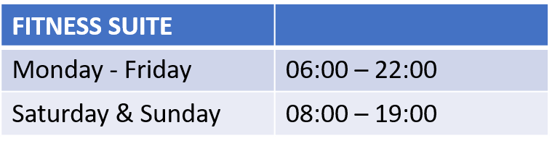
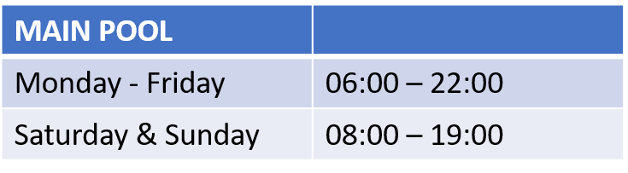
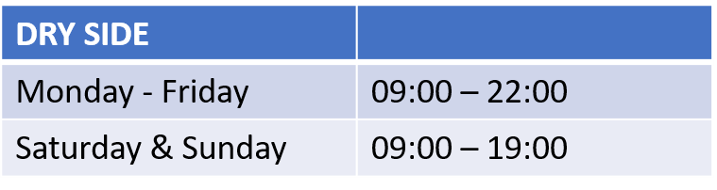
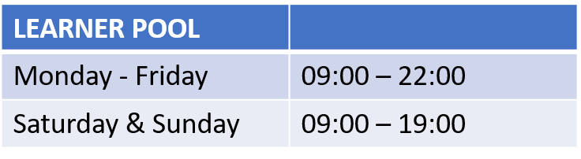
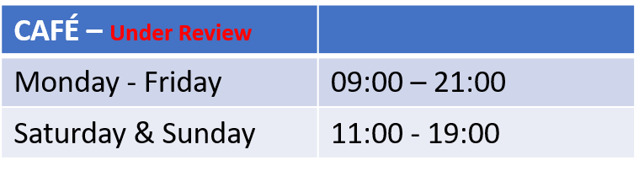
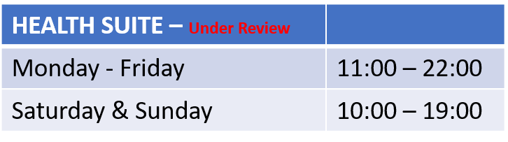

Appendix 2 : MEMBERSHIP PRICES

Swim only membership
 | All Facilities | £19.95

Gym/swim and classes
Premier | All Facilities | £29.95
Standard | Tier 2 facilities (facilities without swimming available) | £22.00
Junior | Juniors 12 - 16 | £16.00
Junior | Juniors Under 12 | £12.00
Thermal spa (SLLC only) | Bolt on to membership | £15.00

Swimming
 |  | Standard | Concession | Over 60 and under 4
Public swimming | Swim | £3.90 | £2.50 | FREE
 | Family swim | £11.00 | £7.10
Fun pool sessions | Per visit | £4.00 | £3.50
 | Per visit toddler time | £6.00

Swimming lessons |  | Standard | Concession
 | Junior per lesson | £6.00 | £24.00 DD
 | Adult per lesson | £6.00
 | Parent & Toddler session | £6.00
 | 1 - 1 Lessons 30 min | £25.00 | £20.00

Any child in Council swimming lessons can avail of public swimming free of charge.

Exercise Classes |  | Standard | Concession
 | 45m Class and over | £6.25 | £4.00
 | 45m Class and under | £4.00 | £3.00
 | getmovingabc Classes | £2.00 | £1.00

Appendix 3: Concession Rates

It has been agreed that the following groups be entitled to a concessionary rate:
Concessionary Group | Entitlement Criteria  ( which may be requested)
Adults of 60 years of age and over | Documentary proof of identification and age
Children of 17 years and under | Documentary proof of identification and age
Students | Documentary proof of student status
Children of 4 years of age and under | Documentary proof of identification and age
Disabled People | Receipt of Disability Living Allowance (DLA) or holder of a ‘Blue Badge’
Unemployed People | Those in receipt of benefits. (This does not include child benefit)

** Free public swimming for Under 4’s, Over 60’s those with a disability and for accompanying carers.

Appendix 4: Bus Timetable
