Frequently asked Questions and Answers for South Lake Leisure Centre
CUSTOMER COPY

Opening and closing times for SLLC can be found in Appendix 1
Prices/charges can be found in Appendix 2.
Concession categories can be found in Appendix 3.
Bus timetable can be found in Appendix 4.

Closing and opening dates:
Question | Answer
When will the buildings close:  Waves  CLC  Cascades | Waves closes Sat 20th June 2020  Craigavon closes Sat 4th July 2020  Cascades closes Fri 14th August 2020
Why is Waves closin^{g} first? | Waves is the oldest of the three and is currently in the poorest condition.
Why not keep CLC open rather than Cascades as it more central? | CLC has the smallest pool and we want to be able to continue with a swim programme up until SLLC opens. Cascades provides the best opportunity for this.
Why is there a gap between Waves/CLC closing and SLLC opening? | We need to properly train the staff on all the new systems and operating procedures before SLLC can open. Some of this can be done prior to handover of the building to ABC and we want to start this asap, but some has to wait until we are on-site. Also July is a very busy holiday period so some staff will be on leave and unavailable for training.
Why close the centres over the summer holidays when people want to use the leisure centres? | We need to properly train staff on all the systems and operating procedures before SLLC can open. The building will be handed over to council on 3rd July; and we want to open it to the public asap after that. This means that the other centres have to close to release staff for training.
When will SLLC open? | Saturday 15th August 2020.
What will happen to the buildings being closed | They will be secured. The Council is currently considering options.

SLLC building - General
Question | Answer
What is the opening and closing times for SLLC? | Please see Appendix 1.
Car parking - how many available spaces? | There are 360 available spaces.
How many disability parking spaces are available? | 28 spaces are available.
Booths to book classes? | Yes, there will be booths to swipe in and out so that customers do not have to go to reception.
Guide dog/service dog in the building? | Yes, guide and service dogs will be allowed in to the new SLLC building as is the case across the borough – the procedure for this will need to be considered.
Will be applying for a Disability excellence award for SLLC? | Council will be going forward for a disability excellence award for SLLC once it opens.
Are there any changing places available in the SLLC building? | There are two changing places available in the new SLLC building – one in the wet side and one in the dry side.
Are there public toilets available? | Public toilets are available in the SLLC building in the reception area.
Will there be free wi-fi for customers? | Yes.
Will there be a bus service to transport people from the town centres of Lurgan & Portadown to SLLC. If so will it run regularly each day and cover the opening and closing times of SLLC? | There is a bus service that runs from each of the town centres past SLLC. We will work with Translink to identify any gaps in service. See Appendix 4
Is there a buggy park available? | Yes, a buggy park is available in SLLC.
Will there be renewable energy sources for the building? | A roof-mounted (photovoltaic) system;  This system is a grid connected PV installation comprising of a roof mounted array of thirty panels with a total area of 6m x 11m

Membership  When can you buy a membership? | Membership for SLLC can be purchased May 2020
What memberships are available? | Membership all sites gym/classes , Membership specific sites gym/classes , swimming only, health & beauty suite + gym/classes, Junior membership, terms of family membership still to be agreed.
Will there be a gap in membership when the three current buildings close to make way for SLLC? | There will be a gap in membership when the C/Avon buildings close and the new building opens:  Waves closes Sat 20th June 2020  Craigavon closes Sat 4th July 2020  Cascades closes Fri 14th August 2020  SLLC opens 15th August 2020
Can we freeze memberships? | Yes, memberships can be frozen if the customer requests this but they will not be able to use any of the centres whilst their membership is frozen.
Will I have to do an induction in each gym? | Only one induction will need to be carried out, as all gym equipment Is the same across all of the gyms in the Borough.
Is there a family membership? | This is still being considered
Is there a junior membership? | There is a junior membership that can be paid for by DD
Gap in membership when a building closes until SLLC opens – compensation? | Customers have the choice to either retain their membership or have use of all the other facilities across the borough for a £10 reduction on the monthly rate or to freeze their membership until SLLC opens.
What will happen to my cash monthly/annual membership when my centre closes? | This will be frozen if the customer requests this or alternatively a refund can be given.
Will I be able to use one of the other centres including Banbridge, Dromore, Gilford and Armagh when my centre closes? | Yes, customers will be offered the use of another centre of their choice.
Can I freeze my membership when my centre closes until SLLC opens without any penalty? | Yes, you can freeze your membership.There will be no penalty.
My membership currently includes use of the health suite will there be a package which includes use of Health suite in SLLC? | Yes, there will be a membership that includes use of the health & beauty suite.
How long will Waves be closed before SLLC is open? | There will be an 8 week gap until SLLC is open.
If I take out a new yearly membership, will it be carried forward and if the pool is closed, can I get an extension on my membership if I do not want to use other Council facilities. | Customers have the choice to either retain their membership and have use of all the other facilities across the borough for a £10 reduction on the their monthly rate or to freeze their membership until SLLC opens.

Soft play
Question | Answer
Opening times of soft play | These are still to be agreed.
Can the soft play be booked exclusively for a birthday party | Yes, although prices are still to be determined.
Is there an age limit for the soft play area | This is still to be agreed.
Will this area need to be supervised by staff | No, staff will not supervise this area.

Sensory Room
Question | Answer
Who can use the sensory room | Anyone who feels their child would benefit from this calming, sensory area are welcome to avail of it.
Will the sensory be open at all times | The sensory room will be available during opening hours.
Is there a charge for using the room | No.

SLLC building - Wet side
General queries
Question | Answer
Will over 60’s still get free swimming during public swim times? | Yes, this will continue.
Is there village style changing rooms available? | There are village style changing rooms that serves 50mt, 20mt and leisure water.
What is the disability access to the pools? | There is a pool pod available at the 50mt pool  Pool hoist 20 mt pool.
Are there family changing rooms available? | There are 5 family rooms available.
Adult to child ratio when swimming? | This will remain unchanged.
Can swimming lessons be paid for by DD? | Yes, this option will be available and those children in the swimming lessons will be able to swim free during public swim times.
Swimming lesson prices? | The swimming lesson prices will have a concession price for those parents who fall in to these categories.

Leisure Water
Question | Answer
Age for using leisure water? | The leisure water can be used by children up to the age of 8yrs.
Can the leisure water be booked exclusively for a birthday party? | This is still to be clarified.

Health suite
Question | Answer
Is there an age limit for using the health & beauty suite? | This is still to be clarified.
Will the health & beauty suite be available for bookings for a private party e.g. hen parties … | Yes, this will be available for private functions.
Will robes be made available for users? | Yes.
Will customer be able to use the health suite after a swim? | Yes, but they have to pay for this option or have a membership to do so.
Is there a max number of users allowed in the health suite? | This will be clarified at a later date.

50 mt Pool
Question | Answer
How many booms are there in this pool? | There are two booms, one that traverses from the right hand side to the left and the other rises from the pool deck.
Total wet changing capacity? | 119 people.
Will there always be pubic swimming sessions available when the pool is open? | There will always be public swimming available when the pool is open.
When will the pool be configured into 50mts? | The programme of activities is being worked on now; this information will be shared as soon as possible.
When will the swimming clubs be using the pool? | Each of the swimming clubs in the borough were asked to put forward their request for the times that they want to use the pool; these are currently being considered.
Is there a timing system available in the pool hall? | Yes, there will be a timing system in the pool.
What is the capacity of the viewing gallery? | 280 people.

20mt pool
Question | Answer
Will water aerobics be held in this pool | Yes, water aerobics will be held in this pool.
Will this be available for public swimming | Yes, the area will be provided for public swimming when required.
What is the depth | 0.9-1.2m.

Dry Side
Rooms
Question | Answer
Will there be a birthday party package - what will this be? | Yes, prices are still to be agreed.
Can you book a birthday party on line? | Yes, we aim to have birthday parties bookings available on line.
Can customers bring in their own food to a birthday party? | No. We will have a café available on site.
Letting policy – for rooms? | This will have to be considered.
How many activity rooms are available? | Level 0 – Reception level  - Room 1A; 52.22m2  - Room 1B; 60.03m2  - Both rooms can be opened up to form a single room  - Room 2; 88.75m2  - Room 3; 77.47m2  - Both rooms can be opened up to form a single room  Level 2 – Gym/Health Suite level  - Studio 02; 166.71m2  - Studio 07; 135.65m2  - Both rooms can be opened up to form a single room.

Squash Courts
Question | Answer
How many squash courts are there? | 2 squash courts with a glass back.  There is a moveable wall between courts.
Where are the squash courts in the building? | They are in the reception area.
Is there a viewing area? | There is a viewing area to the rear.

Main Hall
Question | Answer
Will existing customers be accommodated in the main hall? | Yes, existing customers will be accommodated and will be spoken to individually.
Will there be availability for new groups/clubs/org? | Yes, there should be availability for others/new customers.
Is there a block booking policy for the main hall? | A new block booking policy is being worked on at the moment.
Is there a timing system in the hall? | Yes, there is a timing system in the hall.
How many courts are available in the hall? | There are 8 full size badminton courts.
Is there a viewing gallery in the hall? | There is no viewing gallery; however, there are viewing points.
Is there seating available in the hall for spectators? | There is bleacher seating available in the hall.
What i flooring is being used? | Compacted Beachwood.
What markings will be on the floor? | Basketball, badminton, boccia, futsal, netball, volleyball.  Height adjustable basketball goals are being provided.
Electronic timing system? | There is a scoreboard being provided.

Gym/Spin/Dance studio
Question | Answer
How many spin bikes are available? | 45 will be available in the room.
What is the classes timetable? | This is being considered at the moment.

APPENDIX 1:
SOUTH LAKES LEISURE CENTRE OPENING AND CLOSING HOURS

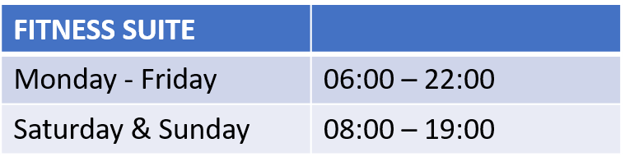
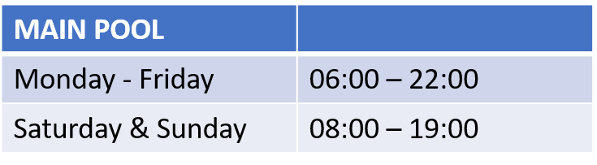
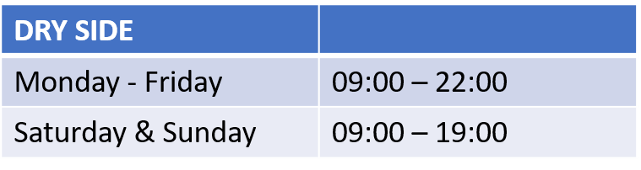
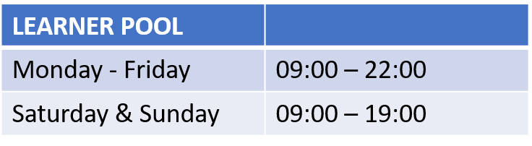
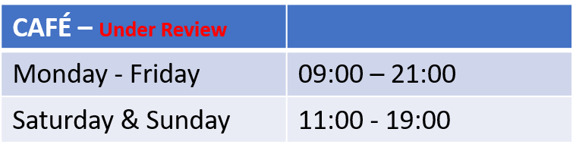
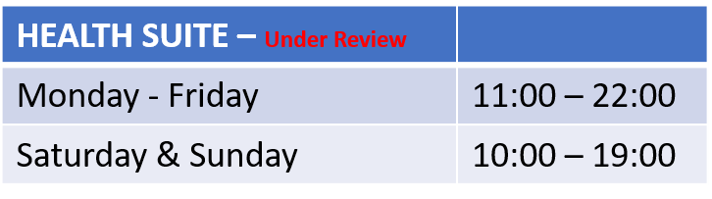

Appendix 2:
MEMBERSHIP PRICES

Swim only membership
 | All Facilities | £19.95

Gym/swim and classes
Premier | All Facilities | £29.95
Standard | Tier 2 facilities (facilities without swimming available) | £22.00
Junior | Juniors 12 - 16 | £16.00
Junior | Juniors Under 12 | £12.00
Thermal spa (SLLC only) | Bolt on to membership | £15.00

Swimming
 |  | Standard | Concession | Over 60 and under 4
Public swimming | Swim | £3.90 | £2.50 | FREE
 | Family swim | £11.00 | £7.10
Fun pool sessions | Per visit | £4.00 | £3.50
 | Per visit toddler time | £6.00

Swimming lessons |  | Standard | Concession
 | Junior per lesson | £6.00 | £24.00 DD
 | Adult per lesson | £6.00
 | Parent & Toddler session | £6.00
 | 1 - 1 Lessons 30 min | £25.00 | £20.00

Any child in Council swimming lessons can avail of public swimming free of charge.

Exercise Classes |  | Standard | Concession
 | 45m Class and over | £6.25 | £4.00
 | 45m Class and  under | £4.00 | £3.00

Appendix 3:
Concession Rates

It has been agreed that the following groups be entitled to a concessionary rate:
Concessionary Group | Entitlement Criteria  ( which may be requested)
Adults of 60 years of age and over | Documentary proof of identification and age
Children of 17 years and under | Documentary proof of identification and age
Students | Documentary proof of student status
Children of 4 years of age and under | Documentary proof of identification and age
Disabled People | Receipt of Personal Independence Payment (PIP) or holder of a ‘Blue Badge’
Unemployed People | Those in receipt of benefits (this does not include child benefit)  (Documentary proof required (proof to be produced every 2 months)

** Free public swimming for Under 4’s, Over 60’s those with a disability and for accompanying carers.

Appendix 4: Bus Timetable
