Town Centre Vacancy Rates
Vacancy rates for non-domestic properties are available for the five main city / town centres in the borough (Armagh, Banbridge, Craigavon, Lurgan and Portadown) and Dromore from the Town Centre Database (using data from Land and Property Services) produced by the Department for Communities. A property refers to a hereditament which is subject to rates and not individual buildings.
As at 30th April 2019, vacancy rates in the borough varied from 5.9% in Craigavon to 28.0% in Dromore. This compares to a Northern Ireland average vacancy level of 25.0%.
 | 30th April 2019
 | No. of Properties | No. of Vacant Properties | % of Properties Vacant
Armagh | 741 | 170 | 22.9%
Banbridge | 422 | 85 | 20.1%
Craigavon | 102 | 6 | 5.9%
Dromore | 118 | 33 | 28.0%
Lurgan | 512 | 133 | 26.0%
Portadown | 700 | 180 | 25.7%
Northern Ireland | 21,533 | 5,382 | 25.0%
Table 1: City/town centre non-domestic property vacancy rates as at 30th April 2019. Source: Land and Property Services via Town Centre Database, Department for Communities.
Figure 1: City/town centre non-domestic property vacancy rates as at 30th April 2019. Source: Land and Property Services via Town Centre Database, Department for Communities.

The vacancy levels in the borough have been similar, with some fluctuations, since April 2016. Dromore has consistently had the highest vacancy rates while Craigavon has maintained the lowest.

 | 30th April 2016 | 31st October 2016 | 7th May 2017 | 31st October  2017 | 30th April 2018 | 31st October  2018 | 30th April 2019
Armagh | 23.6% | 23.1% | 22.0% | 21.9% | 22.8% | 22.8% | 22.9%
Banbridge | 20.7% | 23.2% | 22.1% | 20.3% | 20.8% | 20.6% | 20.1%
Craigavon | 6.3% | 8.5% | 10.5% | 8.4% | 5.4% | 8.4% | 5.9%
Dromore | 30.2% | 29.5% | 29.5% | 28.6% | 29.1% | 28.0% | 28.0%
Lurgan | 25.5% | 23.6% | 24.2% | 24.0% | 25.3% | 24.8% | 26.0%
Portadown | 27.8% | 25.9% | 25.6% | 26.9% | 25.7% | 26.1% | 25.7%
Northern Ireland | 24.8% | 23.9% | 24.2% | 24.0% | 25.3% | 24.9% | 25.0%
Table 2: City/town centre non-domestic property vacancy rates between 30th April 2016 and 30th April 2019. Source: Land and Property Services via Town Centre Database, Department for Communities.

Of the 41 towns and cities contained within the Town Centre Database, Dromore has the third highest non-domestic property vacancy rate. Lurgan and Portadown are ranked sixth and seventh overall. Craigavon has the lowest vacancy rate of the 41 towns and cities.

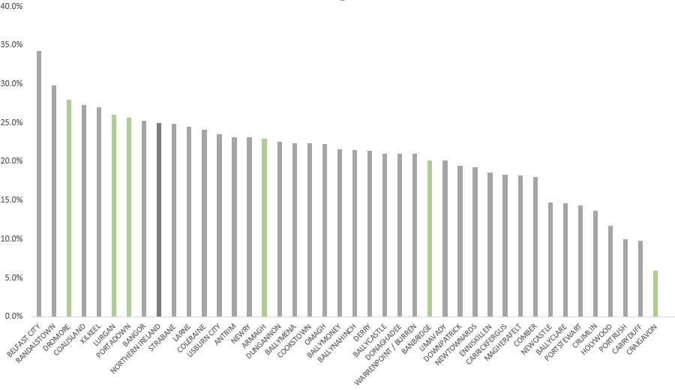Figure 2: City/town centre non-domestic property vacancy rates as at 30th April 2019. Source: Land and Property Services via Town Centre Database, Department for Communities.

Further information on town centre vacancy rates can be found via the following link:
https://www.communities-ni.gov.uk/publications/town-centre-database

