

**Leisure Transformation Programme**

**Staff Engagement Workshops**

**January 2020**

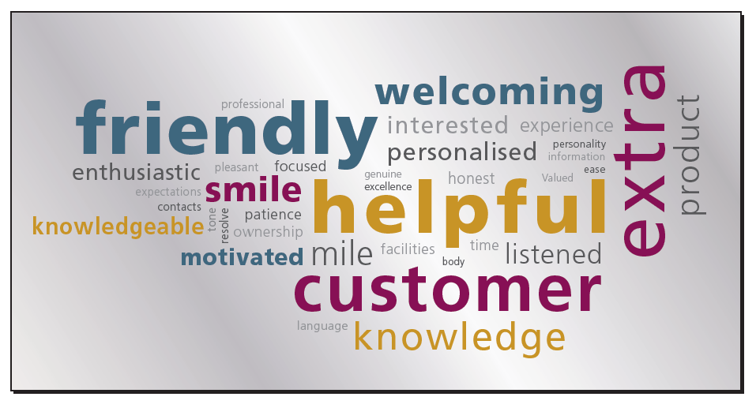



**Staff Engagement Workshops**

As part of the ongoing Leisure Transformation Programme, six staff engagement workshops were held during January 2020.

All members of staff and trade union representatives were invited along to the meetings to work through the following agenda:

1. Updates and Commitments
2. Questions and Comments

Copy of the presentation given on the day can be found on the; Council’s intranet page: Leisure Matters site in the staff engagement section.



**Issues, questions and answers**

* Will customers be able to book and pay via DD for swimming lessons:

Yes, the new booking system (Legend) will allow our customer to do this**.**

* Our swimming lesson enrolment will be for June: so we need to make a decision how we are going to deal with this as our customers will need to know**.**
* V.R. scheme: what is the anticapted date for details to be released: there is no deifinative date for this at the moment, however; once agreed this information will be shared with the staff.
* If there are new jobs in SLLC when these be released:

We don’t know how many posts will be available at the moment as we have to work through a number of steps; It is our priortity to protect the employment of those who work in the centres closing. There will be no compulsory redundancies.We then have to complete a gap analysis (to determine who is staying and leaving employment).

Then advertise posts internally, if not filled they will be sent externally.

* Can the lifeguards colours (Red and Yellow) please be brought back: this is on the agenda and has been raised in a number of the facilites during the staff engagment sessions. This issue will be considered.
* What will be the change in Rotas given the fact that the new facility will be open 7 days a week and not all the C/Avon sites opened on a Sunday in the past:

There will have to be changes made to rotas and hours that people will have to work; these issues can be discussed at the one to one meeting with your union representative. We will consider all requests to take account of personal circumstances but the needs of the service have to be met. Staff need to decide if the new shift patterns suit them and if they want to move to work in SLLC. If staff members decide that they do not want to work at SLLC then suitable alternative employment options will be provided or redundancy. All redundancies will be voluntary and up to each staff member.

* What will happen if I am re-deployed; if redeployed training will be provided for the staff member to carry out the duties required: There may be opportunities within the Council for redeployment for those members of staff who do not want to work in SLLC. Any questions regarding employment can be discussed at the one to one non- committal meeting with the union rep (these meetings will started in the next 2 weeks).
* When will SLLC open: The date for opening is still to be agreed; however, this will be shared with the staff before the end of February.
* When will the buildings in C/Avon close: this is being considered at the moment and this will be shared with the staff before the end of February.
* There are new opening and closing hours proposed for OLC and BLC; what happens if staff can’t committ to the change in the rota: Staff members need to meeting with their union rep over the next couple of weeks to discuss this matter. We will consider all requests to take account of personal circumstances but the needs of the service have to be met. The changing in opening and closing hours will be reviewed after 12 months to look at useage figures.
* How can I apply to the training pathway: Council’s learning and development Officer will come along to the factilities to talk staff through how the pathway training programme will work and how to about for it. This pathway provides staff the opportunity to gain skills and provide an alternative to having a 3rd level qualification; this in turn will allow staff to apply for internal posts that they may not have in the past had the opportunity to. This pathway training does involve the staff member giving up their own time and they have to committ to the training. Council wants to devlop the staff we have and provide an opptuntity for them to develop and ability to move posts.
* There are a number of issues/processes e.g. acting supervisor role/legend that needs to be harmonised when will this be done: We are working throught these issues at the moment; however, anyone working at a higher grade will be paid the appropaite rate.
* There are new opening and closing hours for the larger centres, what about the small centres: At the moment there are no plans to changing the opening/closing hours for these centres.
* An issue was raised regarding the company supplying the gym equipment : is the procurement locked down to ensure that they do they work: The Council will have a contract with the supplier which they are obliged to abide by.
* Has the working time directive been taken in to consideration regarding the new rotas: This is safety law and Council has to adhere to this, there is no opt out for staff on this matter and its is 11hr break every 24 hours.
* When can the plant fitters get access to SLLC as they would need ¾ months training: This will be organised as soon as possible; we are working on a training plan at the moment for all members of staff. Each supplier has been asked to provide a demo (video) on how a system works in SLLC – to assist staff training.
* Will casuals be able to move around the centres: Casual JD’s are being harmonised and it is anticapted that this will allow movement of casual staff through out the faciliites.
* Will all maintenance contracts be kept on in SLLC : these will simply transfer over.
* When applying for courses in the past there sometimes was a problem with the request: There still needs to be a buisness link for staff when applying for courses. Each application will be looked at on an indivdual basis.
* The last rotas showed that staff would have to work every weekend: feeback on rotas will be sought from staff, but since the last engagement session the rotas have been changed, these will be shared and will be put on to the leisure matters page. The lifeguard rotas is not available at the moment but will be distributed as soon as possible.

**Actions:**

* Upload the presentation and Q/A from the staff engagement sessions to: <https://www.armaghbanbridgecraigavon.gov.uk/leisureupdates>
* To create a gym and a swimming working group made up of staff to look at the issue moving to South Lake Leisure Centre.
* Create frequently asked Question and Answers for staff and customers.
* Set up one to one meetings with staff and union rep.

**Reminder of the timescales for decisions being made :**

* **Formal Consultation on JDs.**
* **Opening hours.**
* **Draft Shift patterns/ rotas.**
* **Migration plan and Budget.Severance/Redundancy package.**