**Social Housing Statistics**

The levels of social housing need are assessed and monitored by the Northern Ireland Housing Executive (NIHE). Social Housing is housing that is provided at an affordable rent by the Housing Executive and registered housing associations; that is, housing associations that are registered and regulated by the Department for Communities (DfC) as a social housing provider.

The five-year assessment for Armagh City, Banbridge and Craigavon Borough for 2019-24 shows a need for an additional 504 units over this period.

*Figure 1: Social housing need in Armagh City, Banbridge and Craigavon Borough 2014-19 to 2019-24. Source: Northern Ireland Housing Executive.*

North Lurgan, Banbridge Town and Armagh City exhibit the highest levels of social housing need in the borough.

*Figure 2: Social housing need in Armagh City, Banbridge and Craigavon Borough by settlement 2019-24. Source: Northern Ireland Housing Executive.*

The NIHE waiting list can be used to determine the pressure for social housing in an area. NIHE holds data on all housing applications and allocations (‘the waiting list’) made through the Common Selection Scheme in their Housing Management System.

As at March 2019, there were 3,065 applicants on the waiting list in Armagh City, Banbridge and Craigavon Borough.

Of these applicants, 1,713 (or 55.9%) were in housing stress (where they have 30 or more points under the Common Selection Scheme.) The number of applicants in housing stress is at its highest level of the last seven years, rising by 24.0% between March 2018 and March 2019.

557 applicants were allocated social housing in the borough in the year ending March 2019, similar to the previous year.

*Figure 3: Social housing waiting list trends, Armagh City, Banbridge and Craigavon Borough 2013 to 2019. Source: Northern Ireland Housing Executive.*

The household breakdown of the 1,713 applicants in housing stress shows 709 (41.4%) were single person households, 381 (22.2%) were small family households and 290 (16.9%) were older person households.

|  |  |  |  |  |  |  |  |
| --- | --- | --- | --- | --- | --- | --- | --- |
| **Type** | **Single Person** | **Small Adult** | **Small Family** | **Large Adult** | **Large Family** | **Older Person** | **Total** |
| **Applicant** | 1,184 | 256 | 741 | 117 | 277 | 490 | **3,065** |
| **Applicant in Housing Stress** | 709 | 122 | 381 | 56 | 155 | 290 | **1,713** |
| **% of Applicants in Housing Stress** | 59.9% | 47.7% | 51.4% | 47.9% | 56.0% | 59.2% | **55.9%** |
| **Allocation** | 239 | 34 | 142 | 9 | 46 | 87 | **557** |

*Table 1: Waiting list at March 2019 in Armagh City, Banbridge and Craigavon Borough. Source: Northern Ireland Housing Executive.*

Definitions of each of the household types are provided on the following page.

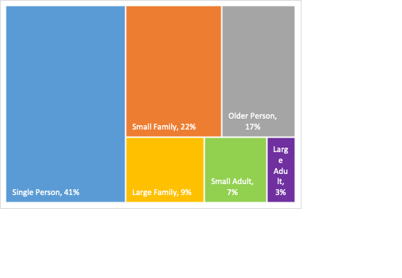

*Figure 4: Composition of housing stress applications at March 2019 (i.e. 30 points or more) in Armagh City, Banbridge and Craigavon Borough. Source: Northern Ireland Housing Executive.*

|  |  |
| --- | --- |
| **Household Type** | **Definition** |
| Single person | 1 person 16-59 years old |
| Older person | 1 or 2 persons aged 16 or over, at least 1 over 60 |
| Small adult | 2 persons 16-59 years old |
| Small family | 1 or 2 persons aged 16 or over, with 1 or 2 children |
| Large family | 1 or 2 persons aged 16 or over, and 3 or more persons 0-15, or 3 or more persons 16 or over and 2 or more persons aged 0-15 |
| Large adult | 3 or more persons aged 16 or over with or without 1 person aged 0-15 |

*Table 2: Household Types Definitions. Source: Northern Ireland Housing Executive.*

Further information on social housing can be found via the following links:

<https://www.nihe.gov.uk/Working-With-Us/Partners/Commissioning-prospectus>

<https://www.nihe.gov.uk/Working-With-Us/Partners/Housing-Investment-Plans-(HIPS)>