Rural Statistics
Results from the 2011 Census show that just over half of the borough’s population (51%) lived in urban areas while just under half (49%) lived in rural areas. This is based on the NISRA default urban/rural settlement classification where settlements with a population greater than or equal to 5,000 are classified as urban while those with a population less than 5,000 are classified as rural. This compares to 63% urban and 37% rural for Northern Ireland overall.
Craigavon Urban Area (which includes Central Craigavon, Lurgan and Portadown), Banbridge, Armagh and Dromore are the four urban areas within the borough, all other settlements are classified as rural according to the NISRA default classification.
NISRA also provides the classification at Super Output Area (SOA) level. Armagh City, Banbridge and Craigavon Borough is made up of 87 SOAs of which 42 are classified as urban, 36 are classified as rural with a further 9 being mixed urban/rural. The rural areas cover a large part of the borough.
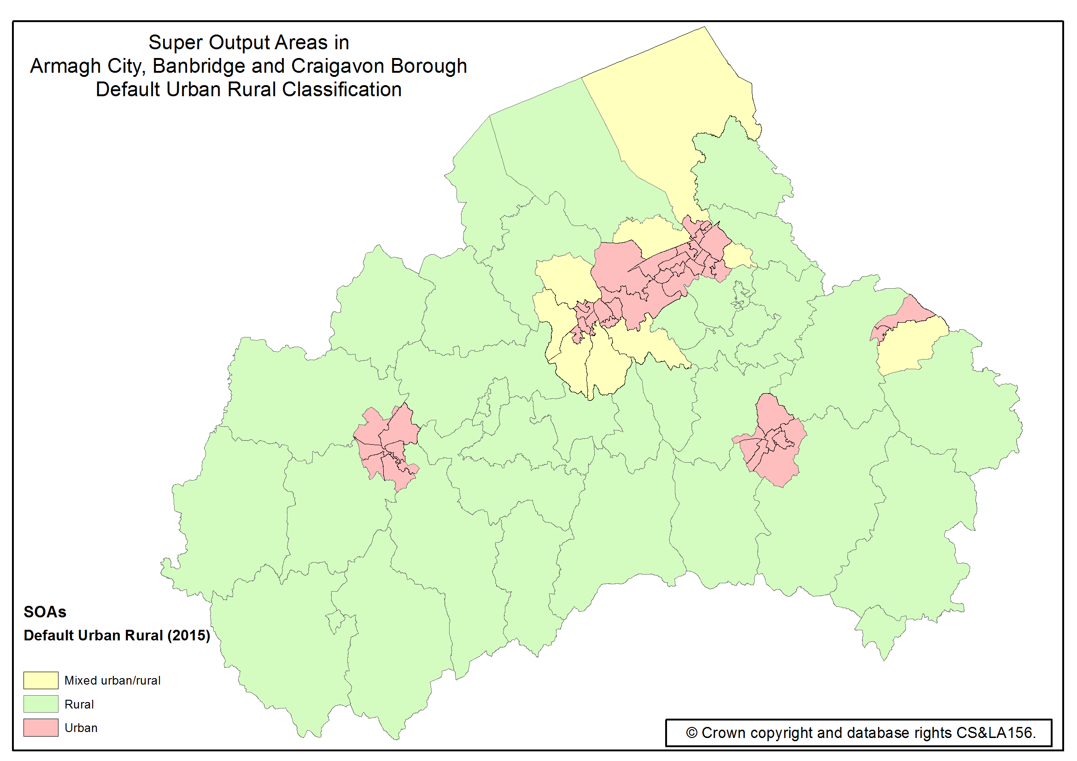Figure 1: Super Output Areas in Armagh City, Banbridge and Craigavon Borough by NISRA default urban/rural classification.
The NI Multiple Deprivation Measure (NIMDM) 2017 provides information on seven distinct types of deprivation, known as domains, along with an overall multiple deprivation measure (MDM). Results are available for the 890 Super Output Areas in Northern Ireland, ranked from 1, most deprived to 890, least deprived.
The Access to Services Domain which measures the extent to which people have poor physical and online access to key services is particularly relevant to rural areas. The borough has nine SOAs (10% of the total 87 SOAs in the borough) in the top 100 most deprived in Northern Ireland on the Access to Services Domain, each of which are defined as rural on the NISRA default classification.
Twenty SOAs in Armagh City, Banbridge and Craigavon Borough (23% of the total 87 SOAs in the borough) are in the top 20% most deprived SOAs in Northern Ireland in terms of the Access to Services Domain. All twenty are classified as rural.
As well as the overall Access to Services deprivation, results are available for its three indicators:
- Service-weighted fastest travel time by private transport
- Service-weighted fastest travel time by public transport
- Proportion of properties with broadband speed below 10Mb/s
The top ten most deprived SOAs in the borough in terms of the Access to Services Domain are shown below, all of which are rural.
Super Output Area | Access to Services Domain Rank | Access to Services Indicators
 |  | Service-weighted fastest travel time by private transport (rank) | Service-weighted fastest travel time by public transport (rank) | Proportion of properties with broadband speed below 10Mb/s (rank)
Bannside | 18 | 100 | 57 | 2
Katesbridge | 33 | 43 | 53 | 33
Derrynoose | 54 | 67 | 41 | 72
Gransha | 64 | 42 | 32 | 178
Derrytrasna 2 | 73 | 56 | 187 | 30
Killylea | 89 | 38 | 86 | 143
The Birches 2 | 96 | 19 | 133 | 202
Quilly | 98 | 199 | 34 | 99
Carrigatuke | 100 | 96 | 84 | 94
Poyntz Pass | 101 | 129 | 116 | 51
Table 1: Top ten most deprived SOAs in Armagh City, Banbridge and Craigavon Borough in terms of the Access to Services Domain. Source: Northern Ireland Multiple Deprivation Measure 2017, NISRA.
Although not all are shown above, the borough has 11 SOAs in the top 100 most deprived in Northern Ireland for service-weighted fastest travel time by private transport, 10 for service-weighted fastest travel time by public transport and 11 for proportion of properties with broadband speed below 10Mb/s. Each of these SOAs are classified as rural.
The purpose of the Income Deprivation Domain is to identify the proportion of the population on low income. Armagh City, Banbridge and Craigavon Borough has nine SOAs (10% of the total 87 SOAs in the borough) in the top 100 most deprived in Northern Ireland on the Income Deprivation Domain. Three of these nine are rural areas according to the NISRA default classification.
The Living Environment Domain aims to identify the prevalence of shortcomings in the quality of housing, access to suitable housing and the outdoor physical environment. Figures for the Housing Quality Sub-Domain show the borough has eight of the top 100 most deprived SOAs in Northern Ireland of which four are rural.
Further information can be found via the following link: https://www.nisra.gov.uk/statistics/deprivation/northern-ireland-multiple-deprivation-measure-2017-nimdm2017

Northern Ireland is split into 890 spatial areas known as Super Output Areas (SOAs), with an average population of around 2,100 people.

