Living Environment Domain
Living Environment Domain
The Living Environment Domain consists of nine indicators, grouped into three sub-domains and identifies the prevalence of shortcomings in the quality of housing, access to suitable housing and the outdoor physical environment as detailed below:

- Housing Quality Sub-Domain:
  - Proportion of domestic dwellings that are unfit
  - Proportion of domestic dwellings in a state of disrepair
  - Proportion of domestic dwellings without (1) modern boiler, or (2) loft insulation and double glazing
- Housing Access Sub-Domain
  - Household overcrowding
  - Proportion of population with disability without adaptations to dwelling
- Outdoor Physical Environment Sub-Domain
  - Proportion of domestic dwellings with Local Area Problem Scores
  - Standardised rate of road defects
  - Road Traffic Collisions
  - Proportion of properties in flood risk area

When the top 100 most deprived Super Output Areas (SOAs) in terms of living environment deprivation in Northern Ireland are selected, seven of these can be found in Armagh City, Banbridge and Craigavon Borough.
The most deprived SOA in the borough according to the Living Environment Domain is Woodville 1, located in Lurgan. It is the 10th most deprived SOA in Northern Ireland in terms of living environment.
Seven of the top ten most deprived living environment SOAs in the borough are also in the borough’s top ten most deprived for the overall Multiple Deprivation Measure (MDM) which combines the seven deprivation domains (allowing areas to be ranked based on multiple types of deprivation).
The SOAs in Armagh City, Banbridge and Craigavon Borough falling within the 20% most deprived in Northern Ireland according to the Living Environment Domain are listed below.

Top ten in the borough
Living Environment Domain Rank (1=most deprived  890=least deprived) | Armagh City, Banbridge and Craigavon Borough SOA | Urban/Rural
10 | Woodville 1 | Urban
15 | Annagh 2 | Urban
58 | Court 1 | Urban
69 | The Cut | Urban
70 | Corcrain 2 | Urban
83 | The Mall | Urban
92 | Callan Bridge | Urban
146 | Drumnamoe 1 | Urban
151 | Carrigatuke | Rural
163 | Milford | Rural
166 | Drumgask 2 | Urban
170 | Hamiltonsbawn 1 | Rural
Table 1: SOAs in Armagh City, Banbridge and Craigavon Borough which are within the 20% most deprived in Northern Ireland according to the Living Environment Domain. Source: Northern Ireland Multiple Deprivation Measure 2017, NISRA.
Also appear in the top ten overall MDM for the borough

A total of 12 SOAs in the borough are within the 20% most deprived in Northern Ireland overall according to the Living Environment Domain. Nine of these SOAs are urban while three are classified as rural. The locations of these SOAs in the borough are shown below, split by those that fall into the top 10% most deprived in Northern Ireland according to the Living Environment Domain and those that are within the 11%-20% most deprived.

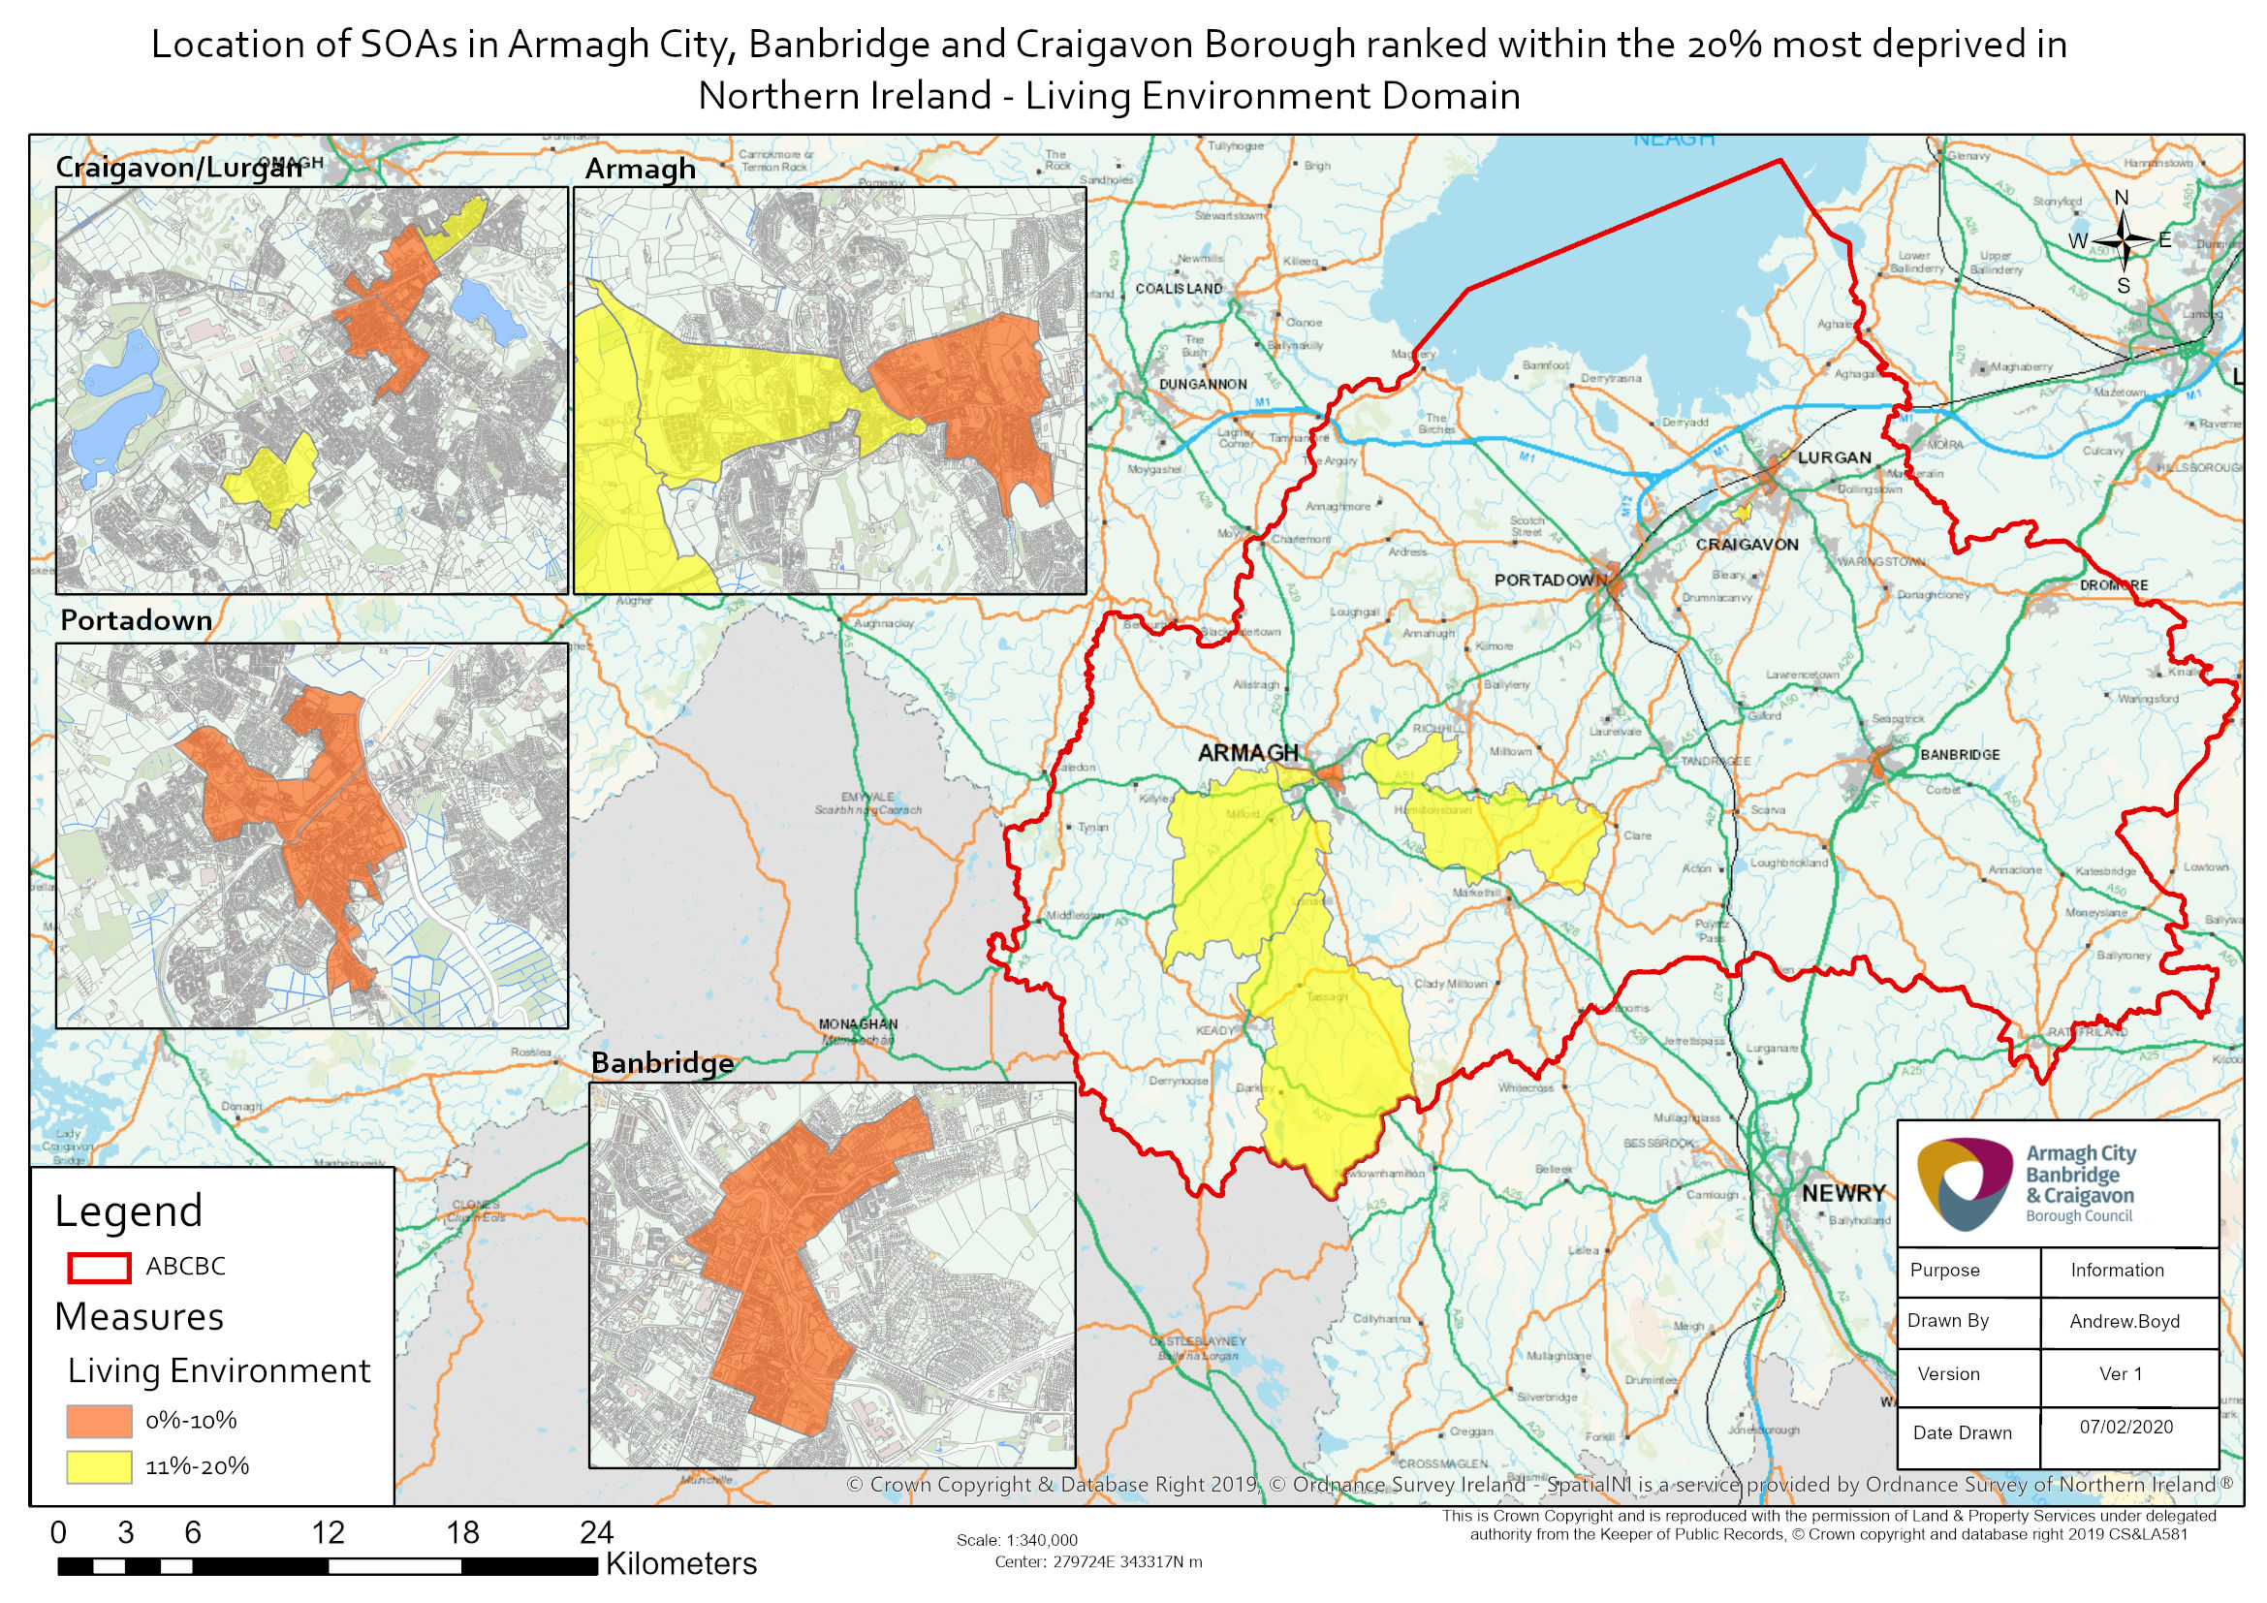

The first sub-domain in the Living Environment Domain is the Housing Quality Sub-Domain.
When the 100 most deprived SOAs according to the Housing Quality Sub-Domain in Northern Ireland are selected, eight of these can be found in Armagh City, Banbridge and Craigavon Borough.
The most deprived SOA in the borough in terms of the Housing Quality Sub-Domain is Annagh 2, located in Portadown. It is the 7th most deprived SOA in Northern Ireland according to the Housing Quality Sub-Domain.
Three of the top ten most deprived Housing Quality Sub-Domain SOAs in the borough are also in the borough’s top ten most deprived for the overall Multiple Deprivation Measure.
The SOAs in Armagh City, Banbridge and Craigavon Borough falling within the 20% most deprived in Northern Ireland according to the Housing Quality Sub-Domain are listed below.
Six of the 16 SOAs in the borough falling within the 20% most deprived in Northern Ireland for the Housing Quality Sub-Domain are urban, while ten are classified as rural.
Top ten in the borough
Housing Quality Sub-Domain Rank (1=most deprived  890=least deprived) | Armagh City, Banbridge and Craigavon Borough SOA | Urban/Rural
7 | Annagh 2 | Urban
12 | Woodville 1 | Urban
21 | The Mall | Urban
24 | The Cut | Urban
63 | Carrigatuke | Rural
78 | Milford | Rural
79 | Katesbridge | Rural
98 | Killylea | Rural
116 | Poyntz Pass | Rural
120 | Edenderry 1 | Urban
132 | Bannside | Rural
134 | Quilly | Rural
139 | Hockley | Rural
165 | Killeen | Rural
167 | Callan Bridge | Urban
169 | Ballymartrim | Rural
Table 2: SOAs in Armagh City, Banbridge and Craigavon Borough which are within the 20% most deprived in Northern Ireland in terms of the Housing Quality Sub-Domain. Source: Northern Ireland Multiple Deprivation Measure 2017, NISRA.
Also appear in the top ten overall MDM for the borough

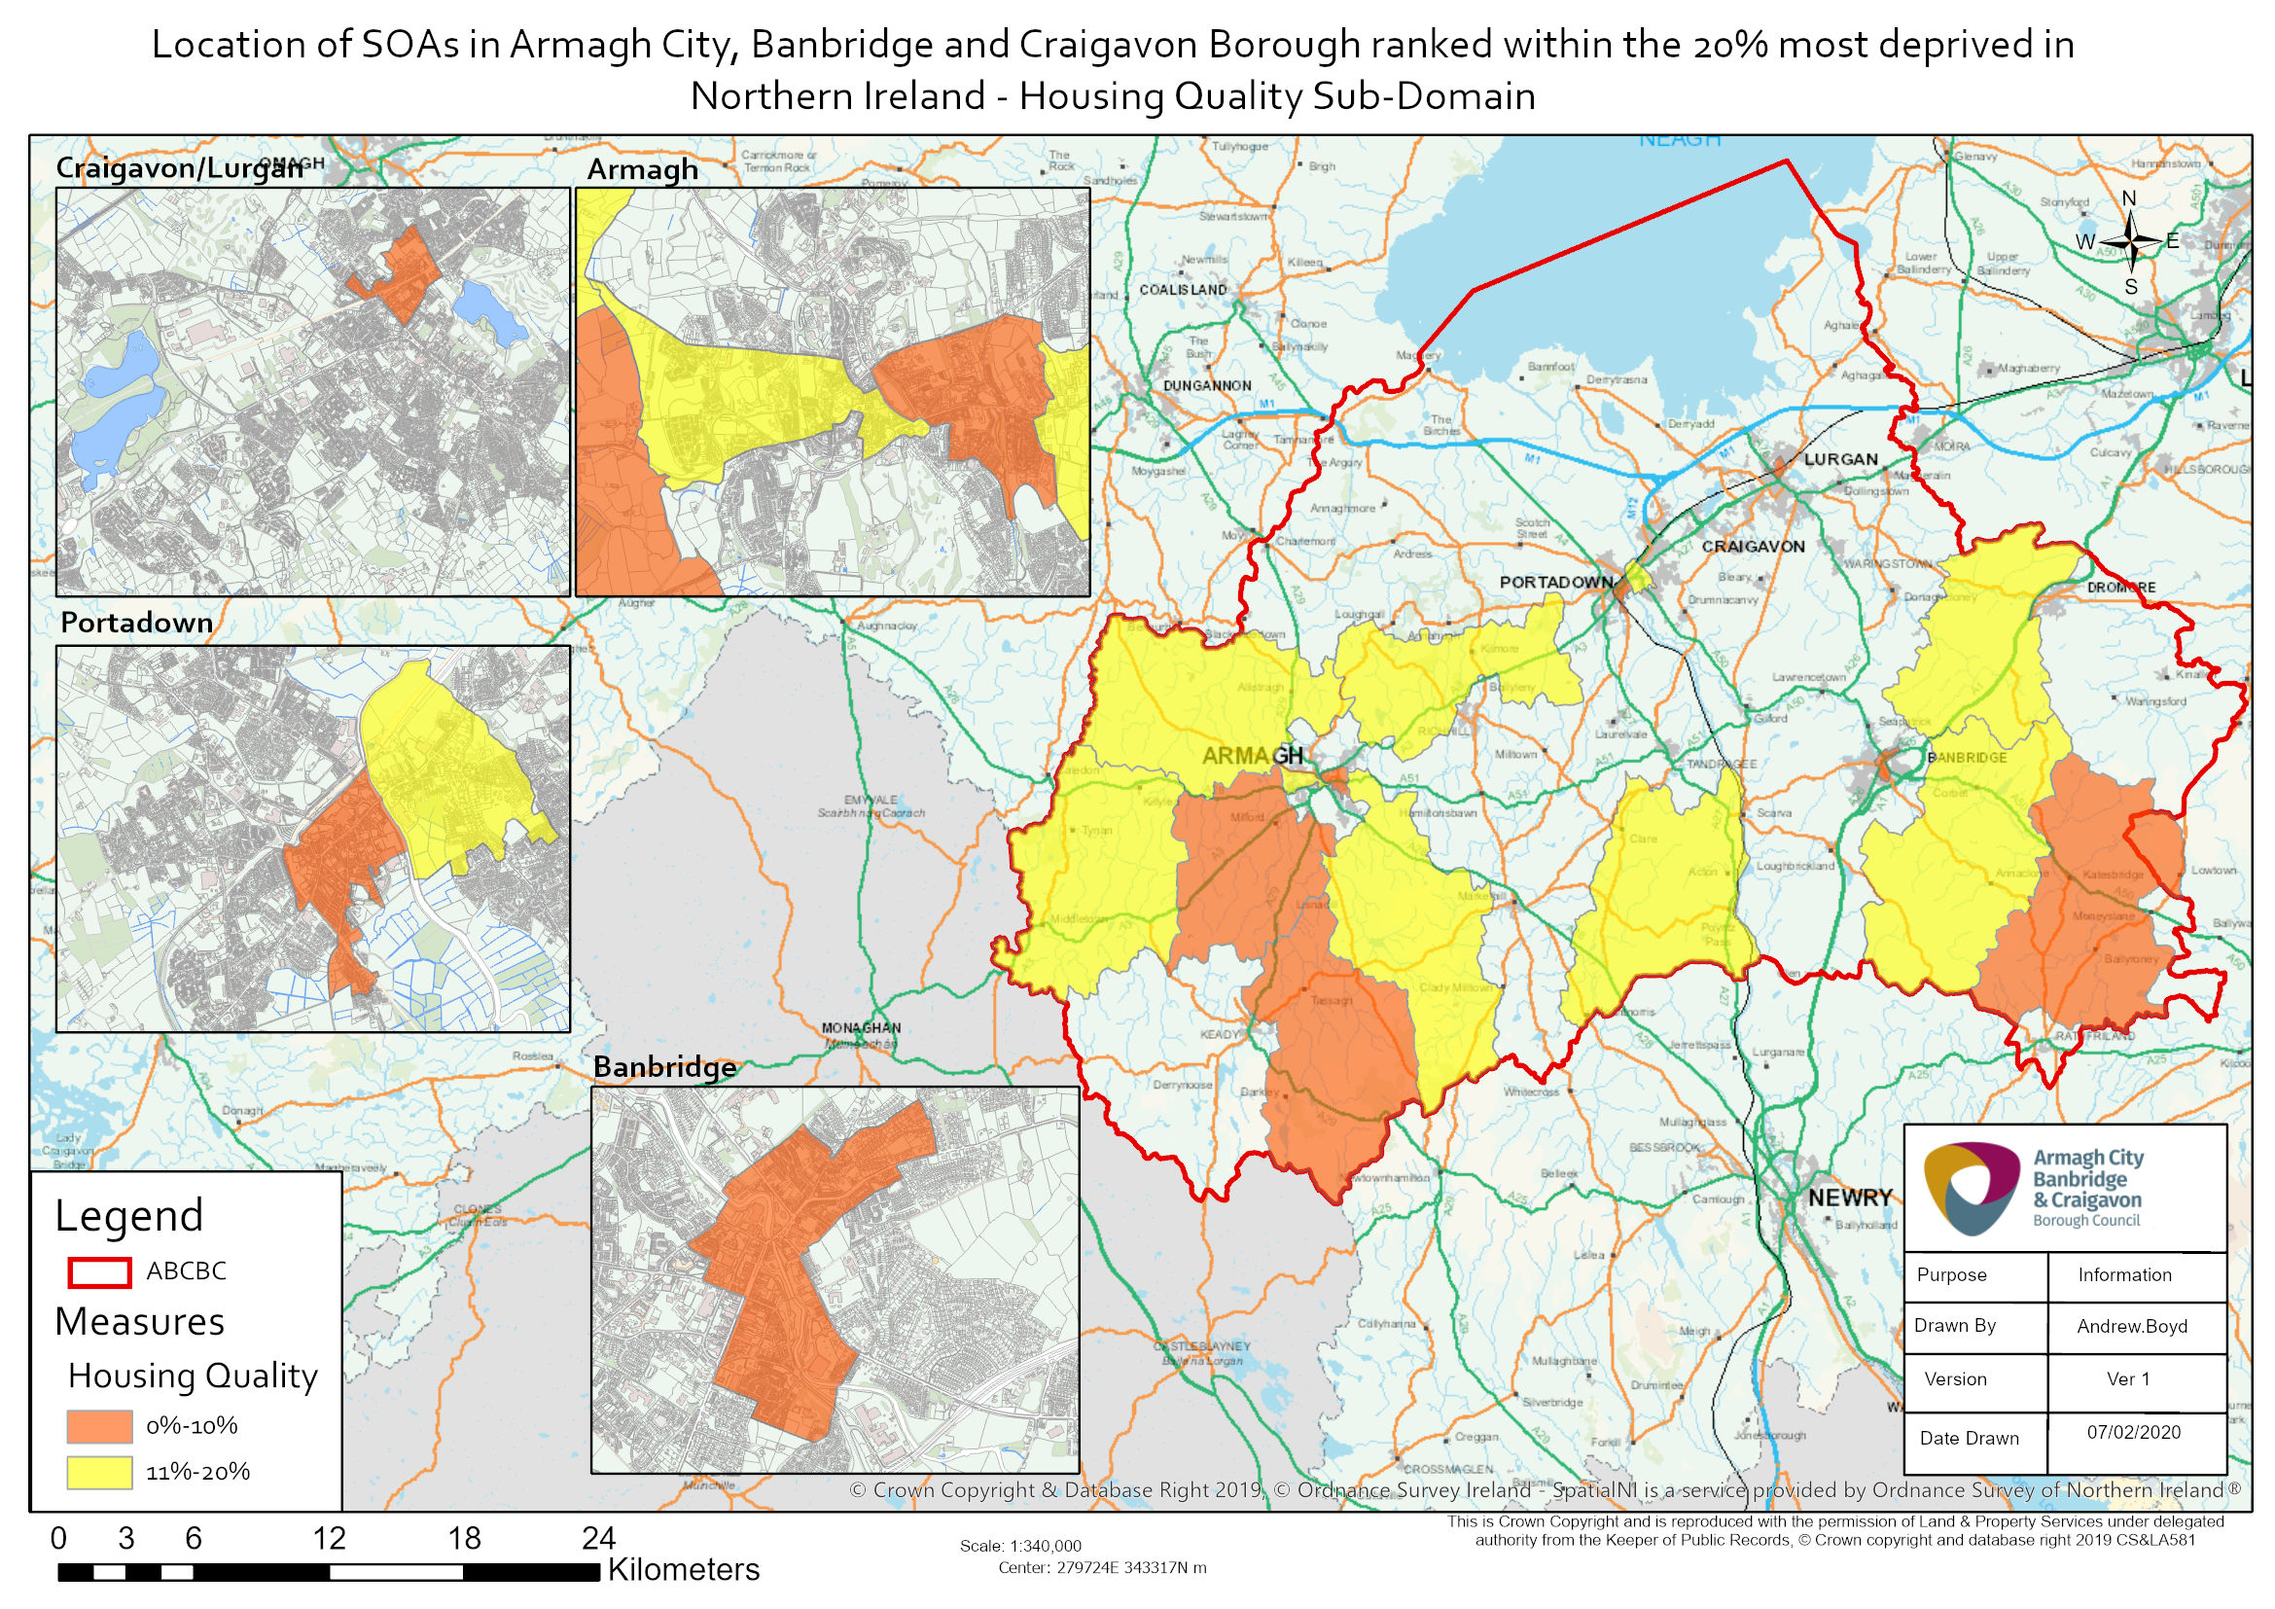
The first indicator in the Housing Quality Sub-Domain is the proportion of domestic dwellings that are unfit.
When the 100 most deprived SOAs in terms of the proportion of domestic dwellings that are unfit in Northern Ireland are selected, eleven of these can be found in Armagh City, Banbridge and Craigavon Borough.
The most deprived SOA in the borough according to this indicator is Annagh 2, located in Portadown. It is the 11th most deprived SOA in Northern Ireland for this indicator.
Two of the top ten most deprived proportion of domestic dwellings that are unfit SOAs in the borough are also in the borough’s top ten most deprived for the overall Multiple Deprivation Measure.
The SOAs in Armagh City, Banbridge and Craigavon Borough falling within the 20% most deprived in Northern Ireland according to the proportion of domestic dwellings that are unfit rank are listed below. The majority of SOAs in the borough that are within the 20% most deprived in Northern Ireland for this indicator are classified as rural (17 out of 20).
Top ten in the borough
Proportion of Domestic Dwellings That Are Unfit Rank (1=most deprived  890=least deprived) | Armagh City, Banbridge and Craigavon Borough SOA | Urban/Rural | Proportion of Domestic Dwellings That Are Unfit  (%)
11 | Annagh 2 | Urban | 7.1%
14 | Katesbridge | Rural | 6.9%
16 | Milford | Rural | 6.8%
17 | Carrigatuke | Rural | 6.8%
23 | Woodville 1 | Urban | 6.5%
43 | Bannside | Rural | 6.1%
60 | Killylea | Rural | 5.8%
67 | Quilly | Rural | 5.7%
77 | Poyntz Pass | Rural | 5.5%
84 | Derrynoose | Rural | 5.4%
89 | Ballymartrim | Rural | 5.4%
105 | Killeen | Rural | 5.1%
115 | The Cut | Urban | 4.9%
118 | Gransha | Rural | 4.9%
126 | Hockley | Rural | 4.8%
128 | Hamiltonsbawn 1 | Rural | 4.8%
132 | Charlemont | Rural | 4.8%
138 | Loughgall | Rural | 4.7%
150 | The Birches 2 | Rural | 4.6%
154 | The Birches 1 | Rural | 4.6%
Table 3: SOAs in Armagh City, Banbridge and Craigavon Borough which are within the 20% most deprived in Northern Ireland in terms of the proportion of domestic dwellings that are unfit rank. Source: Northern Ireland Multiple Deprivation Measure 2017, NISRA.
Also appear in the top ten overall MDM for the borough

The second indicator in the Housing Quality Sub-Domain is the proportion of domestic dwellings in a state of disrepair.
When the 100 most deprived SOAs according to the proportion of domestic dwellings in a state of disrepair in Northern Ireland are selected, seven of these can be found in Armagh City, Banbridge and Craigavon Borough.
The most deprived SOA in the borough for this indicator is Annagh 2, located in Portadown, which is the 6th most deprived SOA in Northern Ireland for this indicator.
Three of the top ten most deprived SOAs in the borough for the proportion of domestic dwellings in a state of disrepair are also in the borough’s top ten most deprived for the overall Multiple Deprivation Measure.
The SOAs in Armagh City, Banbridge and Craigavon Borough falling within the 20% most deprived in Northern Ireland according to the proportion of domestic dwellings in a state of disrepair rank are listed below.
The majority of the SOAs in the borough falling within the 20% most deprived in Northern Ireland for this indicator are rural, 10 of the 16, with 6 classified as urban.
Top ten in the borough
Proportion of Domestic Dwellings in a State of Disrepair Rank (1=most deprived  890=least deprived) | Armagh City, Banbridge and Craigavon Borough SOA | Urban/Rural | Proportion of Domestic Dwellings in a State of Disrepair  (%)
6 | Annagh 2 | Urban | 24.3%
19 | Woodville 1 | Urban | 22.6%
22 | The Cut | Urban | 22.3%
23 | The Mall | Urban | 22.3%
82 | Carrigatuke | Rural | 20.3%
85 | Milford | Rural | 20.3%
94 | Katesbridge | Rural | 20.2%
116 | Killylea | Rural | 19.8%
122 | Poyntz Pass | Rural | 19.7%
129 | Edenderry 1 | Urban | 19.6%
142 | Callan Bridge | Urban | 19.5%
145 | Hockley | Rural | 19.5%
147 | Bannside | Rural | 19.4%
160 | Quilly | Rural | 19.2%
176 | Ballymartrim | Rural | 19.0%
178 | Killeen | Rural | 18.9%
Table 4: SOAs in Armagh City, Banbridge and Craigavon Borough which are within the 20% most deprived in Northern Ireland in terms of the proportion of domestic dwellings in a state of disrepair rank. Source: Northern Ireland Multiple Deprivation Measure 2017, NISRA.
Also appear in the top ten overall MDM for the borough

The third indicator in the Housing Quality Sub-Domain is the proportion of domestic dwellings without (1) modern boiler or (2) loft insulation and double glazing.
When the 100 most deprived SOAs according to this indicator in Northern Ireland are selected, seven of these can be found in Armagh City, Banbridge and Craigavon Borough.
The most deprived SOA in the borough for this indicator is Rich Hill 1, located in Rich Hill, which is the 5th most deprived SOA in Northern Ireland for this indicator.
Three of the top ten most deprived SOAs in the borough for this indicator are also in the borough’s top ten most deprived for the overall Multiple Deprivation Measure.
The SOAs in Armagh City, Banbridge and Craigavon Borough falling within the 20% most deprived in Northern Ireland according to the proportion of domestic dwellings without (1) modern boiler or (2) loft insulation and double glazing rank are listed below. Nine of the 15 SOAS in the borough falling within the 20% most deprived in Northern Ireland for this indicator are rural, with six classified as urban.
Top ten in the borough
Proportion of Domestic Dwellings Without (1) Modern Boiler or (2) Loft Insulation and Double Glazing Rank (1=most deprived  890=least deprived) | Armagh City, Banbridge and Craigavon Borough SOA | Urban/Rural | Proportion of Domestic Dwellings Without (1) Modern Boiler or (2) Loft Insulation and Double Glazing  (%)
5 | Rich Hill 1 | Rural | 39.4%
15 | The Mall | Urban | 37.4%
18 | Woodville 1 | Urban | 36.9%
28 | Annagh 2 | Urban | 36.4%
66 | Carrigatuke | Rural | 34.9%
67 | Keady | Rural | 34.9%
76 | Edenderry 1 | Urban | 34.6%
104 | The Cut | Urban | 33.8%
107 | Killylea | Rural | 33.8%
111 | Quilly | Rural | 33.7%
116 | Observatory | Urban | 33.6%
124 | Katesbridge | Rural | 33.2%
154 | Hockley | Rural | 32.6%
171 | Rich Hill 2 | Rural | 32.4%
176 | Donaghcloney 1 | Rural | 32.3%
Table 5: SOAs in Armagh City, Banbridge and Craigavon Borough which are within the 20% most deprived in Northern Ireland in terms of the proportion of domestic dwellings without (1) modern boiler or (2) loft insulation and double glazing rank. Source: Northern Ireland Multiple Deprivation Measure 2017, NISRA.
Also appear in the top ten overall MDM for the borough

The second sub-domain in the Living Environment Domain is the Housing Access Sub-Domain.
When the 100 most deprived SOAs according to the Housing Access Sub-Domain in Northern Ireland are selected, four of these can be found in Armagh City, Banbridge and Craigavon Borough.
The most deprived SOA in the borough for this sub-domain is Hamiltonsbawn 1, located in the Hamiltonsbawn area. It is the 79th most deprived SOA in Northern Ireland for this sub-domain.
Three of the top ten most deprived SOAs in the borough according to the Housing Access Sub-Domain are also in the borough’s top ten most deprived for the overall Multiple Deprivation Measure.
The SOAs in Armagh City, Banbridge and Craigavon Borough falling within the 20% most deprived in Northern Ireland in terms of the Housing Access Sub-Domain are listed below.
Five of the 10 SOAs in the borough that are within the 20% most deprived in Northern Ireland according to the Housing Access Sub-Domain are urban, four are rural and one is classified as mixed urban/rural.
Top ten in the borough
Housing Access Sub-Domain Rank (1=most deprived  890=least deprived) | Armagh City, Banbridge and Craigavon Borough SOA | Urban/Rural
79 | Hamiltonsbawn 1 | Rural
93 | Demesne 1 | Urban
95 | Brownstown 1 | Mixed urban/rural
99 | Callan Bridge | Urban
101 | Woodville 1 | Urban
117 | Drumnamoe 1 | Urban
118 | Bleary 2 | Rural
123 | Corcrain 1 | Urban
150 | Rich Hill 2 | Rural
175 | Charlemont | Rural
Table 6: SOAs in Armagh City, Banbridge and Craigavon Borough which are within the 20% most deprived in Northern Ireland in terms of the Housing Access Sub-Domain. Source: Northern Ireland Multiple Deprivation Measure 2017, NISRA.
Also appear in the top ten overall MDM for the borough

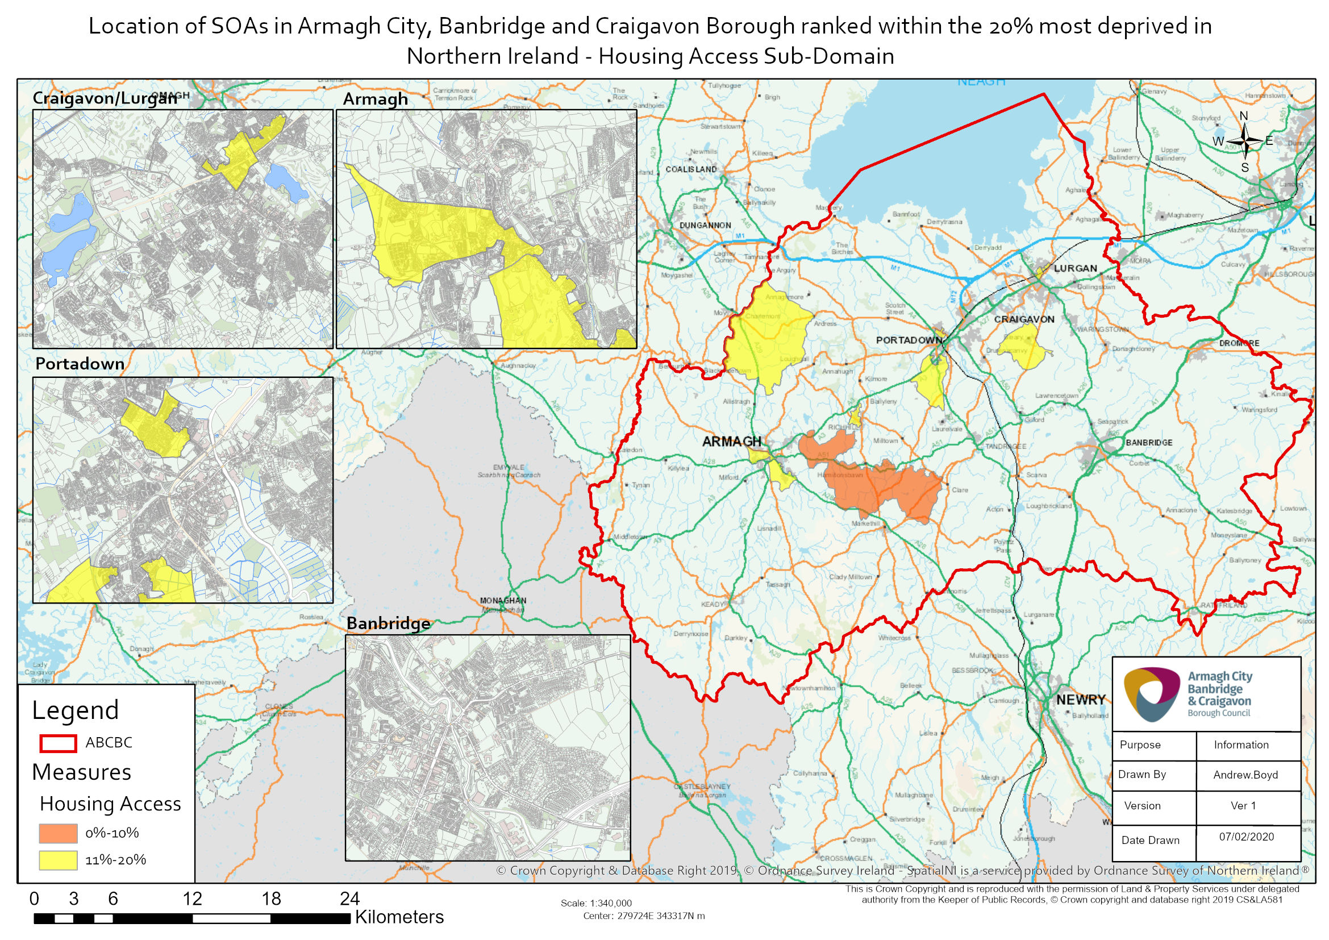

The first indicator in the Housing Access Sub-Domain is household overcrowding.
When the 100 most deprived SOAs according to household overcrowding in Northern Ireland are selected, five of these can be found in Armagh City, Banbridge and Craigavon Borough.
The most deprived SOA in the borough for this indicator is Drumnamoe 1, located in Lurgan. It is the 32nd most deprived SOA in Northern Ireland for this indicator.
Seven of the top ten most deprived SOAs in the borough for household overcrowding are also in the borough’s top ten most deprived for the overall Multiple Deprivation Measure.
The SOAs in Armagh City, Banbridge and Craigavon Borough falling within the 20% most deprived in Northern Ireland in terms of household overcrowding are listed below.
Of the ten that are within the 20% most deprived in Northern Ireland for this indicator, the majority are urban (9) while one is classified as rural.
Top ten in the borough
Household Overcrowding Rank (1=most deprived  890=least deprived) | Armagh City, Banbridge and Craigavon Borough SOA | Urban/Rural | Rate of Household Overcrowding  (%)
32 | Drumnamoe 1 | Urban | 9.8%
37 | Callan Bridge | Urban | 9.1%
47 | Corcrain 1 | Urban | 8.9%
75 | Drumgask 2 | Urban | 7.7%
86 | Corcrain 2 | Urban | 7.5%
104 | Woodville 1 | Urban | 6.8%
115 | Killylea | Rural | 6.6%
119 | Court 1 | Urban | 6.6%
129 | Abbey Park | Urban | 6.3%
153 | Annagh 2 | Urban | 6.0%
Table 7: SOAs in Armagh City, Banbridge and Craigavon Borough which are within the 20% most deprived in Northern Ireland in terms of the household overcrowding rank. Source: Northern Ireland Multiple Deprivation Measure 2017, NISRA.
Also appear in the top ten overall MDM for the borough

The second indicator in the Housing Access Sub-Domain is the proportion of population with a disability without adaptations to dwelling.
When the 100 most deprived SOAs according to the proportion of population with a disability without adaptations to dwelling in Northern Ireland are selected, seven of these can be found in Armagh City, Banbridge and Craigavon Borough.
The most deprived SOA in the borough for this indicator is Demesne 1, located in Armagh. It is the 26th most deprived SOA in Northern Ireland for this indicator.
There is no overlap between the top ten most deprived SOAs in the borough for this indicator and the borough’s top ten most deprived for the overall Multiple Deprivation Measure.
The SOAs in Armagh City, Banbridge and Craigavon Borough falling within the 20% most deprived in Northern Ireland for this indicator are listed below.
Of these 13 SOAs, four are urban, six are rural and three are classified as mixed urban/rural.
Top ten in the borough
Proportion of Population with Disability Without Adaptations to Dwelling Rank (1=most deprived  890=least deprived) | Armagh City, Banbridge and Craigavon Borough SOA | Urban/Rural | Proportion of Population with Disability Without Adaptations to Dwelling  (%)
26 | Demesne 1 | Urban | 91.8%
28 | Hamiltonsbawn 1 | Rural | 91.7%
46 | Brownstown 1 | Mixed urban/rural | 90.9%
66 | Laurelvale | Rural | 90.2%
74 | Magheralin 1 | Mixed urban/rural | 89.9%
79 | Waringstown 2 | Rural | 89.8%
90 | Knocknashane 1 | Urban | 89.6%
109 | Dromore South 1 | Urban | 89.3%
113 | Hamiltonsbawn 2 | Rural | 89.2%
118 | Aghagallon 2 | Mixed urban/rural | 89.1%
122 | Rich Hill 2 | Rural | 89.0%
149 | Bleary 2 | Rural | 88.6%
165 | Woodville 2 | Urban | 88.4%
Table 8: SOAs in Armagh City, Banbridge and Craigavon Borough which are within the 20% most deprived in Northern Ireland in terms of the proportion of population with disability without adaptations to dwelling rank. Source: Northern Ireland Multiple Deprivation Measure 2017, NISRA.
Also appear in the top ten overall MDM for the borough

The third sub-domain in the Living Environment Domain is the Outdoor Physical Environment Sub-Domain.
When the 100 most deprived SOAs in Northern Ireland for the Outdoor Physical Environment Sub-Domain are selected, eight of these can be found in Armagh City, Banbridge and Craigavon Borough.
The most deprived SOA in the borough according to this sub-domain is Court 1, located in Lurgan. It is the 3rd most deprived SOA in Northern Ireland for the Outdoor Physical Environment Sub-Domain.
Eight of the top ten most deprived Outdoor Physical Environment Sub-Domain SOAs in the borough are also in the borough’s top ten most deprived for the overall Multiple Deprivation Measure.
The SOAs in Armagh City, Banbridge and Craigavon Borough falling within the 20% most deprived in Northern Ireland according to the Outdoor Physical Environment Sub-Domain are listed below.
All ten SOAs in the borough falling within the 20% most deprived in Northern Ireland for the Outdoor Physical Environment Sub-Domain are classified as urban.
Top ten in the borough
Outdoor Physical Environment Sub-Domain Rank (1=most deprived  890=least deprived) | Armagh City, Banbridge and Craigavon Borough SOA | Urban/Rural
3 | Court 1 | Urban
45 | Annagh 2 | Urban
48 | Woodville 1 | Urban
65 | Corcrain 2 | Urban
69 | Court 2 | Urban
75 | Church | Urban
84 | Drumgask 2 | Urban
97 | Drumnamoe 2 | Urban
122 | Drumnamoe 1 | Urban
134 | The Cut | Urban
Table 9: SOAs in Armagh City, Banbridge and Craigavon Borough which are within the 20% most deprived in Northern Ireland in terms of the Outdoor Physical Environment Sub-Domain. Source: Northern Ireland Multiple Deprivation Measure 2017, NISRA.
Also appear in the top ten overall MDM for the borough

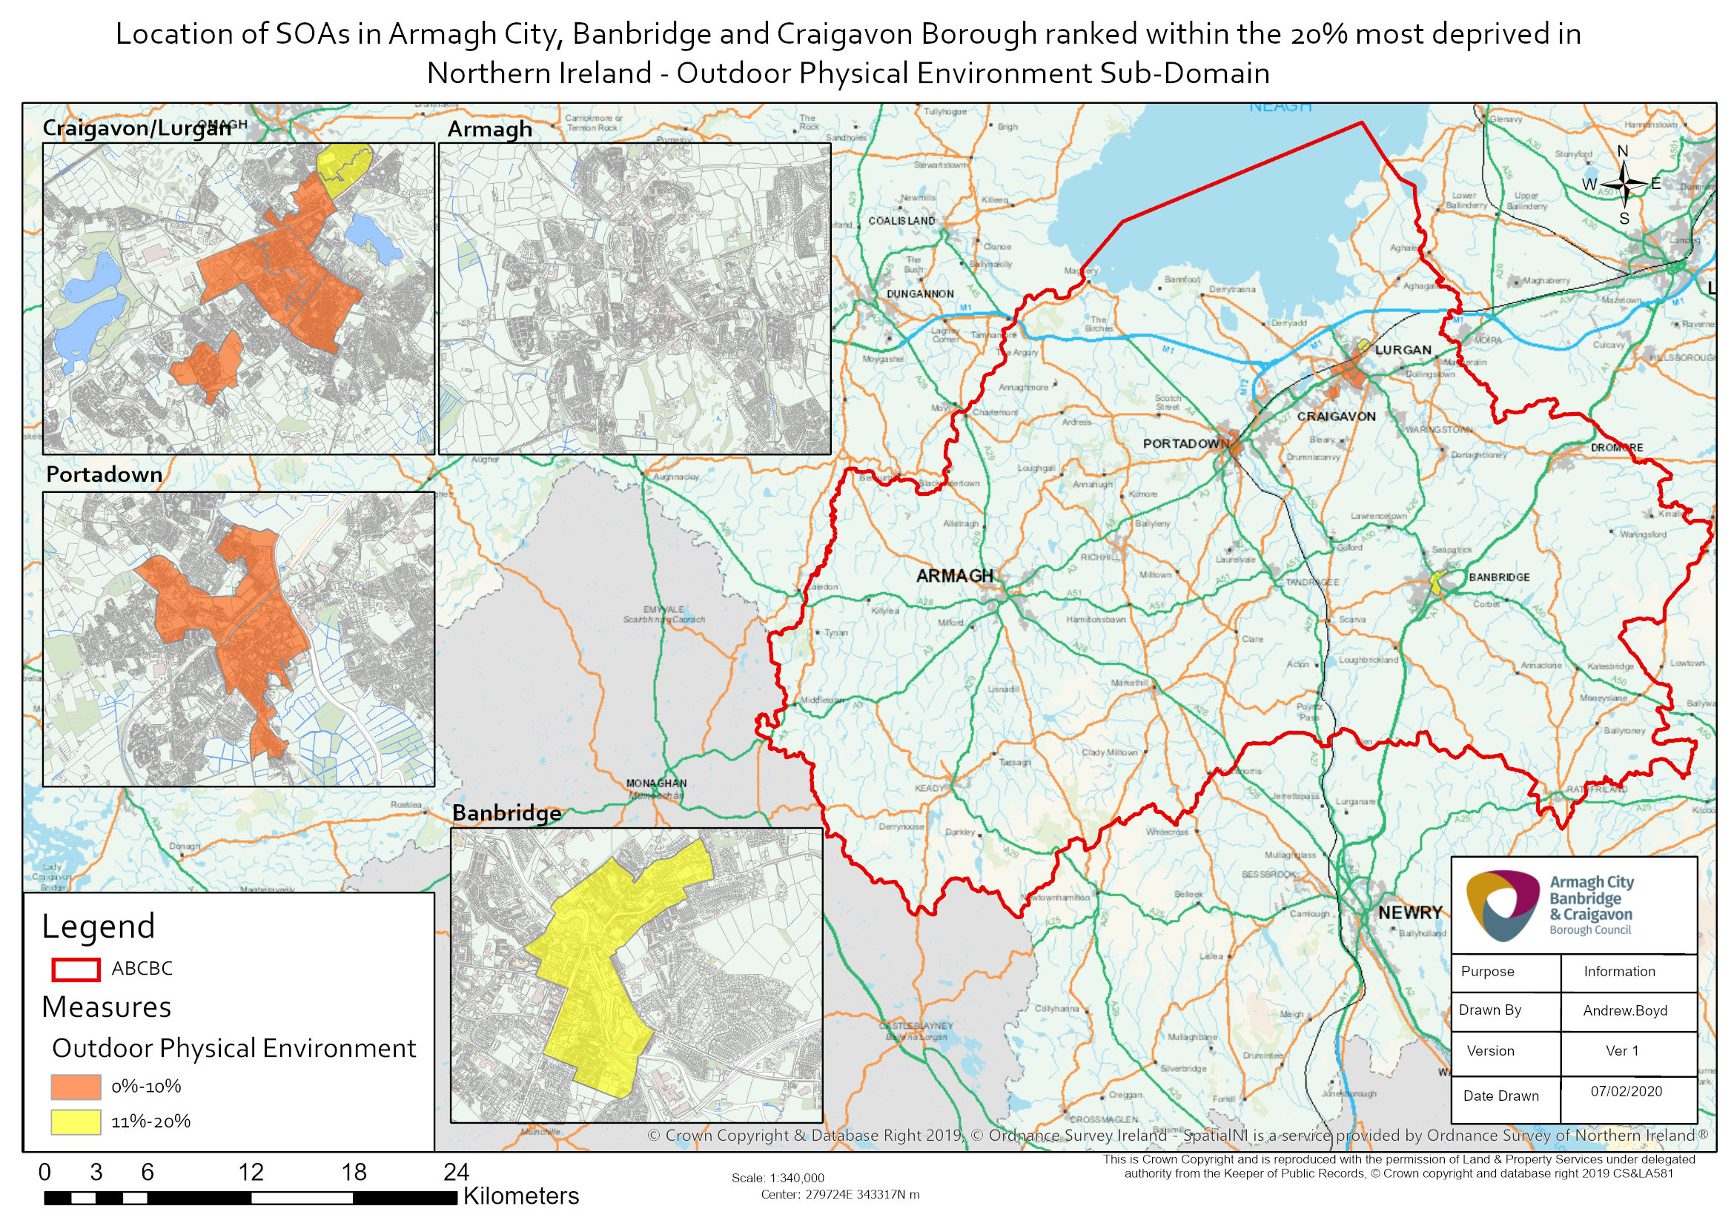
The first indicator in the Outdoor Physical Environment Sub-Domain is the proportion of domestic dwellings with Local Area Problem Scores.
When the 100 most deprived SOAs according to the proportion of domestic dwellings with Local Area Problem Scores in Northern Ireland are selected, five of these can be found in Armagh City, Banbridge and Craigavon Borough.
The most deprived SOA in the borough for this indicator is Keady. It is the 35th most deprived SOA in Northern Ireland for this indicator. Seven of the top ten most deprived proportion of domestic dwellings with Local Area Problem Scores SOAs in the borough are also in the borough’s top ten most deprived for the overall Multiple Deprivation Measure.
The SOAs in Armagh City, Banbridge and Craigavon Borough falling within the top 20% most deprived according to this indicator are listed below. Seven of the nine are classified as urban.
Proportion of Domestic Dwellings with Local Area Problem Scores Rank (1=most deprived  890=least deprived) | Armagh City, Banbridge and Craigavon Borough SOA | Urban/Rural | Proportion of Domestic Dwellings with Local Area Problem Scores  (%)
35 | Keady | Rural | 7.0%
51 | Annagh 2 | Urban | 6.3%
61 | Woodville 1 | Urban | 5.7%
75 | Drumgask 2 | Urban | 5.4%
99 | Church | Urban | 5.0%
122 | Corcrain 2 | Urban | 4.7%
159 | Court 1 | Urban | 4.3%
161 | Drumnamoe 1 | Urban | 4.3%
163 | Tandragee | Rural | 4.3%
Table 10: SOAs in Armagh City, Banbridge and Craigavon Borough which are within the 20% most deprived in Northern Ireland in terms of the proportion of domestic dwellings with Local Area Problem Scores rank. Source: Northern Ireland Multiple Deprivation Measure 2017, NISRA.
The other SOA that completes the top ten in the borough according to the proportion of domestic dwellings with Local Area Problem Scores is listed below.
Proportion of Domestic Dwellings with Local Area Problem Scores Rank (1=most deprived  890=least deprived) | Armagh City, Banbridge and Craigavon Borough SOA | Urban/Rural | Proportion of Domestic Dwellings with Local Area Problem Scores
179 | Edenderry 1 | Urban | 4.2%
Table 11: One further SOA making up the top ten in Armagh City, Banbridge and Craigavon Borough according to the proportion of domestic dwellings with Local Area Problem Scores rank. Source: Northern Ireland Multiple Deprivation Measure 2017, NISRA.
Also appear in the top ten overall MDM for the borough
The second indicator in the Outdoor Physical Environment Sub-Domain is the standardised rate of road defects.
When the 100 most deprived SOAs in terms of the standardised rate of road defects in Northern Ireland are selected, eight of these can be found in Armagh City, Banbridge and Craigavon Borough. The most deprived SOA in the borough according to this indicator is Mourneview, located in Lurgan. It is the 13th most deprived SOA in Northern Ireland for this indicator.
Five of the top ten most deprived standardised rate of road defects SOAs in the borough are also in the borough’s top ten most deprived for the overall Multiple Deprivation Measure.
The SOAs in Armagh City, Banbridge and Craigavon Borough falling within the 20% most deprived in Northern Ireland according to the standardised rate of road defects rank are listed below. The majority of SOAs in the borough that are within the 20% most deprived in Northern Ireland for this indicator are classified as urban (18 of 21).
Top ten in the borough
Standardised Rate of Road Defects Rank (1=most deprived  890=least deprived) | Armagh City, Banbridge and Craigavon Borough SOA | Urban/Rural | Standardised Rate of Road Defects  (NI=100)
13 | Mourneview | Urban | 577.4
19 | Court 1 | Urban | 517.7
32 | Court 2 | Urban | 468.3
35 | Drumnamoe 1 | Urban | 449.2
37 | Drumgask 2 | Urban | 448.9
44 | Woodville 1 | Urban | 421.0
72 | Taghnevan | Urban | 364.5
90 | Waringstown 2 | Rural | 334.1
102 | Annagh 2 | Urban | 316.4
104 | Knocknashane 2 | Urban | 315.3
119 | Corcrain 2 | Urban | 298.4
128 | Church | Urban | 292.3
132 | Woodville 2 | Urban | 288.8
139 | The Mall | Urban | 280.4
150 | Killycomain | Urban | 269.9
157 | Keady | Rural | 264.7
163 | Drumnamoe 2 | Urban | 256.4
167 | Rich Hill 2 | Rural | 253.7
168 | Callan Bridge | Urban | 252.9
170 | Knocknashane 1 | Urban | 251.6
172 | Edenderry 2 | Urban | 250.3
Table 12: SOAs in Armagh City, Banbridge and Craigavon Borough which are within the 20% most deprived in Northern Ireland in terms of the standardised rate of road defects rank. Source: Northern Ireland Multiple Deprivation Measure 2017, NISRA.
Also appear in the top ten overall MDM for the borough

The third indicator in the Outdoor Physical Environment Sub-Domain is Road Traffic Collisions.
When the 100 most deprived SOAs in terms of Road Traffic Collisions in Northern Ireland are selected, eight of these can be found in Armagh City, Banbridge and Craigavon Borough.
The most deprived SOA in the borough according to Road Traffic Collisions is Court 1, located in Lurgan. It is the 14th most deprived SOA in Northern Ireland for this indicator.
Three of the top ten most deprived Road Traffic Collisions SOAs in the borough are also in the borough’s top ten most deprived for the overall Multiple Deprivation Measure.
The SOAs in Armagh City, Banbridge and Craigavon Borough falling within the 20% most deprived in Northern Ireland according to the Road Traffic Collisions rank are listed below.
Five of the SOAs in the borough that are within the 20% most deprived in Northern Ireland for this indicator are classified as urban while six are rural.
Top ten in the borough
Road Traffic Collisions Rank (1=most deprived  890=least deprived) | Armagh City, Banbridge and Craigavon Borough SOA | Urban/Rural | Rate of Road Traffic Collisions (per 1,000 population)
14 | Court 1 | Urban | 13.6
19 | Drumgor 1 | Urban | 11.7
40 | Annagh 2 | Urban | 10.1
53 | Quilly | Rural | 9.0
57 | Lawrencetown | Rural | 8.9
65 | Milford | Rural | 8.5
71 | The Cut | Urban | 8.2
90 | Bannside | Rural | 7.6
130 | Edenderry 1 | Urban | 6.7
141 | Hockley | Rural | 6.5
154 | Hamiltonsbawn 1 | Rural | 6.2
Table 13: SOAs in Armagh City, Banbridge and Craigavon Borough which are within the 20% most deprived in Northern Ireland in terms of Road Traffic Collisions rank. Source: Northern Ireland Multiple Deprivation Measure 2017, NISRA.
Also appear in the top ten overall MDM for the borough

The fourth indicator in the Outdoor Physical Environment Sub-Domain is the proportion of properties in flood risk area.
When the 100 most deprived SOAs in terms of this indicator in Northern Ireland are selected, six of these can be found in Armagh City, Banbridge and Craigavon Borough.
The most deprived SOA in the borough according to the proportion of properties in flood risk area is Drumnamoe 2, located in Lurgan. It is the 6th most deprived SOA in Northern Ireland for this indicator.
Four of the top ten most deprived proportion of properties in flood risk area SOAs in the borough are also in the borough’s top ten most deprived for the overall Multiple Deprivation Measure.
The SOAs in Armagh City, Banbridge and Craigavon Borough falling within the 20% most deprived in Northern Ireland for this indicator are listed below.
Nine of the SOAs in the borough that are within the 20% most deprived in Northern Ireland for this indicator are classified as urban, three are rural and two are mixed urban/rural.
Top ten in the borough
Proportion of Properties in Flood Risk Area Rank (1=most deprived  890=least deprived) | Armagh City, Banbridge and Craigavon Borough SOA | Urban/Rural | Proportion of Properties in Flood Risk Area  (%)
6 | Drumnamoe 2 | Urban | 25.2%
55 | Court 1 | Urban | 8.5%
59 | Ballydown 1 | Urban | 8.1%
73 | Corcrain 2 | Urban | 6.6%
80 | Church | Urban | 6.3%
86 | The Cut | Urban | 6.1%
110 | Waringstown 2 | Rural | 5.2%
115 | Magheralin 1 | Mixed urban/rural | 5.1%
146 | Woodville 2 | Urban | 4.3%
156 | Annagh 1 | Mixed urban/rural | 4.2%
161 | Parklake | Urban | 4.1%
164 | Court 2 | Urban | 4.0%
165 | Hamiltonsbawn 2 | Rural | 4.0%
174 | Lawrencetown | Rural | 3.9%
Table 14: SOAs in Armagh City, Banbridge and Craigavon Borough which are within the 20% most deprived in Northern Ireland in terms of the proportion of properties in flood risk area rank. Source: Northern Ireland Multiple Deprivation Measure 2017, NISRA.
Also appear in the top ten overall MDM for the borough

Further information on NIMDM 2017 can be found via the following link:
https://www.nisra.gov.uk/statistics/deprivation/northern-ireland-multiple-deprivation-measure-2017-nimdm2017

For further information about the Living Environment Domain see page 22 of Technical Report and page 35 of Description of Indicators available at: https://www.nisra.gov.uk/publications/nimdm17-results

