Income Deprivation Domain and Employment Deprivation Domain
Income Deprivation Domain
The Income Deprivation Domain consists of one indicator which identifies the proportion of the population living in households whose equivalised income is below 60% of the NI median.
When the top 100 most deprived Super Output Areas (SOAs) in terms of income deprivation in Northern Ireland are selected, nine of these can be found in Armagh City, Banbridge and Craigavon Borough.
The most deprived SOA in the borough according to the Income Deprivation Domain is Woodville 1, located in Lurgan. It is the 9th most deprived SOA in Northern Ireland in terms of income deprivation.
Six of the top ten most income deprived SOAs in the borough are also in the borough’s top ten most deprived for the overall Multiple Deprivation Measure (MDM) which combines the seven deprivation domains (allowing areas to be ranked based on multiple types of deprivation).
The SOAs in Armagh City, Banbridge and Craigavon Borough falling within the 20% most deprived in Northern Ireland for income deprivation are listed below.
Top ten in the borough
Income Domain Rank (1=most deprived  890=least deprived) | Armagh City, Banbridge and Craigavon Borough SOA | Urban/Rural | Proportion of the population living in households whose equivalised income is below 60 per cent of the NI median (%)
9 | Woodville 1 | Urban | 24.4%
17 | Church | Urban | 21.6%
19 | Annagh 2 | Urban | 21.4%
22 | Keady | Rural | 21.1%
38 | Callan Bridge | Urban | 20.2%
46 | Derrynoose | Rural | 19.6%
86 | Corcrain 2 | Urban | 17.9%
93 | Carrigatuke | Rural | 17.8%
100 | Corcrain 1 | Urban | 17.7%
105 | Court 1 | Urban | 17.5%
117 | Drumgask 2 | Urban | 17.2%
122 | Tavanagh | Urban | 17.1%
131 | Poyntz Pass | Rural | 16.9%
139 | Markethill | Rural | 16.7%
156 | The Mall | Urban | 16.4%
172 | Drumgor 2 | Urban | 16.2%
Table 1: SOAs in Armagh City, Banbridge and Craigavon Borough which are within the 20% most deprived in Northern Ireland according to the Income Deprivation Domain. Source: Northern Ireland Multiple Deprivation Measure 2017, NISRA.
Also appear in the top ten overall MDM for the borough

A total of 16 SOAs in the borough are within the 20% most deprived in Northern Ireland overall for income deprivation. Of these 16, the majority are urban (11 of the 16) and five are rural. The locations of these SOAs in the borough are shown below, split by those that fall into the top 10% most deprived in Northern Ireland for income deprivation and those that are within the 11%-20% most deprived.

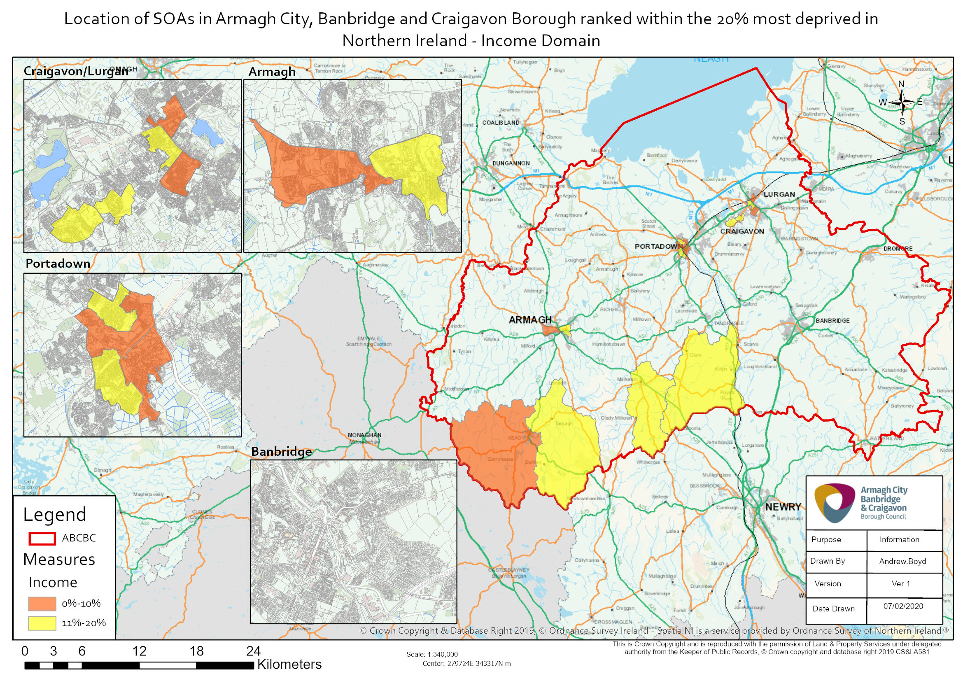

Supporting information has also been produced in respect of income deprivation affecting children (i.e. those aged 15 and under) and older people (i.e. those aged 65 and over) showing:
- The proportion of the population aged 15 and under living in households whose equivalised income is below 60 per cent of the NI median; and
- The proportion of the population aged 65 and over living in households whose equivalised income is below 60 percent of the NI median.
When the top 100 most deprived SOAs in terms of the proportion of the population aged 15 and under living in households whose equivalised income is below 60 per cent of the NI median are selected, seven of these can be found in Armagh City, Banbridge and Craigavon Borough. The most deprived SOA in the borough according to this supporting information relating to those aged 15 and under is Church, located in Lurgan, and is the 9th most deprived SOA in Northern Ireland for income deprivation affecting children. Five of the top ten most deprived SOAs in the borough relating to the proportion of the population aged 15 and under living in households whose equivalised income is below 60 per cent of the NI median are also in the borough’s top ten most deprived for the overall Multiple Deprivation Measure. The SOAs in Armagh City, Banbridge and Craigavon Borough falling within the 20% most deprived in Northern Ireland for income deprivation affecting children are shown below.
Top ten in the borough
Proportion of the population aged 15 and under living in households whose equivalised income is below 60 per cent of the NI median Rank (1=most deprived  890=least deprived) | Armagh City, Banbridge and Craigavon Borough SOA | Urban/Rural | Proportion of the population aged 15 and under living in households whose equivalised income is below 60 per cent of the NI median (%)
9 | Church | Urban | 35.2%
20 | Woodville 1 | Urban | 31.0%
23 | Keady | Rural | 30.5%
51 | Annagh 2 | Urban | 27.9%
64 | Drumgask 2 | Urban | 26.6%
78 | Corcrain 1 | Urban | 25.7%
87 | Drumgor 2 | Urban | 25.4%
109 | Edenderry 1 | Urban | 24.9%
123 | Poyntz Pass | Rural | 24.4%
136 | Rathfriland | Rural | 24.1%
151 | Derrynoose | Rural | 23.9%
153 | Tandragee | Rural | 23.8%
156 | Drumnamoe 1 | Urban | 23.7%
163 | Tavanagh | Urban | 23.5%
Table 2: SOAs in Armagh City, Banbridge and Craigavon Borough which are within the 20% most deprived in Northern Ireland in terms of the proportion of the population aged 15 and under living in households whose equivalised income is below 60 per cent of the NI median rank. Source: Northern Ireland Multiple Deprivation Measure 2017, NISRA.
Also appear in the top ten overall MDM for the borough
When the top 100 most deprived SOAs in terms of the proportion of the population aged 65 and over living in households whose equivalised income is below 60 per cent of the NI median are selected, twelve of these can be found in Armagh City, Banbridge and Craigavon Borough.
The most deprived SOA in the borough according to this supporting information relating to those aged 65 and over is Derrynoose, and is the 11th most deprived SOA in Northern Ireland.
None of the top ten most deprived SOAs in the borough relating to the proportion of the population aged 65 and over living in households whose equivalised income is below 60 per cent of the NI median are in the borough’s top ten most deprived for the overall Multiple Deprivation Measure.
SOAs in Armagh City, Banbridge and Craigavon Borough falling within the 20% most deprived in Northern Ireland for income deprivation affecting older people are shown below, the majority of which are classified as rural (15 out of 18).
Top ten in the borough
Proportion of the population aged 65 and over living in households whose equivalised income is below 60 per cent of the NI median Rank (1=most deprived  890=least deprived) | Armagh City, Banbridge and Craigavon Borough SOA | Urban/Rural | Proportion of the population aged 65 and over living in households whose equivalised income is below 60 per cent of the NI median (%)
11 | Derrynoose | Rural | 13.8%
27 | Katesbridge | Rural | 12.2%
29 | The Birches 1 | Rural | 12.1%
32 | Killylea | Rural | 12.0%
39 | Poyntz Pass | Rural | 11.5%
40 | Bannside | Rural | 11.5%
54 | Charlemont | Rural | 11.0%
57 | Carrigatuke | Rural | 11.0%
69 | Ballymartrim | Rural | 10.3%
82 | Loughbrickland | Rural | 9.9%
91 | Annagh 2 | Urban | 9.7%
92 | Lawrencetown | Rural | 9.7%
108 | Donaghcloney 2 | Rural | 9.4%
121 | Dromore South 1 | Urban | 9.1%
129 | Dromore South 2 | Mixed urban/rural | 9.0%
143 | The Birches 2 | Rural | 8.8%
145 | Aghagallon 1 | Rural | 8.7%
166 | Rich Hill 1 | Rural | 8.4%
Table 3: SOAs in Armagh City, Banbridge and Craigavon Borough which are within the 20% most deprived in Northern Ireland in terms of the proportion of the population aged 65 and over living in households whose equivalised income is below 60 per cent of the NI median rank. Source: Northern Ireland Multiple Deprivation Measure 2017, NISRA.
Also appear in the top ten overall MDM for the borough

Employment Deprivation Domain
The Employment Deprivation Domain consists of one indicator which identifies the proportion of the working age population (aged 18 – 64) who are excluded from work.
When the top 100 most deprived SOAs in terms of employment deprivation in Northern Ireland are selected, six of these can be found in Armagh City, Banbridge and Craigavon Borough.
The most deprived SOA in the borough according to the Employment Deprivation Domain is Drumnamoe 1, located in Lurgan. It is the 42nd most deprived SOA in Northern Ireland in terms of income deprivation.
Seven of the top ten most employment deprived SOAs in the borough are also in the borough’s top ten most deprived for the overall Multiple Deprivation Measure.
The SOAs in Armagh City, Banbridge and Craigavon Borough falling within the 20% most deprived in Northern Ireland for employment deprivation are listed below.
Top ten in the borough
Employment Domain Rank (1=most deprived  890=least deprived) | Armagh City, Banbridge and Craigavon Borough SOA | Urban/Rural | Proportion of the working age population who are employment deprived (%)
42 | Drumnamoe 1 | Urban | 43.2%
59 | Woodville 1 | Urban | 40.1%
67 | Drumgask 2 | Urban | 38.4%
69 | Court 1 | Urban | 37.7%
92 | Court 2 | Urban | 34.6%
98 | Callan Bridge | Urban | 34.2%
107 | Drumgor 2 | Urban | 33.7%
119 | The Cut | Urban | 32.4%
147 | Corcrain 1 | Urban | 30.3%
170 | Edenderry | Urban | 29.1%
178 | Corcrain 2 | Urban | 28.6%
Table 4: SOAs in Armagh City, Banbridge and Craigavon Borough which are within the 20% most deprived in Northern Ireland according to the Employment Deprivation Domain. Source: Northern Ireland Multiple Deprivation Measure 2017, NISRA.
Also appear in the top ten overall MDM for the borough

A total of 11 SOAs in the borough are within the 20% most deprived in Northern Ireland overall for employment deprivation. All 11 of these SOAs are classified as urban areas. The locations of these SOAs in the borough are shown below, split by those that fall into the top 10% most deprived in Northern Ireland for employment deprivation and those that are within the 11%-20% most deprived.

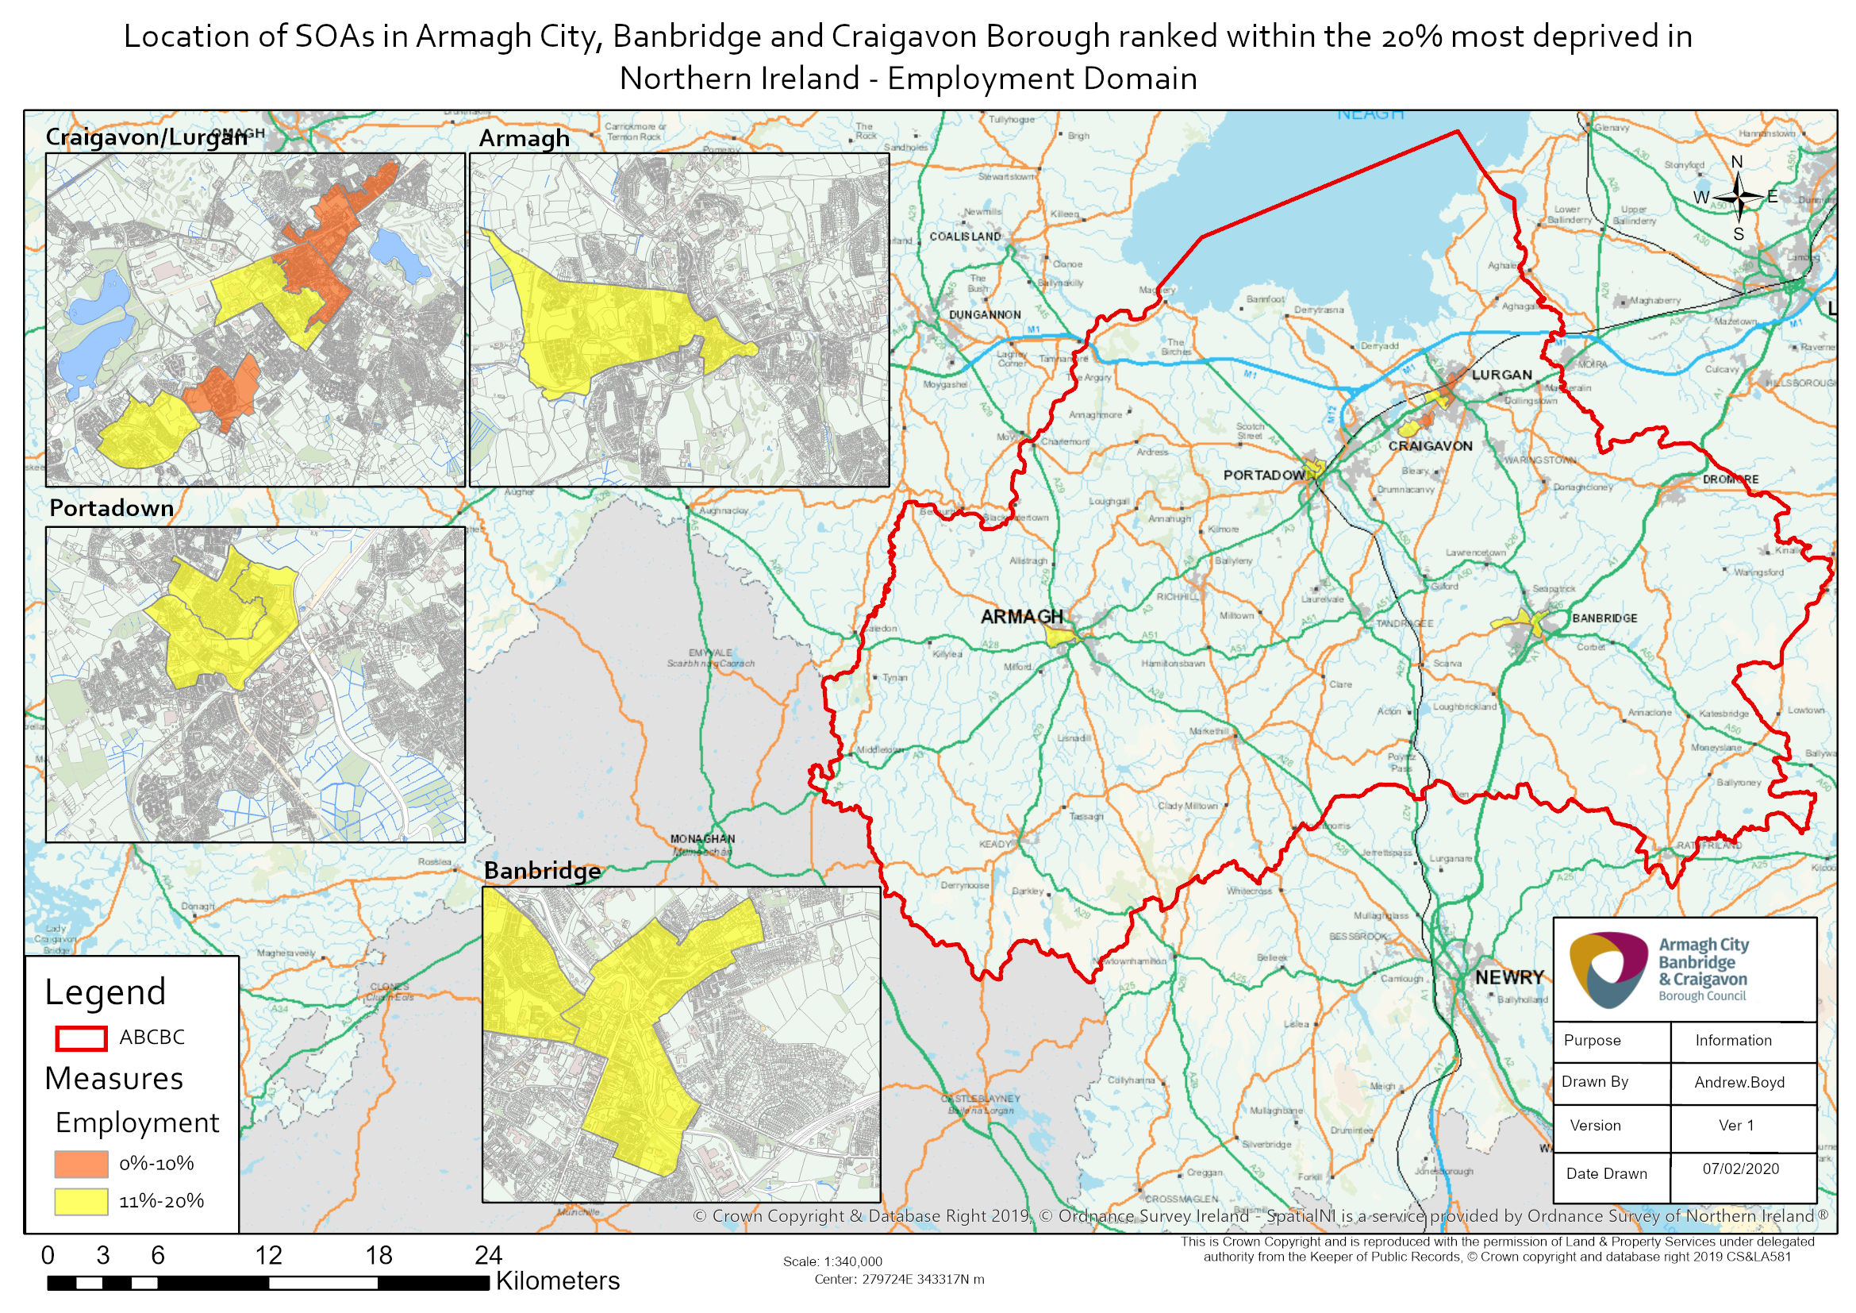

Further information of Northern Ireland Multiple Deprivation Measure 2017 can be found via the following link:
https://www.nisra.gov.uk/statistics/deprivation/northern-ireland-multiple-deprivation-measure-2017-nimdm2017

For further information about the Income Deprivation Domain see page 8 of Technical Report and page 6 of Description of Indicators available at: https://www.nisra.gov.uk/publications/nimdm17-results
For further information about the Employment Deprivation Domain see page 10 of Technical Report and page 8 of Description of Indicators available at: https://www.nisra.gov.uk/publications/nimdm17-results

