Cultural Deprivation Index
Cultural Deprivation Index 2014
The calculation of the cultural deprivation index involves producing scores for each output area (OA) for each of four cultural facility types: sports, arts, libraries and museums. The scores at OA level are based on the average distance to the nearest facility. A combined score, the Cultural Deprivation Index (CDI) is then produced for each OA. The OA level scores are used to produce scores for each Super Output Area (SOA). These SOAs are then ranked from 1 to 890 where 1 is the most deprived with regard to proximity of cultural facilities while 890 is the least deprived.
When the 100 most deprived SOAs in Northern Ireland are selected, according to the Cultural Deprivation Index, four of these can be found in Armagh City, Banbridge and Craigavon Borough. The most deprived SOA in the borough according to the Cultural Deprivation Index is Katesbridge, which is ranked 24th most deprived in Northern Ireland overall. The SOAs in Armagh City, Banbridge and Craigavon Borough falling within the 20% most deprived in Northern Ireland according to the overall Cultural Deprivation Index are listed below.
Top ten in the borough
Cultural Deprivation Index (1=most deprived  890=least deprived) | Armagh City, Banbridge and Craigavon Borough SOA | Urban/Rural
24 | Katesbridge | Rural
27 | The Birches 2 | Rural
65 | Gransha | Rural
93 | Killylea | Rural
110 | Poyntz Pass | Rural
114 | Quilly | Rural
115 | Donaghcloney 2 | Rural
124 | Bannside | Rural
125 | Carrigatuke | Rural
127 | Donaghcloney 1 | Rural
135 | Derrynoose | Rural
137 | The Birches 1 | Rural
144 | Markethill | Rural
145 | Aghagallon 2 | Mixed urban/rural
160 | Aghagallon 1 | Rural
164 | Hamiltonsbawn 2 | Rural
Table 1: SOAs in Armagh City, Banbridge and Craigavon Borough which are within the 20% most deprived in Northern Ireland according to the Cultural Deprivation Index. Source: Cultural Deprivation Index 2014, Department for Communities.
The majority of these SOAs are rural (15 of the 16) with one being classified as mixed urban/rural. The locations of these SOAs in the borough are shown below.
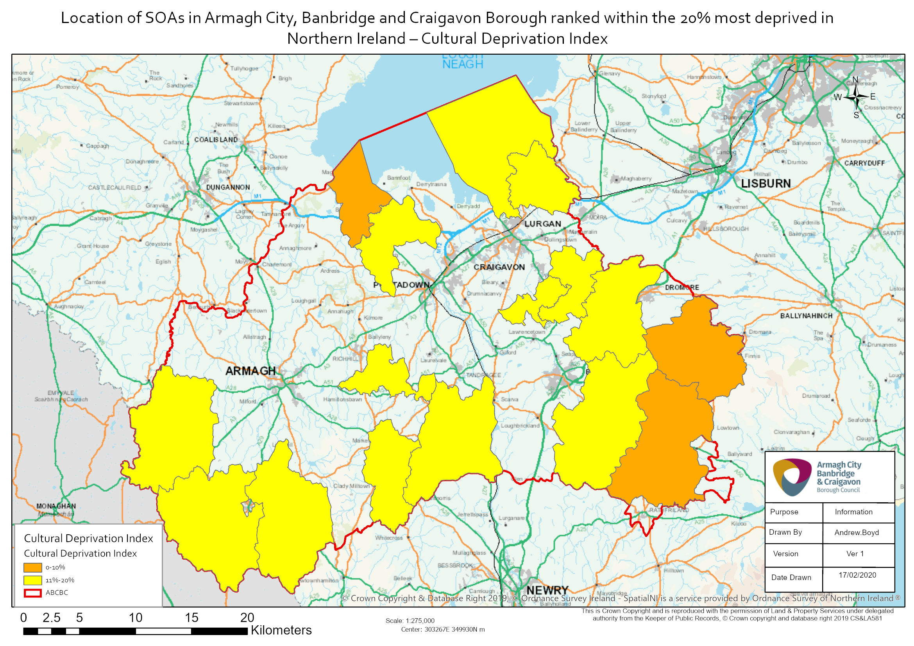
The first of the four cultural facility types that combine to make the Cultural Deprivation Index is sports.
When the top 100 most deprived SOAs in terms of the Sport Deprivation Index are selected, ten of these can be found in Armagh City, Banbridge and Craigavon Borough. The most deprived SOA in the borough according to the Sport Deprivation Index is The Birches 2, which is the most deprived SOA in Northern Ireland for sport deprivation.
Five of the top ten most deprived SOAs in the borough relating to the Sport Deprivation Index are also in the borough’s top ten most deprived for the overall Cultural Deprivation Index.
The SOAs in Armagh City, Banbridge and Craigavon Borough falling within the 20% most deprived in Northern Ireland according to the Sport Deprivation Index are shown below. The majority of these SOAs are rural (21 of 22) with one classified as mixed urban/rural.
Top ten in the borough
Sport Deprivation Index  (1=most deprived  890=least deprived) | Armagh City, Banbridge and Craigavon Borough SOA | Urban/Rural
1 | The Birches 2 | Rural
6 | Katesbridge | Rural
21 | The Birches 1 | Rural
32 | Hamiltonsbawn 2 | Rural
39 | Carrigatuke | Rural
75 | Quilly | Rural
83 | Hockley | Rural
89 | Charlemont | Rural
92 | Poyntz Pass | Rural
93 | Hamiltonsbawn 1 | Rural
108 | Bannside | Rural
111 | Donaghcloney 1 | Rural
114 | Milford | Rural
123 | Gransha | Rural
124 | Loughgall | Rural
132 | Derrynoose | Rural
133 | Ballymartrim | Rural
137 | Aghagallon 2 | Mixed urban/rural
138 | Killylea | Rural
146 | Loughbrickland | Rural
147 | Killeen | Rural
151 | Derrytasna 2 | Rural
Table 2: SOAs in Armagh City, Banbridge and Craigavon Borough which are within the 20% most deprived in Northern Ireland according to the Sport Deprivation Index. Source: Cultural Deprivation Index 2014, Department for Communities.
Also appear in the top ten overall CDI for the borough

The second cultural facility type that combines to make the Cultural Deprivation Index is arts.
When the top 100 most deprived SOAs in terms of the Arts Deprivation Index are selected, thirteen of these can be found in Armagh City, Banbridge and Craigavon Borough. The most deprived SOA in the borough according to the Arts Deprivation Index is Katesbridge, which ranks 40th most deprived in Northern Ireland. Five of the top ten most deprived SOAs in the borough according to the Arts Deprivation Index are also in the borough’s top ten most deprived for the overall Cultural Deprivation Index. SOAs in Armagh City, Banbridge and Craigavon Borough falling within the 20% most deprived in Northern Ireland in terms of arts deprivation are shown below, the majority of which are classified as rural (15 out of 27).
Top ten in the borough
Arts Deprivation Index  (1=most deprived  890=least deprived) | Armagh City, Banbridge and Craigavon Borough SOA | Urban/Rural
40 | Katesbridge | Rural
42 | Gransha | Rural
57 | Bannside | Rural
58 | Quilly | Rural
69 | Donaghcloney 2 | Rural
75 | Ballydown 2 | Urban
77 | Dromore South 2 | Mixed urban/rural
79 | Ballydown 1 | Urban
81 | Dromore South 1 | Urban
88 | The Cut | Urban
89 | Aghagallon 1 | Rural
90 | Fort | Urban
93 | Aghagallon 2 | Mixed urban/rural
103 | Rathfriland | Rural
107 | Banbridge West | Urban
110 | Dromore North | Urban
111 | Edenderry | Urban
112 | Seapatrick | Urban
123 | Derrynoose | Rural
128 | Loughbrickland | Rural
136 | Magheralin 2 | Rural
149 | Poyntz Pass | Rural
158 | Donaghcloney 1 | Rural
163 | Killylea | Rural
167 | Magheralin 1 | Mixed urban/rural
177 | Lawrencetown | Rural
178 | Carrigatuke | Rural
Table 3: SOAs in Armagh City, Banbridge and Craigavon Borough which are within the 20% most deprived in Northern Ireland according to the Arts Deprivation Index. Source: Cultural Deprivation Index 2014, Department for Communities.
Also appear in the top ten overall CDI for the borough

The third cultural facility type that combines to make the Cultural Deprivation Index is libraries.
When the top 100 most deprived SOAs in terms of the Library Deprivation Index in Northern Ireland are selected, nine of these can be found in Armagh City, Banbridge and Craigavon Borough.
The most deprived SOA in the borough according to the Library Deprivation Index is The Birches 2, which is ranked as the 32nd most deprived SOA in Northern Ireland in terms of library deprivation.
Six of the top ten most library deprived SOAs in the borough are also in the borough’s top ten most deprived for the overall Cultural Deprivation Index.
The SOAs in Armagh City, Banbridge and Craigavon Borough falling within the 20% most deprived in Northern Ireland according to the Library Deprivation Index are listed below. Seventeen of the 18 SOAs are classified as rural, while one is classified as mixed urban/rural.
Top ten in the borough
Library Deprivation Index (1=most deprived  890=least deprived) | Armagh City, Banbridge and Craigavon Borough SOA | Urban/Rural
32 | The Birches 2 | Rural
40 | Killylea | Rural
53 | Markethill | Rural
72 | Gransha | Rural
84 | Derrytrasna 2 | Rural
88 | Donaghcloney 2 | Rural
89 | Loughgall | Rural
96 | Katesbridge | Rural
97 | Poyntz Pass | Rural
112 | Killeen | Rural
113 | The Birches 1 | Rural
114 | Donaghcloney 1 | Rural
119 | Bannside | Rural
122 | Ballymartrim | Rural
127 | Aghagallon 2 | Mixed urban/rural
143 | Aghagallon 1 | Rural
164 | Hamiltonsbawn 1 | Rural
171 | Loughbrickland | Rural
Table 4: SOAs in Armagh City, Banbridge and Craigavon Borough which are within the 20% most deprived in Northern Ireland according to the Library Deprivation Index. Source: Cultural Deprivation Index 2014, Department for Communities.
Also appear in the top ten overall CDI for the borough

The fourth cultural facility type that combines to make the Cultural Deprivation Index is museums.
When the top 100 most deprived SOAs in terms of the Museum Deprivation Index in Northern Ireland are selected, none of these are found in Armagh City, Banbridge and Craigavon Borough.
The most deprived SOA in the borough according to the Museum Deprivation Index is Gransha. It is the 106th most deprived SOA in Northern Ireland in terms of museum deprivation.
Four of the top ten most deprived SOAs in the borough according to the Museum Deprivation Index are also in the borough’s top ten most deprived for the overall Cultural Deprivation Index.
The SOAs in Armagh City, Banbridge and Craigavon Borough falling within the 20% most deprived in Northern Ireland for museum deprivation are listed below. Ten of these SOAs are classified as rural, two as urban and two as mixed urban/rural.
Top ten in the borough
Museum Deprivation Index (1=most deprived  890=least deprived) | Armagh City, Banbridge and Craigavon Borough SOA | Urban/Rural
106 | Gransha | Rural
109 | Rathfriland | Rural
114 | Derrynoose | Rural
133 | Laurelvale | Rural
141 | Katesbridge | Rural
146 | Dromore North | Urban
152 | Dromore South 2 | Mixed urban/rural
158 | Killylea | Rural
161 | Carrigatuke | Rural
166 | Tandragee | Rural
169 | Dromore South 1 | Urban
173 | Keady | Rural
176 | Annagh 1 | Mixed urban/rural
177 | Poyntz Pass | Rural
Table 5: SOAs in Armagh City, Banbridge and Craigavon Borough which are within the 20% most deprived in Northern Ireland according to the Museum Deprivation Index. Source: Cultural Deprivation Index 2014, Department for Communities.
Also appear in the top ten overall CDI for the borough

Further information on the Cultural Deprivation Index can be found via the following link:
https://www.ninis2.nisra.gov.uk/public/Theme.aspx
Filter for:
- Subset – people
- Geography – SOA
- Year – 2014

Output areas were designed to have similar population sizes of around 125 households and 350 people. They are also as socially similar as possible.
Northern Ireland is split into 890 spatial areas known as Super Output Areas (SOAs), with an average population of around 2,100 people.

