Crime and Disorder Domain
Crime and Disorder Domain
The Crime and Disorder Domain consists of seven indicators, split into two sub-domains and identifies the rate of crime and disorder as detailed below:

- Crime Sub-Domain:
  - Violent crime (including sexual offences), robbery and public order
  - Burglary
  - Theft
  - Vehicle crime
  - Criminal damage and arson
- Disorder Sub-Domain
  - Deliberate primary and secondary fires
  - Anti-social behaviour incidents

When the top 100 most deprived Super Output Areas (SOAs) according to the Crime and Disorder Domain in Northern Ireland are selected, seven of these can be found in Armagh City, Banbridge and Craigavon Borough.
The most deprived SOA in the borough according to the Crime and Disorder Domain is Court 1, located in Lurgan. It is the 7th most deprived SOA in Northern Ireland in terms of crime and disorder.
Seven of the top ten most deprived crime and disorder SOAs in the borough are also in the borough’s top ten most deprived for the overall Multiple Deprivation Measure (MDM) which combines the seven deprivation domains (allowing areas to be ranked based on multiple types of deprivation).
The SOAs in Armagh City, Banbridge and Craigavon Borough falling within the 20% most deprived in Northern Ireland according to the Crime and Disorder Domain are listed below.

Crime and Disorder Domain Rank (1=most deprived  890=least deprived) | Armagh City, Banbridge and Craigavon Borough SOA | Urban/Rural
7 | Court 1 | Urban
15 | The Cut | Urban
26 | Drumgor 2 | Urban
27 | Woodville 1 | Urban
42 | Annagh 2 | Urban
69 | Callan Bridge | Urban
97 | Court 2 | Urban
104 | Church | Urban
125 | Drumgor 1 | Urban
132 | Edenderry | Urban
173 | Taghnevan | Urban
175 | Corcrain 2 | Urban
Table 1: SOAs in Armagh City, Banbridge and Craigavon Borough which are within the 20% most deprived in Northern Ireland according to the Crime and Disorder Domain. Source: Northern Ireland Multiple Deprivation Measure 2017, NISRA.
Top ten in the borough
Also appear in the top ten overall MDM for the borough

A total of 12 SOAs in the borough are within the 20% most deprived in Northern Ireland overall according to the Crime and Disorder Domain. All 12 of these SOAs are urban. The locations of these SOAs in the borough are shown below, split by those that fall into the top 10% most deprived in Northern Ireland according to the Crime and Disorder Domain and those that are within the 11%-20% most deprived.

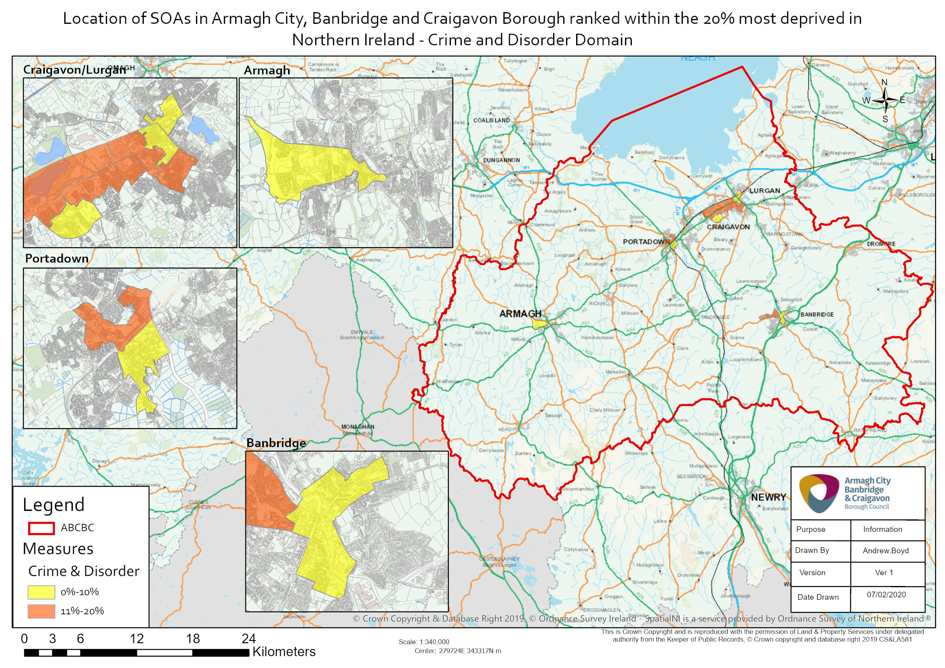
The first sub-domain in the Crime and Disorder Domain is the Crime Sub-Domain.
When the 100 most deprived SOAs according to the Crime Sub-Domain rank in Northern Ireland are selected, seven of these can be found in Armagh City, Banbridge and Craigavon Borough.
The most deprived SOA in the borough in terms of the Crime Sub-Domain is Court 1, located in Lurgan. It is the 4th most deprived SOA in Northern Ireland according to the Crime Sub-Domain.
Seven of the top ten most deprived Crime Sub-Domain SOAs in the borough are also in the borough’s top ten most deprived for the overall Multiple Deprivation Measure.
The SOAs in Armagh City, Banbridge and Craigavon Borough falling within the 20% most deprived in Northern Ireland according to the Crime Sub-Domain are listed below.
All 13 of the SOAs in the borough falling within the 20% most deprived in Northern Ireland for the Crime Sub-Domain are classified as urban.
Top ten in the borough
Crime Sub-Domain Rank (1=most deprived  890=least deprived) | Armagh City, Banbridge and Craigavon Borough SOA | Urban/Rural
4 | Court 1 | Urban
11 | The Cut | Urban
33 | Annagh 2 | Urban
35 | Woodville 1 | Urban
43 | Drumgor 2 | Urban
77 | Callan Bridge | Urban
97 | Church | Urban
112 | Drumgor 1 | Urban
130 | Court 2 | Urban
161 | Taghnevan | Urban
163 | Edenderry | Urban
174 | Corcrain 2 | Urban
177 | Tavanagh | Urban
Table 2: SOAs in Armagh City, Banbridge and Craigavon Borough which are within the 20% most deprived in Northern Ireland in terms of the Crime Sub-Domain. Source: Northern Ireland Multiple Deprivation Measure 2017, NISRA.
Also appear in the top ten overall MDM for the borough

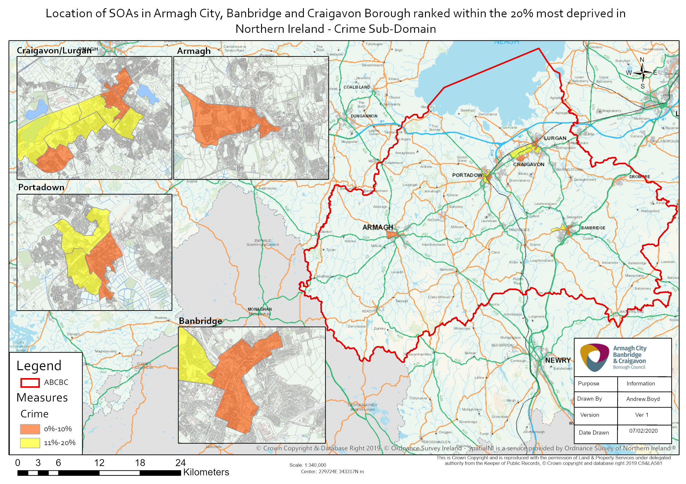

The first indicator in the Crime Sub-Domain is the rate of violent crime (including sexual offences), robbery and public order.
When the 100 most deprived SOAs in terms of the rate of violent crime (including sexual offences), robbery and public order in Northern Ireland are selected, seven of these can be found in Armagh City, Banbridge and Craigavon Borough.
The most deprived SOA in the borough according to this indicator is Court 1, located in Lurgan. It is the 2nd most deprived SOA in Northern Ireland for this indicator.
Eight of the top ten most deprived rate of violent crime (including sexual offences), robbery and public order SOAs in the borough are also in the borough’s top ten most deprived for the overall Multiple Deprivation Measure.
The SOAs in Armagh City, Banbridge and Craigavon Borough falling within the 20% most deprived in Northern Ireland according to this indicator are listed below. All 17 of the SOAs in the borough that are within the 20% most deprived in Northern Ireland for this indicator are classified as urban.
Top ten in the borough
Rate of Violent Crime (including sexual offences), Robbery and Public Order Rank (1=most deprived  890=least deprived) | Armagh City, Banbridge and Craigavon Borough SOA | Urban/Rural | Rate of Violent Crime (including sexual offences), Robbery and Public Order  (per 1,000 population)
2 | Court 1 | Urban | 109.2
6 | The Cut | Urban | 75.5
12 | Annagh 2 | Urban | 64.9
22 | Woodville 1 | Urban | 52.1
64 | Callan Bridge | Urban | 35.9
68 | Church | Urban | 34.8
85 | Drumgor 2 | Urban | 31.8
108 | Tavanagh | Urban | 29.3
112 | Corcrain 2 | Urban | 28.9
119 | Drumgor 1 | Urban | 27.5
125 | Drumgask 2 | Urban | 27.1
128 | Court 2 | Urban | 26.9
141 | Demesne 2 | Urban | 25.5
155 | Corcrain 1 | Urban | 24.3
163 | Downs | Urban | 23.6
172 | Parklake | Urban | 22.9
178 | Edenderry 1 | Urban | 21.8
Table 3: SOAs in Armagh City, Banbridge and Craigavon Borough which are within the 20% most deprived in Northern Ireland in terms of the rate of violent crime (including sexual offences), robbery and public order rank. Source: Northern Ireland Multiple Deprivation Measure 2017, NISRA.
Also appear in the top ten overall MDM for the borough

The second indicator in the Crime Sub-Domain is the rate of burglary.
When the 100 most deprived SOAs according to the rate of burglary in Northern Ireland are selected, five of these can be found in Armagh City, Banbridge and Craigavon Borough.
The most deprived SOA in the borough for this indicator is Drumgor 2, located in Craigavon, which is the 7th most deprived SOA in Northern Ireland for this indicator.
Five of the top ten most deprived SOAs in the borough according to the rate of burglary are also in the borough’s top ten most deprived for the overall Multiple Deprivation Measure.
The SOAs in Armagh City, Banbridge and Craigavon Borough falling within the 20% most deprived in Northern Ireland according to the rate of burglary rank are listed below.
The majority of the SOAs in the borough falling within the 20% most deprived in Northern Ireland for this indicator are urban, 13 of the 17, with 4 classified as rural.
Top ten in the borough
Rate of Burglary Rank (1=most deprived  890=least deprived) | Armagh City, Banbridge and Craigavon Borough SOA | Urban/Rural | Rate of Burglary  (per 1,000 population)
7 | Drumgor 2 | Urban | 13.8
14 | Court 1 | Urban | 11.7
15 | Annagh 2 | Urban | 11.3
24 | Woodville 1 | Urban | 10.6
83 | Court 2 | Urban | 7.3
115 | Drumgor 1 | Urban | 6.5
117 | Keady | Rural | 6.5
118 | The Cut | Urban | 6.5
120 | Taghnevan | Urban | 6.4
121 | Drumgask 1 | Urban | 6.4
131 | Callan Bridge | Urban | 6.3
132 | Church | Urban | 6.3
140 | Gilford | Rural | 6.1
142 | Poyntz Pass | Rural | 6.1
143 | Fort | Urban | 6.1
154 | Loughbrickland | Rural | 5.8
161 | Edenderry | Urban | 5.6
Table 4: SOAs in Armagh City, Banbridge and Craigavon Borough which are within the 20% most deprived in Northern Ireland in terms of the rate of burglary rank. Source: Northern Ireland Multiple Deprivation Measure 2017, NISRA.
Also appear in the top ten overall MDM for the borough

The third indicator in the Crime Sub-Domain is the rate of theft.
When the 100 most deprived SOAs according to this indicator in Northern Ireland are selected, five of these can be found in Armagh City, Banbridge and Craigavon Borough.
The most deprived SOA in the borough for this indicator is The Cut, located in Banbridge, which is the 21st most deprived SOA in Northern Ireland for this indicator.
Six of the top ten most deprived SOAs in the borough according to the rate of theft are also in the borough’s top ten most deprived for the overall Multiple Deprivation Measure.
The SOAs in Armagh City, Banbridge and Craigavon Borough falling within the 20% most deprived in Northern Ireland according to the rate of theft rank are listed below.
Nine of the ten SOAS in the borough falling within the 20% most deprived in Northern Ireland for this indicator are urban, with one classified as mixed urban/rural.
Top ten in the borough
Rate of Theft Rank (1=most deprived  890=least deprived) | Armagh City, Banbridge and Craigavon Borough SOA | Urban/Rural | Rate of Theft  (per 1,000 population)
21 | The Cut | Urban | 22.8
38 | Court 1 | Urban | 19.5
45 | Annagh 2 | Urban | 18.4
73 | Drumgor 1 | Urban | 14.3
91 | Edenderry 1 | Urban | 13.0
108 | Callan Bridge | Urban | 12.0
132 | Drumgor 2 | Urban | 10.6
164 | Aghagallon 2 | Mixed urban/rural | 9.3
170 | Knocknashane 1 | Urban | 9.0
171 | Woodville 1 | Urban | 8.9
Table 5: SOAs in Armagh City, Banbridge and Craigavon Borough which are within the 20% most deprived in Northern Ireland in terms of the rate of theft rank. Source: Northern Ireland Multiple Deprivation Measure 2017, NISRA.
Also appear in the top ten overall MDM for the borough

The fourth indicator in the Crime Sub-Domain is the rate of vehicle crime.
When the 100 most deprived SOAs according to the rate of vehicle crime in Northern Ireland are selected, four of these can be found in Armagh City, Banbridge and Craigavon Borough.
The most deprived SOA in the borough for this indicator is Court 1, located in Lurgan. It is the 53rd most deprived SOA in Northern Ireland for the rate of vehicle crime.
Seven of the top ten most deprived SOAs in the borough according to the rate of vehicle crime are also in the borough’s top ten most deprived for the overall Multiple Deprivation Measure.
The SOAs in Armagh City, Banbridge and Craigavon Borough falling within the 20% most deprived in terms of the rate of vehicle crime rank are listed below.
Five of the six SOAs in the borough that are within the 20% most deprived in Northern Ireland for this indicator are urban, while one is classified as rural.

Rate of Vehicle Crime Rank (1=most deprived  890=least deprived) | Armagh City, Banbridge and Craigavon Borough SOA | Urban/Rural | Rate of Vehicle Crime  (per 1,000 population)
53 | Court 1 | Urban | 4.5
59 | Loughbrickland | Rural | 4.3
64 | The Cut | Urban | 4.2
82 | Woodville 1 | Urban | 3.9
110 | Callan Bridge | Urban | 3.5
144 | Drumgor 2 | Urban | 3.2
Table 6: SOAs in Armagh City, Banbridge and Craigavon Borough which are within the 20% most deprived in Northern Ireland in terms of the rate of vehicle crime rank. Source: Northern Ireland Multiple Deprivation Measure 2017, NISRA.
The four other SOAs that complete the top ten in the borough according to the rate of vehicle crime are listed below.
Rate of Vehicle Crime Rank (1=most deprived  890=least deprived) | Armagh City, Banbridge and Craigavon Borough SOA | Urban/Rural | Rate of Vehicle Crime  (per 1,000 population)
183 | Drumgor 1 | Urban | 2.9
212 | Keady | Rural | 2.7
213 | Annagh 2 | Urban | 2.7
234 | Drumnamoe 1 | Urban | 2.5
Table 7: Four further SOAs making up the top ten in Armagh City, Banbridge and Craigavon Borough according to the rate of vehicle crime rank. Source: Northern Ireland Multiple Deprivation Measure 2017, NISRA.
Also appear in the top ten overall MDM for the borough

The fifth indicator in the Crime Sub-Domain is the rate of Criminal Damage and Arson.
When the 100 most deprived SOAs according to the rate of Criminal Damage and Arson in Northern Ireland are selected, seven of these can be found in Armagh City, Banbridge and Craigavon Borough.
The most deprived SOA in the borough for this indicator is The Cut, located in Banbridge. It is the 12th most deprived SOA in Northern Ireland for this indicator.
Seven of the top ten most deprived SOAs in the borough according to the rate of Criminal Damage and Arson are also in the borough’s top ten most deprived for the overall Multiple Deprivation Measure.
The SOAs in Armagh City, Banbridge and Craigavon Borough falling within the 20% most deprived in terms of this indicator are listed below.
All 13 SOAs that are within the 20% most deprived in Northern Ireland for this indicator are classified as urban.
Top ten in the borough
Rate of Criminal Damage and Arson Rank (1=most deprived  890=least deprived) | Armagh City, Banbridge and Craigavon Borough SOA | Urban/Rural | Rate of Criminal Damage and Arson  (per 1,000 population)
12 | The Cut | Urban | 36.7
15 | Court 1 | Urban | 34.9
30 | Drumgor 2 | Urban | 29.6
44 | Woodville 1 | Urban | 25.7
62 | Annagh 2 | Urban | 22.7
89 | Callan Bridge | Urban | 19.0
91 | Church | Urban | 18.8
107 | Edenderry | Urban | 17.4
137 | Court 2 | Urban | 15.3
141 | Drumgor 1 | Urban | 15.0
144 | Taghnevan | Urban | 14.9
156 | Tavanagh | Urban | 14.1
162 | Fort | Urban | 13.7
Table 8: SOAs in Armagh City, Banbridge and Craigavon Borough which are within the 20% most deprived in Northern Ireland in terms of the rate of Criminal Damage and Arson rank. Source: Northern Ireland Multiple Deprivation Measure 2017, NISRA.
Also appear in the top ten overall MDM for the borough

The second sub-domain in the Crime and Disorder Domain is the Disorder Sub-Domain.
When the 100 most deprived SOAs according to the Disorder Sub-Domain in Northern Ireland are selected, eight of these can be found in Armagh City, Banbridge and Craigavon Borough.
The most deprived SOA in the borough according to the Disorder Sub-Domain is Drumgor 2, located in Craigavon. It is the 10th most deprived SOA in Northern Ireland for this sub-domain.
Seven of the top ten most deprived SOAs in the borough for the Disorder Sub-Domain are also in the borough’s top ten most deprived for the overall Multiple Deprivation Measure.
The SOAs in Armagh City, Banbridge and Craigavon falling within the 20% most deprived in Northern Ireland according to the Disorder Sub-Domain are listed below.
Of these 12 SOAs, the majority are classified as urban (11) with one classified as mixed urban/rural.
Top ten in the borough
Disorder Sub-Domain Rank (1=most deprived  890=least deprived) | Armagh City, Banbridge and Craigavon Borough SOA | Urban/Rural
10 | Drumgor 2 | Urban
16 | Woodville 1 | Urban
22 | Court 1 | Urban
26 | The Cut | Urban
63 | Court 2 | Urban
66 | Annagh 2 | Urban
69 | Callan Bridge | Urban
95 | Edenderry | Urban
117 | Church | Urban
132 | Drumgor 1 | Urban
171 | Drumgask 1 | Urban
174 | Ballybay | Mixed urban/rural
Table 9: SOAs in Armagh City, Banbridge and Craigavon Borough which are within the 20% most deprived in Northern Ireland in terms of the Disorder Sub-Domain. Source: Northern Ireland Multiple Deprivation Measure 2017, NISRA.
Also appear in the top ten overall MDM for the borough

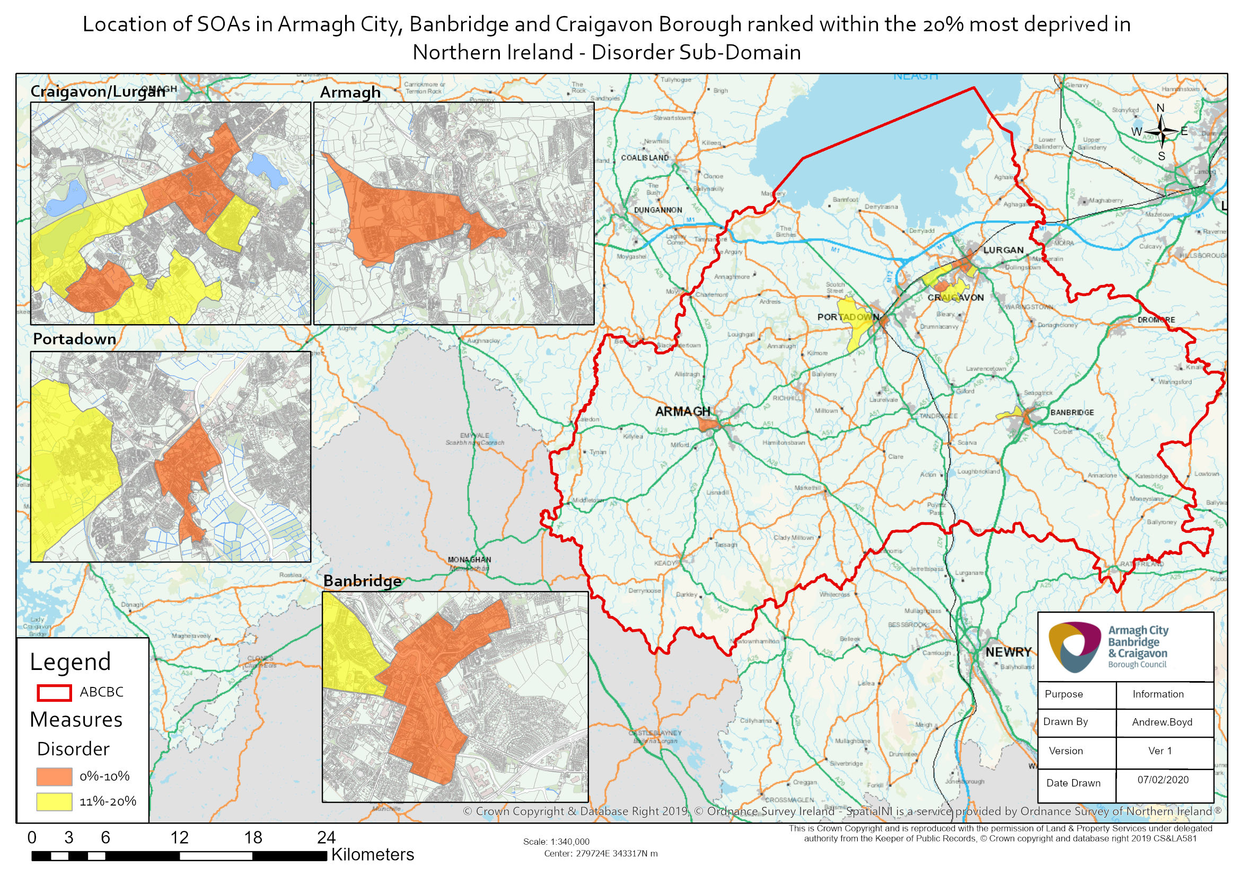

The first indicator in the Disorder Sub-Domain is the rate of deliberate primary and secondary fires.
When the 100 most deprived SOAs in Northern Ireland according to the rate of deliberate primary and secondary fires are selected, four of these can be found in Armagh City, Banbridge and Craigavon Borough.
The most deprived SOA in the borough according to this indicator is Drumgor 2, located in Craigavon. It is the 10th most deprived SOA in Northern Ireland according to the rate of deliberate primary and secondary fires.
Three of the top ten most deprived SOAs in the borough for this indicator are also in the borough’s top ten most deprived for the overall Multiple Deprivation Measure.
The SOAs in Armagh City, Banbridge and Craigavon falling within the 20% most deprived in Northern Ireland according to the rate of deliberate primary and secondary fires rank are listed below.
Eight of the ten SOAs in the borough falling within the 20% most deprived in Northern Ireland for this indicator are classified as urban, one is rural and one is mixed urban/rural.
Top ten in the borough
Rate of Deliberate Primary and Secondary Fires Rank (1=most deprived  890=least deprived) | Armagh City, Banbridge and Craigavon Borough SOA | Urban/Rural | Rate of Deliberate Primary and Secondary Fires  (per 1,000 population)
10 | Drumgor 2 | Urban | 16.3
20 | Woodville 1 | Urban | 14.5
55 | Drumgask 1 | Urban | 10.1
68 | Court 2 | Urban | 9.3
107 | Drumgor 1 | Urban | 7.1
111 | Derrynoose | Rural | 7.0
127 | Edenderry | Urban | 6.4
129 | Corcrain 1 | Urban | 6.3
174 | Ballybay | Mixed urban/rural | 5.1
178 | Court 1 | Urban | 5.0
Table 10: SOAs in Armagh City, Banbridge and Craigavon Borough which are within the 20% most deprived in Northern Ireland in terms of the rate of deliberate primary and secondary fires rank. Source: Northern Ireland Multiple Deprivation Measure 2017, NISRA.
Also appear in the top ten overall MDM for the borough

The second indicator in the Disorder Sub-Domain is the rate of Anti-Social Behaviour Incidents.
When the 100 most deprived SOAs in terms of the rate of Anti-Social Behaviour Incidents in Northern Ireland are selected, eight of these can be found in Armagh City, Banbridge and Craigavon Borough.
The most deprived SOA in the borough according to this indicator is The Cut, located in Banbridge. It is the 5th most deprived SOA in Northern Ireland for this indicator.
Seven of the top ten most deprived rate of Anti-Social Behaviour Incidents SOAs in the borough are also in the borough’s top ten most deprived for the overall Multiple Deprivation Measure.
The SOAs in Armagh City, Banbridge and Craigavon Borough falling within the 20% most deprived in Northern Ireland according to this indicator are listed below.
All 13 of the SOAs in the borough that are within the 20% most deprived in Northern Ireland for this indicator are classified as urban.
Top ten in the borough
Rate of Anti-Social Behaviour Incidents  Rank (1=most deprived  890=least deprived) | Armagh City, Banbridge and Craigavon Borough SOA | Urban/Rural | Rate of Anti-Social Behaviour Incidents  (per 1,000 population)
5 | The Cut | Urban | 121.3
8 | Court 1 | Urban | 114.4
22 | Annagh 2 | Urban | 88.8
34 | Drumgor 2 | Urban | 78.5
42 | Woodville 1 | Urban | 74.9
44 | Callan Bridge | Urban | 74.7
70 | Church | Urban | 60.1
95 | Court 2 | Urban | 52.0
105 | Edenderry | Urban | 50.6
107 | Corcrain 2 | Urban | 50.2
129 | Tavanagh | Urban | 46.6
142 | Downs | Urban | 44.4
163 | Drumgor 1 | Urban | 41.3
Table 11: SOAs in Armagh City, Banbridge and Craigavon Borough which are within the 20% most deprived in Northern Ireland in terms of the rate of Anti-Social Behaviour Incidents rank. Source: Northern Ireland Multiple Deprivation Measure 2017, NISRA.
Also appear in the top ten overall MDM for the borough

Further information on NIMDM 2017 can be found via the following link:
https://www.nisra.gov.uk/statistics/deprivation/northern-ireland-multiple-deprivation-measure-2017-nimdm2017

For further information about the Crime and Disorder Domain see page 26 of Technical Report and page 44 of Description of Indicators available at: https://www.nisra.gov.uk/publications/nimdm17-results

