Access to Services Domain
Access to Services Domain
The Access to Services Domain consists of three indicators and measures the extent to which people have poor physical and online access to key services as detailed below:
- Service-weighted fastest travel time by private transport
- Service-weighted fastest travel time by public transport
- Proportion of properties with broadband speed below 10Mb/s
The services to be included in the private transport travel time are:
- Accident and Emergency hospital
- GP premises
- Dentists
- Pharmacists
- Opticians
- Job Centre or Jobs and Benefits Office
- Post Office
- Supermarket / food store
- Primary Schools
- Post-Primary Schools
- Council Leisure Centre
- Libraries
- Day nurseries and Crèches
- Financial services
- Large service centres
- Other general services: Restaurants, fast-food outlets, pubs, filling stations, and health and beauty establishments
Public transport time will include the same services as the private transport with the exception of schools, A&Es and petrol stations: the public transport model does not include bespoke school bus routes and time tables, and it was postulated that for emergency treatment, people would not rely on public transport.
When the top 100 most deprived Super Output Areas (SOAs) in terms of the Access to Services Domain in Northern Ireland are selected, nine of these can be found in Armagh City, Banbridge and Craigavon Borough.
The most deprived SOA in the borough according to the Access to Services Domain is Bannside, located just outside Banbridge. It is the 18th most deprived SOA in Northern Ireland in terms of access to services.
None of the top ten most deprived access to services SOAs in the borough are in the borough’s top ten most deprived for the overall Multiple Deprivation Measure (MDM) which combines the seven deprivation domains (allowing areas to be ranked based on multiple types of deprivation).
The SOAs in Armagh City, Banbridge and Craigavon Borough falling within the 20% most deprived in Northern Ireland for access to services are listed below.
Top ten in the borough
Access to Services Domain Rank (1=most deprived  890=least deprived) | Armagh City, Banbridge and Craigavon Borough SOA | Urban/Rural
18 | Bannside | Rural
33 | Katesbridge | Rural
54 | Derrynoose | Rural
64 | Gransha | Rural
73 | Derrytrasna 2 | Rural
89 | Killylea | Rural
96 | The Birches 2 | Rural
98 | Quilly | Rural
100 | Carrigatuke | Rural
101 | Poyntz Pass | Rural
102 | Ballymartrim | Rural
110 | Hockley | Rural
113 | Killeen | Rural
125 | Hamiltonsbawn 1 | Rural
127 | Donaghcloney 2 | Rural
130 | The Birches 1 | Rural
135 | Charlemont | Rural
137 | Loughgall | Rural
156 | Hamiltonsbawn 2 | Rural
166 | Milford | Rural
Table 1: SOAs in Armagh City, Banbridge and Craigavon Borough which are within the 20% most deprived in Northern Ireland according to the Access to Services Domain. Source: Northern Ireland Multiple Deprivation Measure 2017, NISRA.
Also appear in the top ten overall MDM for the borough

A total of 20 SOAs in the borough are within the 20% most deprived in Northern Ireland overall according to the Access to Services Domain. All 20 of these SOAs are classified as rural. The locations of these SOAs in the borough are shown below, split by those that fall into the top 10% most deprived in Northern Ireland for access to services and those that are within the 11%-20% most deprived.

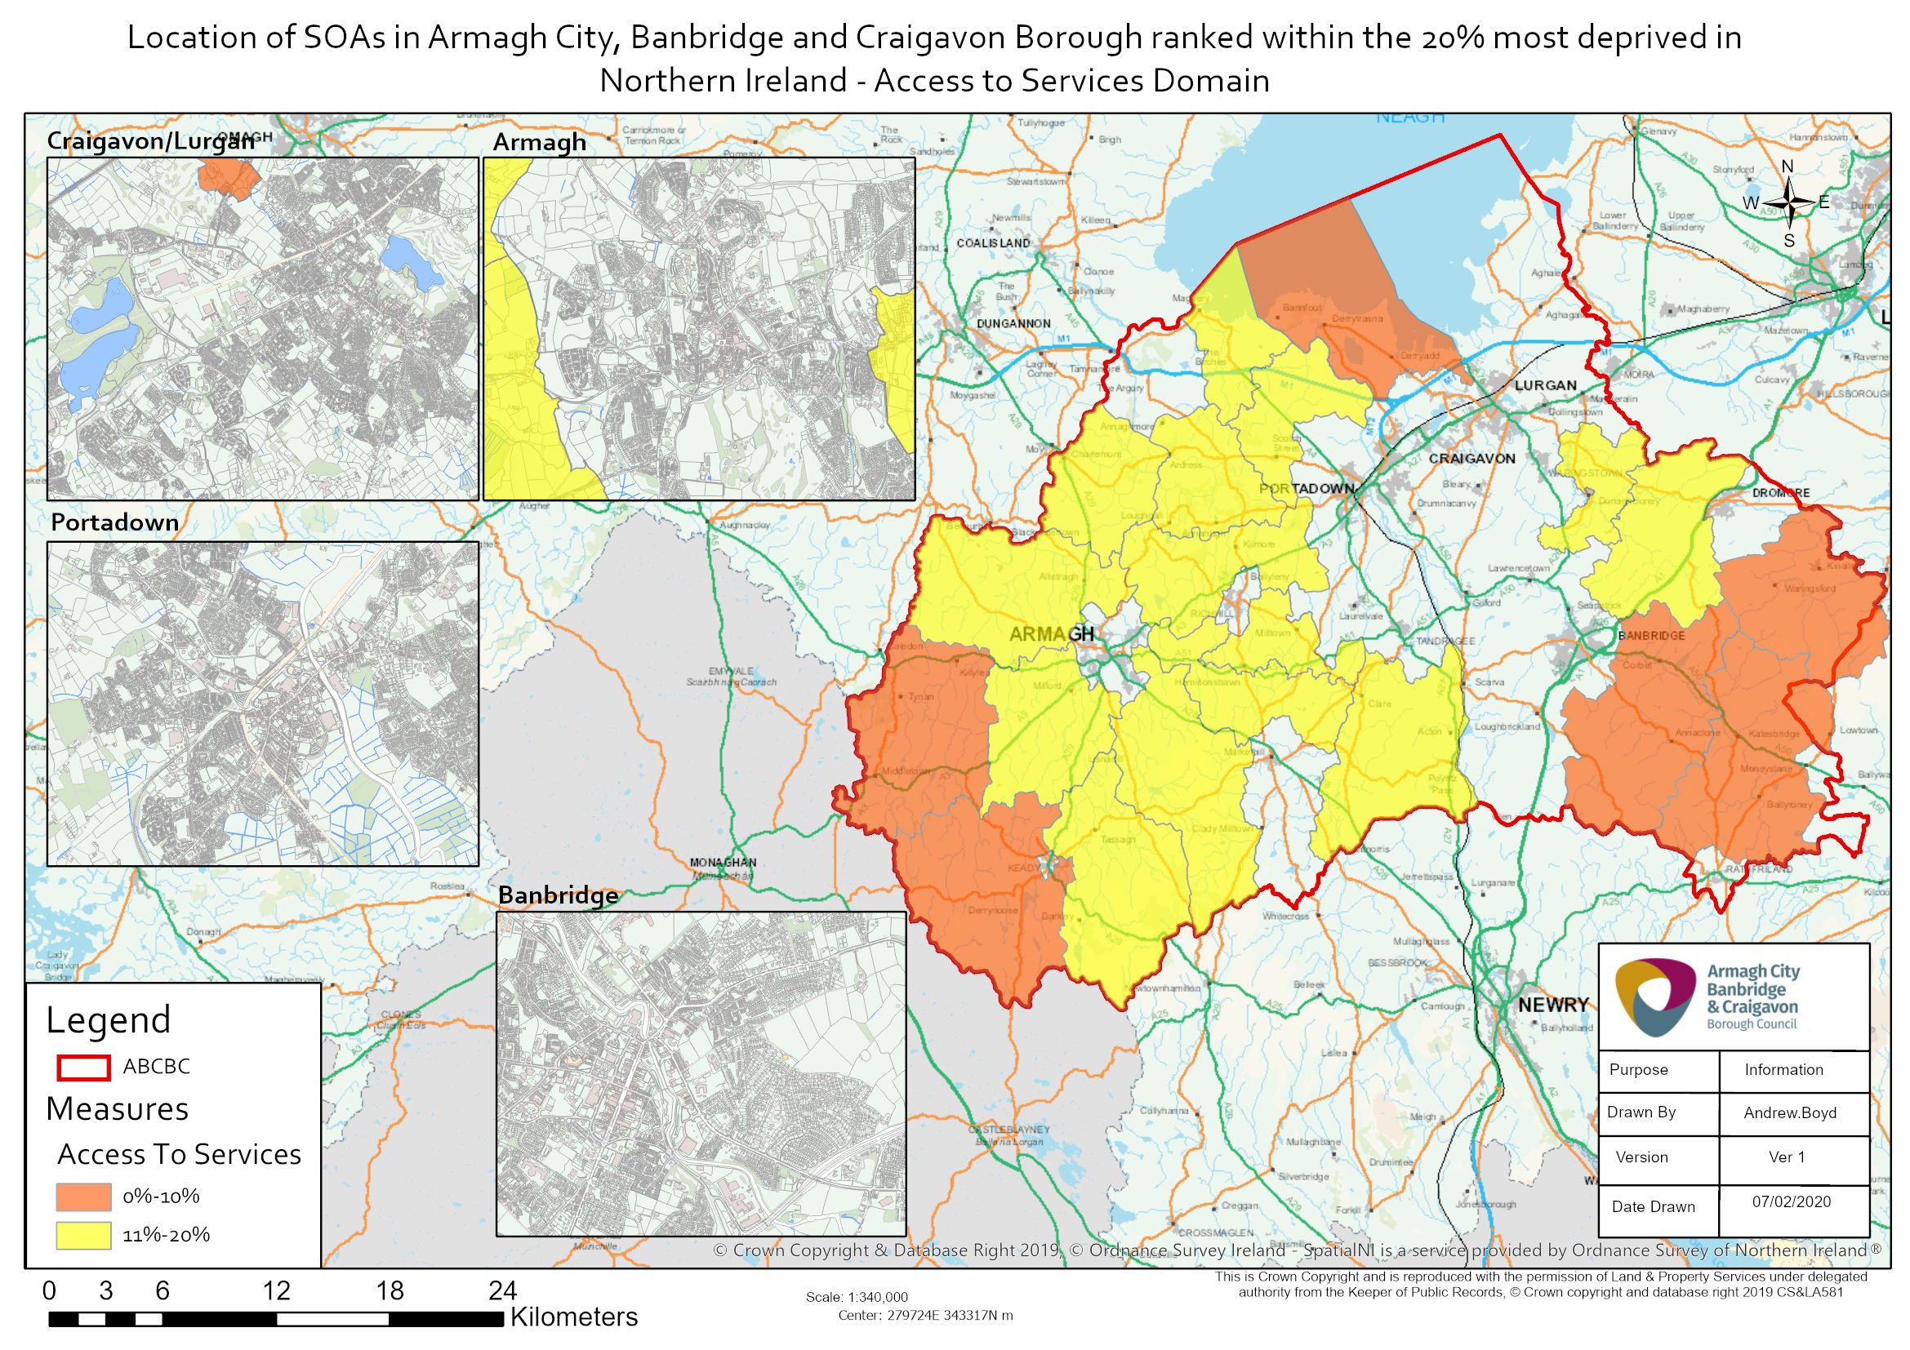

The first indicator in the Access to Services Domain is the service-weighted fastest travel time by private transport.
When the 100 most deprived SOAs according to this indicator in Northern Ireland are selected, eleven of these can be found in Armagh City, Banbridge and Craigavon Borough. The most deprived SOA in the borough in terms of the service-weighted fastest travel time by private transport is The Birches 2, located near Maghery. It is the 19th most deprived SOA in Northern Ireland for this indicator.
None of the top ten most deprived SOAs in the borough for service-weighted fastest travel time by private transport appear in the borough’s top ten most deprived for the overall Multiple Deprivation Measure. The SOAs in Armagh City, Banbridge and Craigavon Borough falling within the 20% most deprived in Northern Ireland according to this indicator are listed below.
Twenty of the 21 SOAs in the borough falling within the 20% most deprived in Northern Ireland for this indicator are rural, with Aghagallon 2, located outside Lurgan, classified as mixed urban/rural.
Top ten in the borough
Service-Weighted Fastest Travel Time by Private Transport Rank (1=most deprived  890=least deprived) | Armagh City, Banbridge and Craigavon Borough SOA | Urban/Rural
19 | The Birches 2 | Rural
38 | Killylea | Rural
42 | Gransha | Rural
43 | Katesbridge | Rural
56 | Derrytrasna 2 | Rural
61 | Loughgall | Rural
67 | Derrynoose | Rural
70 | Ballymartrim | Rural
96 | Carrigatuke | Rural
98 | The Birches 1 | Rural
100 | Bannside | Rural
112 | Donaghcloney 2 | Rural
115 | Aghagallon 2 | Mixed urban/rural
125 | Killeen | Rural
129 | Poyntz Pass | Rural
143 | Donaghcloney 1 | Rural
145 | Hamiltonsbawn 1 | Rural
148 | Hamiltonsbawn 2 | Rural
156 | Charlemont | Rural
164 | Aghagallon 1 | Rural
165 | Milford | Rural
Table 2: SOAs in Armagh City, Banbridge and Craigavon Borough which are within the 20% most deprived in Northern Ireland in terms of the service-weighted fastest travel time by private transport rank. Source: Northern Ireland Multiple Deprivation Measure 2017, NISRA.
Also appear in the top ten overall MDM for the borough

The second indicator in the Access to Services Domain is the service-weighted fastest travel time by public transport.
When the 100 most deprived SOAs in terms of service-weighted fastest travel time by public transport in Northern Ireland are selected, ten of these can be found in Armagh City, Banbridge and Craigavon Borough.
The most deprived SOA in the borough according to this indicator is Gransha, located south-east of Dromore. It is the 32nd most deprived SOA in Northern Ireland for this indicator.
There is no overlap between the borough’s top ten most deprived for this indicator and the borough’s top ten most deprived for the overall Multiple Deprivation Measure.
The SOAs in Armagh City, Banbridge and Craigavon Borough falling within the 20% most deprived in Northern Ireland according to the service-weighted fastest travel time by public transport are listed below.
Eighteen of the 19 SOAs in the borough that are within the 20% most deprived in Northern Ireland for this indicator are classified as rural while one, Dromore South 2, is mixed urban/rural.
Top ten in the borough
Service-Weighted Fastest Travel Time by Public Transport Rank (1=most deprived  890=least deprived) | Armagh City, Banbridge and Craigavon Borough SOA | Urban/Rural
32 | Gransha | Rural
34 | Quilly | Rural
41 | Derrynoose | Rural
53 | Katesbridge | Rural
57 | Bannside | Rural
60 | Donaghcloney 2 | Rural
70 | The Birches 1 | Rural
79 | Killeen | Rural
84 | Carrigatuke | Rural
86 | Killylea | Rural
113 | Hamiltonsbawn 1 | Rural
116 | Poyntz Pass | Rural
133 | The Birches 2 | Rural
155 | Milford | Rural
157 | Dromore South 2 | Mixed urban/rural
161 | Hamiltonsbawn 2 | Rural
167 | Hockley | Rural
170 | Loughgall | Rural
174 | Charlemont | Rural
Table 3: SOAs in Armagh City, Banbridge and Craigavon Borough which are within the 20% most deprived in Northern Ireland in terms of the service-weighted fastest travel time by public transport rank. Source: Northern Ireland Multiple Deprivation Measure 2017, NISRA.
Also appear in the top ten overall MDM for the borough
The third indicator in the Access to Services Domain is the proportion of properties with broadband speed below 10Mb/s.
When the 100 most deprived SOAs according to this indicator in Northern Ireland are selected, eleven of these can be found in Armagh City, Banbridge and Craigavon Borough. The most deprived SOA in the borough for this indicator is Bannside, located outside Banbridge, which is the 2nd most deprived SOA in Northern Ireland for this indicator.
None of the top ten most deprived SOAs in the borough for proportion of properties with broadband speed below 10Mb/s appear in the borough’s top ten most deprived for the overall Multiple Deprivation Measure. All 19 of the SOAs in the borough falling within the 20% most deprived in Northern Ireland for this indicator, listed below, are rural.
Top ten in the borough
Proportion of Properties with Broadband Speed Below 10Mb/s Rank (1=most deprived  890=least deprived) | Armagh City, Banbridge and Craigavon Borough SOA | Urban/Rural | Proportion of Properties with Broadband Speed Below 10Mb/s  (%)
2 | Bannside | Rural | 79.2%
25 | Hockley | Rural | 53.4%
30 | Derrytrasna 2 | Rural | 52.0%
33 | Katesbridge | Rural | 51.1%
51 | Poyntz Pass | Rural | 45.1%
61 | Ballymartrim | Rural | 41.1%
72 | Derrynoose | Rural | 39.5%
76 | Charlemont | Rural | 38.3%
91 | Hamiltonsbawn 1 | Rural | 35.8%
94 | Carrigatuke | Rural | 35.5%
99 | Quilly | Rural | 33.4%
108 | Killeen | Rural | 30.4%
126 | Hamiltonsbawn 2 | Rural | 27.9%
136 | Lawrencetown | Rural | 26.3%
137 | Milford | Rural | 26.1%
143 | Killylea | Rural | 25.0%
158 | Loughbrickland | Rural | 22.5%
167 | Aghagallon 1 | Rural | 21.0%
178 | Gransha | Rural | 19.5%
Table 4: SOAs in Armagh City, Banbridge and Craigavon Borough which are within the 20% most deprived in Northern Ireland in terms of the proportion of properties with broadband speed below 10Mb/s rank. Source: Northern Ireland Multiple Deprivation Measure 2017, NISRA.
Also appear in the top ten overall MDM for the borough

Further information on NIMDM 2017 can be found via the following link:
https://www.nisra.gov.uk/statistics/deprivation/northern-ireland-multiple-deprivation-measure-2017-nimdm2017

For further information about the Access to Services Domain see page 19 of Technical Report and page 30 of Description of Indicators available at: https://www.nisra.gov.uk/publications/nimdm17-results
https://www.nisra.gov.uk/sites/nisra.gov.uk/files/publications/NIMDM_2010_description_of_indicators_domains_and_the_multiple_deprivation_measure.pdf#page=60

