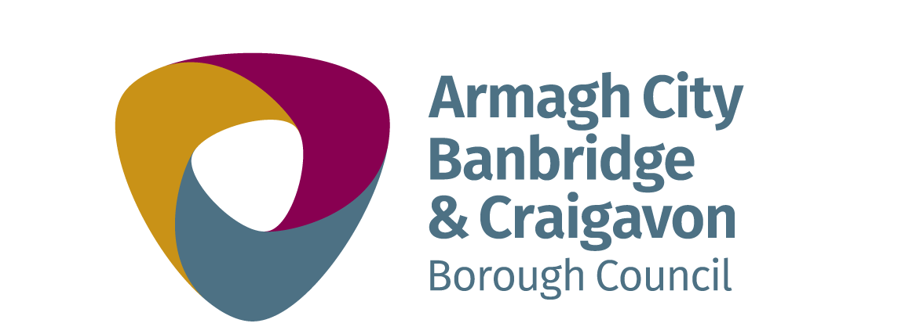
JOB DESCRIPTION

Post: Maintenance Technician

Directorate: People

Department: Health and Recreation

Location: South Lake Leisure Centre

Reports To: Operations Manager/Duty Manager

Salary: Scale 6

Hours: 37 hours per week.

Duration: Permanent

All employees are expected to model the Customer Care behaviours of “Serve Passionately, Engage Positively and Deliver Consistently.”

JOB PURPOSE:

Committing to the one-team ethos, you will be flexible and collaborative and you will actively support all colleagues and other activities necessary to deliver the service objectives.

As a Maintenance Technician, you will be responsible for the proper operation and maintenance of all plant, technical systems and general building maintenance to ensure that customers have a high-quality, safe and enjoyable experience.
1The P4

main Duties and Responsibilities:

- Responsible for the day-to-day operation, record keeping, regulation, servicing and maintenance of the mechanical and electrical machinery and fittings within the Centre, report any major faults and arrange for them to be actioned.

- Carry out the full range of pool/spa plant and water hygiene operations to ensure that all water quality is maintained to the required pool water quality standards and regulations e.g. Legionella and provide guidance on these.

- Work with SLLC General Manager and Estates & Assets team to develop and implement planned maintenance schedules for all mechanical, electrical and plumbing services throughout the Centre.

- Monitor and regulate air temperatures in all areas of the Centre and record all tests carried out.

- Monitor and control energy and water functions within the Centre to achieve efficiencies and prepare reports, as required.

- Perform daily, weekly, monthly inspections in relation to health and safety and fire safety and take appropriate action to ensure compliance with regulations.

- Carry out and implement risk assessments for all maintenance activities and ensure health and safety standards and industry standards are maintained within the remit of the post.

- Work with relevant departments to ensure compliance with ISO 14001 and other quality awards.

- Order chemicals, consumables and any other items required for on-going maintenance and control all stock held.

- Provide training for those employees performing pool water system tasks.

- Respond to out-of-hours emergencies, as requested.

- Liaise with other Council departments, external contractors and suppliers.

- Be flexible and collaborative and actively support all colleagues and other activities or processes which impact on the performance of the Centre.

