

**Leisure Transformation Programme**

**Staff Engagement Workshops**

**November 2019**

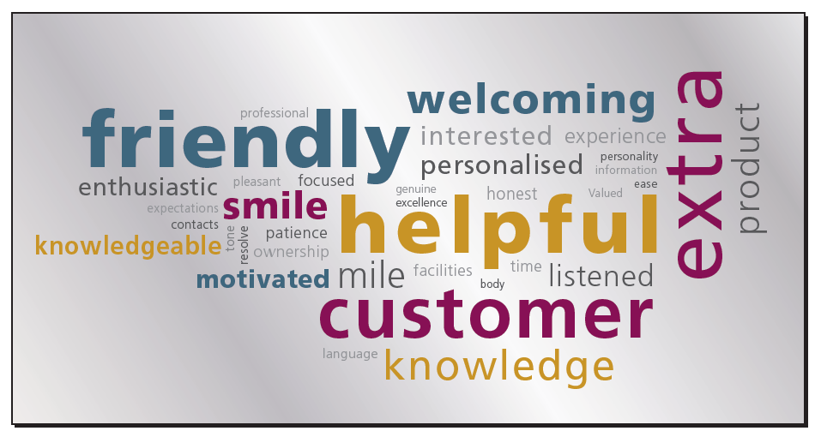



**Staff Engagement Workshops**

As part of the ongoing Leisure Transformation Programme, six staff engagement workshops where held during November 2019.

All members of staff and Trade Union representatives were invited along to the meetings to work through the following agenda:

1. What you’ve told us so far.
2. Recent Engagement.
3. Stakeholders.
4. Work in progress.
5. Commitments.
6. Draft opening hours.
7. Draft structures.
8. New ways of working.
9. Questions and comments.

Copy of the presentation given on the day can be found on the following link : <https://www.armaghbanbridgecraigavon.gov.uk/leisureupdates/>



**Question and Answers raised:**

* **What is the role of the Leisure Champions**:

They will act as a conduit for information being cascasded down to staff or if a

staff member has a question they can raise it through a leisure champion.

If any other members of staff are interested in becoming a Champion or has a query/question, please contact Stephen Tully - stephen.tully@ armaghbanbrigecraigavon.gov.uk or Joanne Grattan – joanne.grattan@ armaghbanbrigecraigavon.gov.uk

* **Customers now want to know what the prices will be for the new centre:**

This information will hopefully be available in the New Year and will be communicated to the public/customers as soon as possible.

* **There have been issues with staff leaving and a long delay filling posts will this be the same moving forward to SLLC**.

The support services e.g. Business Support, IT, Finance, HR will be signing up to a ‘Service Level Agreement, S.L.A’ this will set out the service that they will be providing/offering; to help improve response times.

We need our support services to buy in to the S.L.A. to help us deliver an excellent service that Council has asked us to commit to.

* **Specification for gym equipment:**

It was agreed that the specification would be added on the the new website for staff information: <https://www.armaghbanbridgecraigavon.gov.uk/leisureupdates/>

* **Equipment purchase**

Staff raised concerns that they were not consulted on the gym equipment that has been purchased and it was asked that in future staff be consulted as they will be working with the equipment/customers.

Staff stated that they need the right tools/equipment to deliver a service that customers need and expect.

Staff were consulted in the design of this specification however it is clear that this consultation/communication did not filter to all staff in all centres. The successful supplier, when appointed, will work with each centre.

It was agreed that the gym specification would be added to the leisure matters page.

* **Is there a possibiliy to move to another job, e.g. move from indoor to outdoor.**

Staffing will be mapped out/scoped out to look at the people we have, who is moving to SLLC, who would like to leave and the posts that need filled etc…

All requests will be considered with the individual concerned.

* **Will pricing be the same across the A.B.C. area.**

All prices are being harmonised across all leisure facilities in the Borough. Whilst we are reviewing pricing, the overall objective is that pricing is as consistent as possible across the borough.

* **In the Craigavon Area, mental health is a real issue that needs to be tackled, can we do something to help.**

Through the F.E.R.N. stategy that is being abopted in our gym facilites we will be asking staff to make links with the local community. They will then go out to the community to work with them to tackle social issues that they may be experiencing .

* **J.D.’s – pay scales will this be taken into consideration**

When jobs are evaulated pay will be considered.

Moving forward all indoor leisure staff doing the same job will have the same J.D and pay scale no matter where they work.

**Will we receive back pay to when the 3 Councils amalagmated in 2015;** Staff will not be receiving back pay with respect to this harmonisation of terms and conditions process.

* **Redundancy scheme**

Council will be looking at a redundancy scheme for the Council as a whole not just for indoor leisure.

It is recognised that there may be some staff who may not want to take up employment in SLLC; this this information will be available for staff in February 2020 so that they have time to consider their individual situation/requirements.

* **Staff issues**

As the three centres are closing in the Craigavon area this means that staff are in a redundancy situation.

This is a complex area of work and HR and Union representatives will consider this.

There will be staffing issues that need to be considered which include:

* + - Transfer for staff from one post to another.
    - Redundancy requests from staff
    - Find suitable alternative employment for those who do not want to work in SLLC.
    - Some staff may have to re-apply for a post (dependant on T&C of employment).
    - Casuals.
    - Staff on temporary contacts
    - Staff on secondment.
* **At the moment some staff members are not obligated to work on Sundays (those in Cascades/Waves) with the new opening hours for SLLC how will this affect those staff**

This will be worked through with staff when discussions are taking place regarding J.D’s, rotas and shift pattern requirements.

We have a number of policies that rest in statute these will be considered; however, the needs of the services will come first. Those staff who have special provisions e.g. family friendly hours etc….these issues will be discussed and considered on an individual basis.

* **Is the café/spa/play area being kept in house**

Yes, the current position is that each of these services will be run in house; certain financial criteria will need to be achieved.

* **Will the pool plant operators sit in estates or leisure**

This decision has not been agreed yet.

* **Will there be more class options for under 16’s**

There will be a greater offering for structure exercise for under 16’s**.**

* **Will there by opportunity for the receptionists to go and shadow staff in Banbridge to see how the legend management system works**

A legend co-ordinator has been appointed and this will be part of their duties; there will be a structured programme of training and an agreement made regarding date that the system will be phased in to the other facilities.

* **Can the electricians/plant men get over to see the new SLLC facility as it would be worthwhile for them to see the plant room etc….**

This will be organised and a date circulated.

* **Timescale for closure of building in Craigavon – how will this work**

Staff will be involved in deciding how this will work best for them and our customers.

We need to consider what training time is required for staff moving to the new building and how we minimise disruption for our customers.

* **If staff avail of the redundancy scheme will they be expected to stay until the new building is open** ?

We need a commitment from those staff availing of redundancy to stay until the new building opens; this will help with the transition, transfer of staff, and help provide continuity of service to the public.

* **Will SLLC have a soft opening phase**

We hope to have soft opening of the building in different parts e.g. the leisure water, gym, spa, to test the building in a phased way.

* Concern was raised over the number of car parking spaces at the new SLLC build and the fact if it was very busy would the staff be able to park at the Civic Centre.
* **Staff raised concern over the earlier opening hours for B/B and Armagh**

It was suggested that if the opening hours move to 6am there would need to be a lot of marketing done for this to unsure that people will attend. The question was asked what would happen if customers did come in to use the building at 6am – this issue would be reviewed after a period of time and if required the opening times would be adjusted.

* **If the opening hours are changing in the Banbridge and Armagh area will this affect our shift pattern.**

Yes, the shift patterns will change to accommodate the new opening hours; this will be discussed with staff when looking at the new J.D’s.

Each person will need consider what the impact this we will have for them; it is planned that, by Christmas, a draft rota will be available for staff to have a look at and consider this issue.

* **If ‘Legend’ is being installed across the A.B.C., area will the memberships be linked.**

All centres will be linked to the one database of customers, and staff will be able to see what membership each/every customer has.

All existing customers with a DD will be moved over to the legend system.

* **How will the Legend system work with swimming lessons**

The legend system will allow parents to pay for their children’s swimming lessons by DD. We are also investigating other swim lesson software which could work in conjunction with legend.

The issue of how our swimming teachers will record a child’s progress through the lessons is being considered; however, it is thought that the swimming teachers will have a PDA/Tablet of some sort on poolside to record progress (this means that a parent can go on line to track progress).

One issue was raised regarding using an electronic device on poolside from a safeguarding point of view: it was agreed that a form of words would be formatted to address this issue with parents**.**

* **Will we get more staff to cope with the extended opening hours.**

This will have be considered when the scoping exercise is taking place regarding staffing levels.

* **Will staff have the opportunity to train in other areas e.g. wet to dry, indoor/outdoor**

There is a training pathway that has been established for staff; more details of this will follow.

* **If SLLC needed more staff to work can management ring over to another site to ask for an available staff and vis a versa**

Both HR/unions are looking at new J.D’s to make sure that staff have the ability to move from place to place**.**

* **Casual workers have always been employed to work in only one site, can we change this to provide easier movement and ability to cover when required**

When the J.D’s are being considered this issue will be discussed.

* **When staff are applying for training, will there be a contract for staff to sign to say that they will deliver on the training provided or pay back the training fee paid by Council.**

Yes, part of the new training pathway will be that all staff members will sign a contract to say that they have an obligation to deliver on the training provided or they will pay back the training fee.

* **Concern was raised regarding the capability/flexibility of the legend booking system to take the wide range of bookings at the Watersports Centre**

It was agreed that the legend co-ordinator would meet with the relevant watersports staff to discuss this matter as the system used at the moment is very successfully in this facility at the moment with 90% of payment/booking being made on line.

* **Will the receptionists at SLLC be able to cross sell e.g. they not only sell indoor products but also watersports**

Yes, all reception/customer advisor staff will be knowledgeable enough and have the capability to cross sell products.

* **Concern was raised regarding trying to meet customer expectations as we have a new 35 million pound building with a 50 year old slipway – this needs to be addressed as outdoor needs to look at good as indoor, they need to match.**

This issue is being progressed through Estates; staff will be involved in any decision or discussions regarding the slipway.

* It was suggested by staff that we need a dedicated marketing team to ensure that the new building is marketed correctly to ensure that we get people through the door. We need a one team approach in the new building and staff need to have ability to change prices and products to make our business pro-active rather that re-active.
* **Will there be signage on the building indicating where the Watersport Centre is?**

Andrew Stevenson will be contacted regarding this issue.

* Money needs to be secured to up-grade boats and Aqua-Park for the lake.
* Consideration needs to be given to the products that we are offering at SLLC; so that there are packages that include activities for indoor and outdoor.
* We need joined up thinking for indoor/outdoor to work together regarding investment.

**Actions:**

* Upload the presentation and Q/A from the staff engagement sessions to: <https://www.armaghbanbridgecraigavon.gov.uk/leisureupdates/> and share this link.
* Upload the results of the internal staff survey that ran in June 2019 to:

<https://www.armaghbanbridgecraigavon.gov.uk/leisureupdates/>

* Next internal staff survey will run in November 2019 – notice to be send out to staff.
* Ensure that management provide paper copies of the leisure matters newsletter for staff.
* Ensure that will all information being produced for SLLC that the Watersports Centre is mentioned.

**Reminder of the timescales for decisions being made :**

* **Consultation on** **SLLC & IL structures** – by end November
* **Principles of shift patterns/ rotas** – consultation starts end November
* **Consultation on** **JDs** – by mid-December
* **Opening hours** – to be agreed by Project Board December
* **Shift patterns/ rotas** – Information to staff Christmas Holidays
* **Pricing policy** – to be agreed by Project Board December
* **Migration plan** – to be agreed by Project Board January
* **Severance package** – agreed by Council by end January
* **Small Group or Individual Meetings** if requested