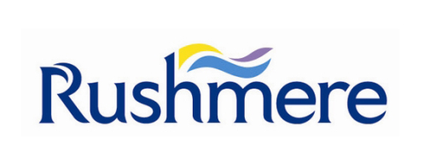
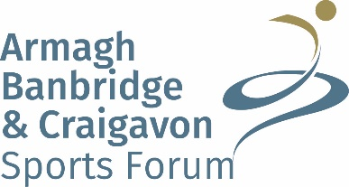

Armagh, Banbridge and Craigavon Senior Sports Awards
for Achievements from January – December 2018
The awards ceremony will be held on Friday 1st March 2019 in Craigavon Civic & Conference Centre
Nominations will only be accepted on the official nomination form and must be completed in full
Closing date for nominations is Friday 4 January 2019 at 12noon
All nominees must reside in the Armagh City, Banbridge and Craigavon Borough Council area, must be over 18 at the time of competition in 2018 and involved in a sport whose Governing Body is recognised by Sport NI, Sport Ireland or UK Sport. Junior Sport Awards 2018 nominees are ineligible.

Nominee
Sport |  |  |  |  | Club
Address
Postcode |  |  |  | Tel No
DOB |  |  |  | Email
AWARD CATEGORIES
Each nominee can only be nominated in one category
*ABC Sports Forum reserve the right to move nominees to other categories or create new categories as required
Sports Person with a Disability  Please note that depending on the nominations received this category may be further subdivided. |  |  | Sportswoman  Sportsman |  |  |  |  |  | Coach *  Team |  | Service to Sport*  Volunteer*  Club of the Year *  For the above 3 categories please record information on a separate page (not to be more than 500 words) and attach
*Coach: this award recognises the achievement of a coach in getting more people engaging and/or excelling in local sport as well as working with athletes at a high level e.g. club/athlete success/recognition at national/international level, high quality coaching that’s player centred. Nominees must be coaching over 18’s.

*Service to Sport: this award recognises the contribution an individual has made to sport over a significant period of time. Please be sure to state the number of years’ service, which must be at least 25 years. Only 1 nominee per club will be accepted and previous winners are ineligible.

* Volunteer: this award recognises the invaluable contribution our volunteers make. Please note only to record volunteering details for the time period stated ie Jan – Dec 2018. Only 1 nominee per club will be accepted.

*Club of the Year: this award is for a Club who have had a successful year which may include facility development, coach development, securing grant aid, achieving clubmark accreditation, hosting of major events, success with individuals/teams in competitions or have been innovative by developing something new at the club ie a new section within the club or a new programme.

Nominated By
Address
(inc Postcode)
Telephone No |  |  |  |  |  | Email
Achievements from January – December 2018
Please list the HIGHEST achievements in priority order giving as much detail as possible for the above time period only.
(Details to include: who you were representing; journey to the achievement i.e. who you defeated; scores; number of competitors in your section; national rankings; venue etc.)

1. ACHIEVEMENT |  | DATE

2. ACHIEVEMENT |  | DATE

3. ACHIEVEMENT |  | DATE

Any other relevant comments: ________________________________________________________________________

__________________________________________________________________________________________________

__________________________________________________________________________________________________

I confirm that the information listed above is a true and accurate record of the nominee’s achievements from January –December 2018.

Signed: ______________________________________________________ Date: ________________________

Completed forms should be sent to: Anne Benson, Senior Sports Awards, Lough Neagh Discovery Centre, Oxford Island, Lurgan, BT66 6NJ or email anne.benson@armaghbanbridgecraigavon.gov.uk

Please also email a photo of the nominee and any video footage to laural.ohagan@armaghbanbridgecraigavon.gov.uk

The closing date for nominations is Friday 4 January 2019 @ 12noon

Please advise if you require receipt of your application
PLEASE INFORM THE NOMINEE OF THIS NOMINATION

