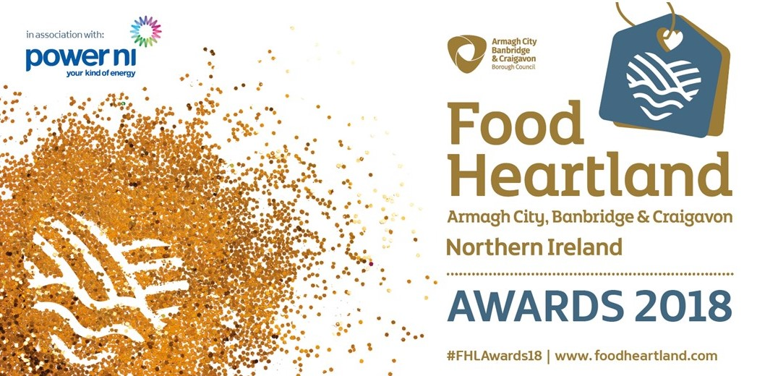
Best Marketing Campaign Award
Entry Form

To enter the Best Marketing Campaign Award at the Food Heartland Awards 2018, please complete all sections of this entry form and submit by email by 5.00pm on Friday 6th July 2018.

Company Name

Company Address

Postcode

Telephone Number

Name of person who can be contacted regarding this entry

Email Address

Web Address

Year Established

Number of Employees

Approx. Turnover

Summary of Business Activity
(in no more than 50 words)

Best Marketing Campaign Award

This award will recognise a food and drink business that can demonstrate a creative, innovative and effective marketing initiative that has inspired their target market and increased sales, profit, and company profile. The judging panel will be looking for effective use of the chosen marketing initiative or campaign to promote the business. Applications will be judged on:

- Outline of the problem that the marketing initiative sought to solve with key objectives and targets of the marketing initiative or campaign;
- Evidence of the market research and approach of the initiative; and
- The return on investment, the outcome and outputs of the initiative.

Please outline how your company meets the criteria detailed for this award category (see above). Please provide detailed information (e.g. statistics, evidence, amounts) to demonstrate why you/the nominee should be considered for this award. Remember that a brief answer will not make your application stand out – maximum 1000 words.

I can confirm that the information given above to the best of my knowledge is truthful and accurate.

Submitted by
Date
Position in Company

Entry Rules and Information

- All entries must be submitted to ND Events by 5:00 pm on Friday 6th July 2018 by email to foodheartland@ndevents.co.uk
- Any private sector organisation within the food and drink industry operating in the Armagh City, Banbridge & Craigavon Borough Council area is eligible to enter the awards
- Entering more than one category is allowed, but each entry must be submitted on separate entry forms (please note each award category has individual criteria)
- The judges, organisers and sponsors cannot accept responsibility for the validity of claims made by entrants
- If appropriate, the judges may decide to submit your nomination for an additional category
- Winners will be announced at the Awards Gala Dinner on Wednesday 12th September - no results will be announced before this date
- Shortlisting will take place by Monday 23rd July 2018 and shortlisted applicants will be contacted if successful
- Shortlisted applicants for the following award categories; Best New Start, Best Business Growth, Best Export, Best Marketing Initiative, Innovation Award, Sustainability Award, Best Use of a PGI Product in a Packaged Food or Drink Product and Rising Star Award will be required to attend a 15-minute interview/presentation on Tuesday 14th August 2018. Unfortunately, we are not able to reschedule this date and by entering the awards you are agreeing that you will be available for interview on this date. Any shortlisted applicants who are unable to attend the interview will automatically scored a zero in this stage of the competition.
- Shortlisted applicants for the following award categories; Best Licensed Eating Establishment, Best Non-Licensed Eating Establishment, Best Independent Retail Food Business – a mystery shopping visit will be conducted on the premise and the results of this activity will decide the winners of each category.
- Shortlisted applicants for the Best Dish Using Local Ingredients will have a visit from the judges to taste your proposed dish within your business premises. This visit will take place on Wednesday 15th August 2018.
- Award winners may state in advertising/promotional activities that they are winners, but must include the category and the year in which the award was won
- Entry to the Food Heartland Awards implies acceptance of the rules and conditions
- Data Protection - The information you provide on your entry form(s) will be held on a database to allow processing of your entry. Your details may be used to inform you of other events and services relating to the Food Heartland Awards as well as development opportunities for local businesses that are supported by Armagh City, Banbridge & Craigavon Borough Council. Your contact details will be kept for a maximum of two years when we will contact you to notify you of the Food Heartland Awards 2020.

The Gala Awards Event

The presentation of the Food Heartland Awards 2018 will take place at The Palace Demesne, Armagh on Wednesday 12th September.

The gala awards dinner is a unique event designed to combine the excitement of a glittering black-tie awards ceremony with an invaluable opportunity to strengthen your relationships with business leaders and entrepreneurs with the food and drink sector in the Armagh City, Banbridge & Craigavon Borough Council areas. Tickets are priced at £55 + VAT and include a four-course dinner, entertainment and the awards presentation. To reserve your tickets or for any queries please contact ND Events on 028 92 633232 or foodheartland@ndevents.co.uk

