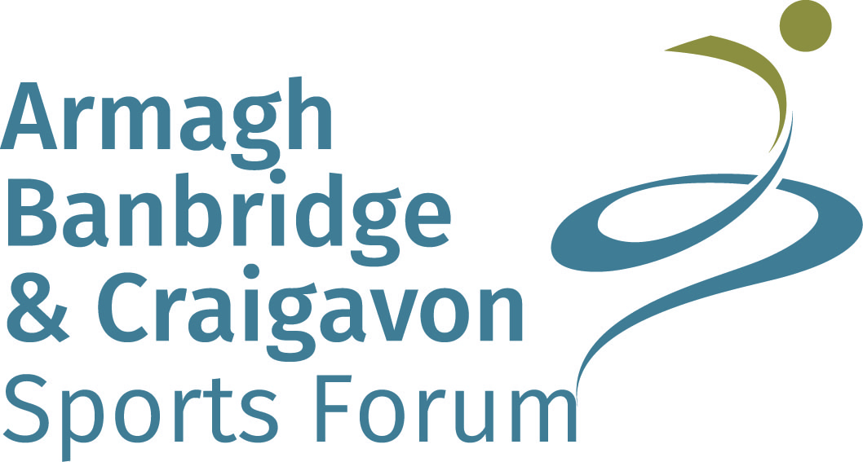



Armagh, Banbridge and Craigavon Junior Sports Awards 2018
The awards ceremony will be held on Friday 28th September 2018 in Craigavon Civic and Conference Centre
Nominations will only be accepted on the official nomination form and must be completed in full
Closing date for nominations is Friday 22nd June 2018 at 12noon
All nominees must reside in the Armagh City, Banbridge and Craigavon Borough Council area, be aged 18 years & under at the time of achievement during the period July 2017 – June 2018 and be involved in a sport whose Governing Body is recognised by Sport NI, Sport Ireland or UK Sport

Nominated Individual/Team
Sport |  |  |  |  | Club
Address
Postcode |  |  |  |  |  | Tel No
DOB |  |  |  |  |  | Email
AWARD CATEGORIES
Each nominee can only be nominated in one category
*ABC Sports Forum reserve the right to move nominees to other categories or create new categories as required

Junior Male  Junior Female  Junior School Team  Junior Club Team  Junior – Aged 10 -14yrs at time of achievement |  |  | Youth Male  Youth Female  Youth School Team  Youth Club Team  Youth – Aged 15 -18yrs at time of achievement |  |  |  |  |  | School Coach  Club Coach  School/Club Coach – Coaches can be aged over 18 but must be coaching Junior/Youth Teams |  | Volunteer  Sports Person  With a Disability  Volunteer – Please record details of volunteering for July 17 – June 18 on a separate page (500 words max) and attach. Only 1 nominee per club/school will be accepted.  Sports Person with a Disability – Please note that depending on the nominations received this category may be further subdivided.
Nominated By
Address inc Postcode
Tel No |  |  |  |  |  |  |  |  | Email

Achievements from July 2017 – June 2018
Please list the 3 HIGHEST achievements giving a much detail as possible for the above time period only.
(Details to include: who you were representing; journey to the achievement i.e. who you defeated; scores; number of competitors; venue etc.)

ACHIEVEMENT |  | DATE

ACHIEVEMENT |  | DATE

ACHIEVEMENT |  | DATE

Any other relevant comments: ________________________________________________________________________

__________________________________________________________________________________________________

__________________________________________________________________________________________________

I confirm that the information listed above is a true and accurate record of the nominee’s achievements from July 2017 – June 2018. Armagh City, Banbridge and Craigavon Borough Council, which you are submitting this information to, is collecting this data in conjunction with Armagh, Banbridge and Craigavon (ABC) Sports Forum, for the purposes of the Junior Sports Awards. Personal data submitted will be retained securely and in line with Council’s Records Retention and Disposal Schedule. We will not disclose your personal data to other persons or organisations; however, we may have to disclose where law requires it.
Signed: ___________________________________________________ Date: ________________________

Completed forms should be sent to: Laura O’Hagan, Junior Sports Awards, Old Technical Building, 3 Downshire Road, Banbridge, Co. Down, BT32 3JY
Please also email a photo of the nominee and any video footage to laural.ohagan@armaghbanbridgecraigavon.gov.uk

The closing date for nominations is Friday 22nd June 2018 @ 12 noon

Please advise if you require receipt of your nomination
PLEASE INFORM THE NOMINEE OF THIS NOMINATION

