Connected
A Community Plan
for Armagh City Banbridge & Craigavon Borough
2017-2030

Establishing a Community and
Voluntary Sector Panel
Expression of Interest

Armagh City, Banbridge and Craigavon Borough Community Panel

Expression of Interest Pack

Armagh City, Banbridge and Craigavon Borough Community Planning Partnership are seeking expressions of interest from local Community, Voluntary and Social Enterprise Organisations across the Borough to apply for membership of the Community and Voluntary Sector Panel.
The purpose of the panel is to ensure that the Community and Voluntary Sector is actively involved in Community Planning.
An Expression of Interest Pack has been prepared and includes:
- Information on Community Planning
- Role and Purpose of Community and Voluntary Sector Panel
- Membership and Recruitment process
- Expression of Interest Form
To register your interest to join the Community and Voluntary Sector Panel you need to:
- Complete the attached Expression of Interest form – all sections.
- Complete an Equal Opportunities Monitoring form
- Provide the additional documentation that is requested.
- Return the form on or before Monday 30th April 2018 at 4:00 pm to Community Planning Team via email or post.
Please read this pack carefully If you have any questions or should you wish to receive the document in hard copy or an alternative format please contact Community Planning Team at the address, email or telephone number given below.
Email: communityplanning@armaghbanbridgecraigavon.gov.uk
Telephone: 028 40660644
In writing: Community Planning Department, Armagh City, Banbridge and Craigavon Borough Council, Old Technical Building, Downshire Road, Banbridge, BT32 3JY

Armagh City, Banbridge and Craigavon Borough Community and Voluntary Sector Panel

Ensuring community and voluntary sector participation in community planning

Background
Connected is the first community plan for the Armagh City, Banbridge and Craigavon Borough and was developed through a series of thematic workshops with attendees from council, statutory partners, community and voluntary sectors, business and local people in 2016. The plan was published in March 2017 and focusses on improving the social, economic and environmental well-being of the borough. The Community Plan can be viewed on the Council’s website here:
https://www.armaghbanbridgecraigavon.gov.uk/resident/community-planning/

The Council and the Community Planning Partners have specific duties outlined in the community planning legislation. To date the community planning process has been overseen by these thirteen partners named in the community planning legislation. In November 2017 an agreed governance structure was established with a Community Planning Strategic Partnership, which has strategic oversight of the process, and six Thematic Action Planning Teams reporting into the partnership. The Community Planning Partnership also agreed the formation of a Community and Voluntary Sector Panel to ensure participation of the community and voluntary sector within the community planning governance structure. The overall governance structure is flexible and will evolve to meet the needs of the community plan.

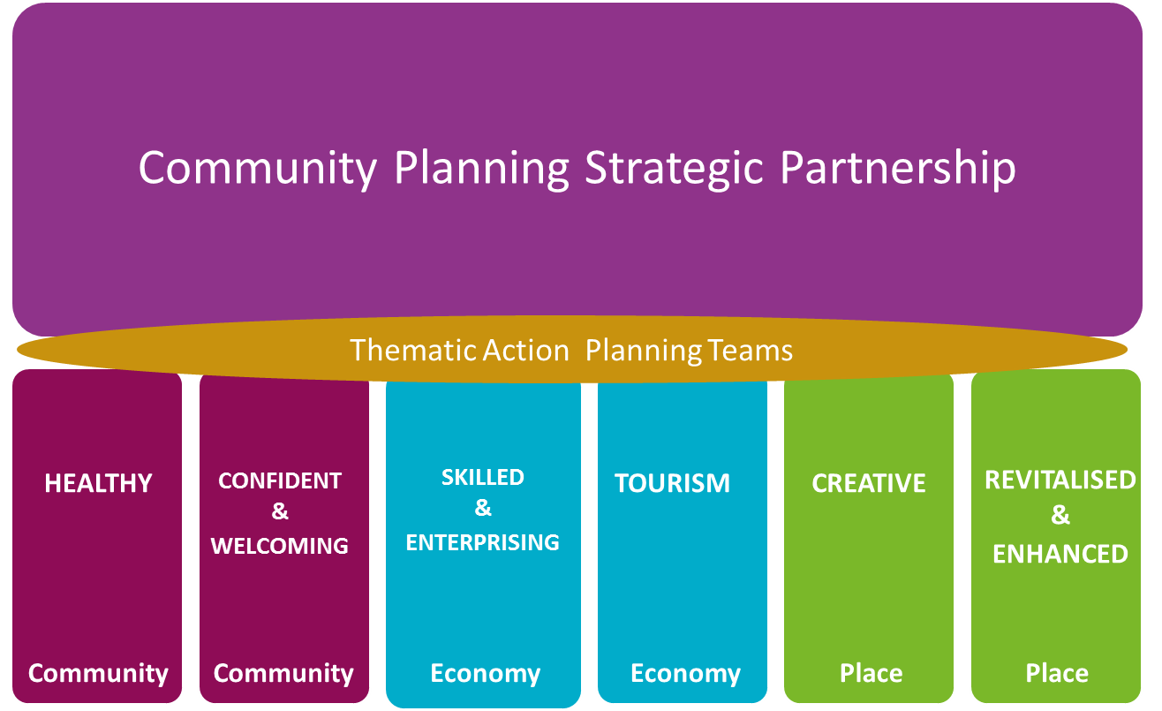
COMMUNITY & VOLUNTARY SECTOR PANEL
ENGAGEMENT & COMMS Working Group

An Engagement Working Group, consisting of staff from Council and Community Planning Partners, has also been formed to support the establishment of the Community and Voluntary Sector Panel and to develop a coordinated approach to community engagement.

Rationale for establishing a Community and Voluntary Sector Panel
The community and voluntary sector plays a crucial role in improving the quality of life for local communities across the Borough. At the same time, the Council and partners have a duty to provide opportunities for all sections of the community to participate in community planning. A community and voluntary sector panel will provide a means of ensuring that all sectors are actively involved and working in partnership to support the community planning process.

Through the early part of 2018 further consultation with the community and voluntary sector across the Borough was undertaken to ensure that the purpose of the Community and Voluntary Sector Panel, its membership and the recruitment of members were in line with the sector’s views and wishes. The feedback from those consultations has shaped and informed the process outlined below.

Role and Purpose of the Community and Voluntary Sector Panel
The role and purpose of the Community and Voluntary Sector Panel is to:

Ensure the Community, Voluntary and Social Enterprise Sector is represented
- to influence the community planning process through participation in the governance structures
- to nominate representatives to sit on the Community Planning Strategic Partnership, the six Thematic Action Planning Teams and the Engagement and Communications Working Group
- to build the capacity of the sector to participate in the community planning process

Promote ongoing Community Engagement
- to promote broad community engagement in the community planning process, including all section 75 groups and across the borough
- to connect the wider community and voluntary sector and existing partnerships, networks, forums and inter-agencies into the community planning process
- to act in an advisory capacity to the Engagement and Communications Working Group

Articulate the voice of the Community and Voluntary Sector
- to ensure a two-way flow of information and communication between the community planning structures and the wider sector and communities
- to ensure the views, experiences and needs of those sections of the community who are seldom heard, are expressed, acknowledged and considered
- to assess how the work of the Partnership and implementation of Plans meets the needs of those most marginalised and disadvantaged over time

Support the development of cross-sectoral relationships and improved partnership working
- to increase collaboration between voluntary, statutory and business sectors through panel member participation in both the Community Planning Strategic Partnership and Thematic Action Planning Teams

A range of wider benefits will also arise from the establishment of the Community Panel including; greater networking of groups and organisations across the community and voluntary sector; increased public awareness of opportunities and resources, building a more unified identity for the Borough and the Community and Voluntary sector as part of it.

Membership and Recruitment Process
Membership of the Community and Voluntary Sector Panel is open to individuals from organisations and networks from across the borough. Membership is limited to one person per organisation.

Recruitment is by completion of an Expression of Interest form submitted by 4 pm on 30th April 2018. Expression of Interest forms will be reviewed by an independent External Facilitator who has been appointed to support the establishment of the Community Panel. Forms will be checked for completion and that the eligibility criteria are met. All those meeting the criteria will be invited to join the Community and Voluntary Sector Panel. Feedback will be given to everyone whose form does not fully meet the criteria and an opportunity will be provided to resubmit.

To ensure a fair process and that membership reflects the range of groups and communities across the borough, a number of eligibility criteria have been set:

 | Eligibility Criteria | Rationale for Criteria (from Consultation feedback)
1 | Panel members should have a good understanding of the needs of different communities experiencing inequality and disadvantage within and across the Council area, including S75 groups and communities of place. | Groups and organisations working with minority and marginalised communities should be reflected in the Panel makeup.  Minority and marginalised communities need to have their voices heard, valued and acted upon.
2 | Panel members should be committed and able to gather views of the wider sector to feed into the community planning process and to disseminate and share information about the community planning process with the sector. | Willingness to share information and feedback to the wider CV sector also seen as very important. Panel members need to be connected into the sector generally and within specific sub sectors and these connections need to be fostered, utilised and nurtured to grow the trust, relationships and ongoing communication
3 | Panel members should be committed to signing an agreed code of conduct/way of working as a group | Acceptance of an agreed code of conduct (like those outlined in the Nolan Principles of Standards in Public Life) was seen as a fundamental expectation that everyone on the panel should sign up to.  Also, panel members should show their commitment to promoting the Borough – have a positive attitude, be open to new and innovative thinking and ideas.
4 | Panel members should have experience and/or knowledge of one or more of the thematic areas from the community plan | Arts  Housing and Homelessness  Built and/or natural heritage Skills/Education/Employability  Community Development  Social Inclusion  Community Safety  Sport  Connectivity  Sustainability/Environment  Equality  Regeneration  Good Relations  Tourism  Health and Wellbeing
5 | All panel members should be either a Trustee/Director, Volunteer or staff member of a constituted community, voluntary or social enterprise organisation operating within the ABC Council area. | Only community and voluntary representatives should be on the Community Panel. Statutory sector representatives working with communities or community/voluntary sector groups does not apply.
6 | Panel members should be willing and able to commit to attending 4 meetings per year of the community and voluntary sector panel. In addition to this there will be opportunities for some or all panel members to join 1 thematic group or the Community Planning Strategic Partnership meetings in order to ensure there is community representation across the levels of decision making within the community planning process. | Taking forward the work of the Community Partnership will require a time commitment from everyone involved. The Strategic Partnership will meet at least 4 times per year, the Thematic Action Planning Groups will meet at least 4 times to each develop a Thematic Action Plan and the Community Panel will meet at least 4 times a year also.  It will also be helpful if Panel members have experience of community work, sitting on committees etc. and be confident and willing to undergo training.
7 | Panel members should be drawn from different geographical areas across the borough and from a mix of rural and urban communities. | Ensuring Panel membership reflects geographical spread right across the borough will help local communities feel connected to a borough wide plan. As the needs and experiences of rural and urban communities can vary, it was considered important to ensure this mix is reflected.

The Community and Voluntary Sector Panel will be convened for a period of three years after which membership will be reviewed and a new panel will be recruited. The panel will be subject to review by the Community Planning Strategic Partnership.

Time commitments
It is anticipated that the Community and Voluntary Sector Panel will meet approximately four times a year. Panel members who are nominated onto the Community Planning Strategic Partnership or Thematic Action Planning Teams will attend additional meetings.

Timeline for Establishing a Community and Voluntary Sector Panel
TASK | Apr  Wk 2 | Apr  Wk 3 | Apr  Wk 4 | May  Wk 1 | May  Wk 2 | May  Wk 3
Advertise open call for Expressions of Interest
Promotion and support for EoIs
Review of Expressions of Interest and follow up
Convene first meeting of community panel
Some panel members start participate in TAP Teams

The first meeting of the Community and Voluntary Sector Panel will be held on Wednesday 9th May from 7 pm to 9 pm in Craigavon Civic Centre.

Summary of Key Actions for the Community and Voluntary Sector Panel – first meeting
- Agree a terms of reference/code of conduct for approval by the Community Planning Strategic Partnership
- Agree a meeting schedule
- Agree delegation to each Thematic Action Planning Team, the Community Planning Strategic Partnership and the Engagement and Communications Working Group
- Agree methods for connecting wider community and voluntary sector to community planning process

Armagh City, Banbridge and Craigavon Borough Community Panel
Ref no:

Expression of Interest form

Your Contact Information
Name
Address
Town
Post Code
Phone
Mobile Phone
E-Mail Address

Your Group/Organisation
Name of Group/Organisation
Address
Town
Post Code
Phone
E-Mail Address
Website
Purpose of your Group/Organisation
Please tick to indicate the focus of your Group /Organisation: | Mostly rural:  Mostly urban:  Both:
Please tick to indicate your Role in the Group /Organisation: | Committee member/Trustee/Director:  Staff member:  Volunteer
Please provide contact details of Trustee/Manager who can confirm your role in the group/organisation
Name
Email

Is your Group/Organisation registered with the Charity Commission for Northern Ireland? If yes,
please give Registration Number
Registered: YES/NO | Registration No.
Is your organisation registered as a Community Interest Company?
Registered: YES/NO |  | CIC Registration No.

If your group/organisation is not registered as a Charity or as a Community Interest Company, please include a copy of its governing documents/Constitution.

Interests

Please tick to tell us in which areas you have experience/knowledge
- Arts |  | - Housing and Homelessness
- Built and/or natural heritage |  | - Skills/Education/Employability
- Community Development |  | - Social Inclusion
- Community Safety |  | - Sport
- Connectivity |  | - Sustainability/Environment
- Equality |  | - Regeneration
- Good Relations |  | - Tourism
- Health and Wellbeing

Understanding the Needs of different Communities in the Borough

Please tell us about the groups and different communities that you work/volunteer with particularly highlighting work with marginalised and minority groups within community.

Communicating and Sharing Information

Please tell us what links you have with other groups and networks in the community and voluntary sector. How will you share information, gather views and feedback to groups and organisations within the sector to ensure good communication?

Potential Conflicts of Interest

Please tell us about your involvement with any other groups, organisations, statutory agencies, companies or charities.

Agreement and Signature

By submitting this Expression of Interest, I confirm that:
- the information provided is true and complete
- I commit to signing an agreed code of conduct/way of working as a group for the Community Panel
- I will meet the necessary time commitment of at least 4 to 8 meetings per year.

Name (printed)
Signature
Date

Thank you for completing this Expression of Interest form.
Please return to Community Planning Team by Monday 30th April by 4:00pm
Email: communityplanning@armaghbanbridgecraigavon.gov.uk
In writing: Community Planning Department, Armagh City, Banbridge and Craigavon Borough Council, Old Technical Building, Downshire Road, Banbridge, BT32 3JY

Community and Voluntary Sector Panel Expression of Interest Privacy Notice
Armagh City, Banbridge and Craigavon Borough Council is a Data Controller under the Data Protection Act 1998 and the forthcoming General Data Protection Regulation (GDPR). This notice confirms that Armagh City, Banbridge and Craigavon Borough Council’s commitment to protect your privacy and to process any personal data submitted by you in a manner that meets the Data Protection Legislation.
The purpose of the Community and Voluntary Sector Panel is fully described in the introduction to this document. Armagh City, Banbridge and Craigavon Borough Council is collecting data for the purpose of establishing the Community and Voluntary Sector Panel for community planning.
In order to process expressions of interest we are required to share your information with a third party provider. All information and personal data will be retained securely and in line with Armagh City, Banbridge and Craigavon Borough Council’s retention and disposal schedule.

Statutory Guidance for the Operation of Community Planning, Local Government Act (Northern Ireland) 2014, https://www.communities-ni.gov.uk/publications/circular-lg-2815-%E2%80%93-statutory-guidance-operation-community-planning
The Housing Executive, Invest NI, PSNI, Public Health Agency, Education Authority, NIFRS, Health and Social Care Board, Tourism NI, Southern Health and Social Care Trust, CCMS, Sport NI and Armagh City, Banbridge & Craigavon Borough Council. The Local Government (Community Planning Partners) Order (Northern Ireland) 2016

