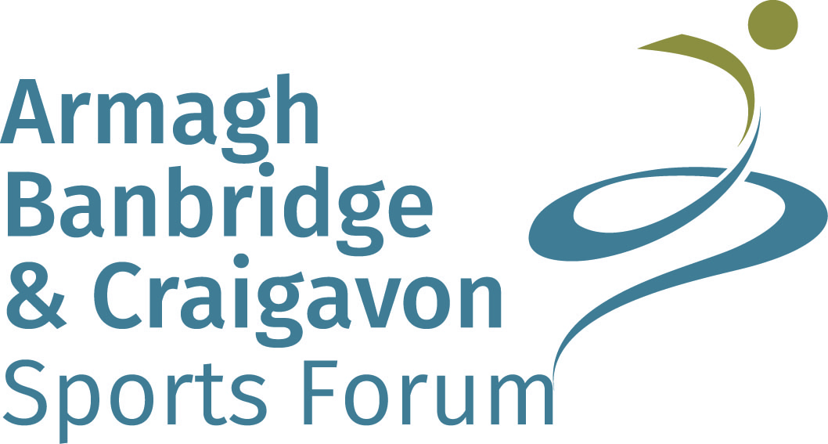





**Armagh, Banbridge and Craigavon   
Senior Sports Awards for Achievements from January 2016 – December 2016**

The awards ceremony will be held on **Thursday 30th March 2017** in Craigavon Civic & Conference Centre

To nominate please complete this nomination form and return to the address overleaf

Closing date for nominations is **Friday 6th January 2017 at 12noon**

Nominations will only be accepted on the official nomination form and must be completed in full

**All nominees must reside in the Armagh City, Banbridge and Craigavon Borough Council area**

**and must be over 18 at the 1 January 2016**

|  |  |  |  |  |  |  |  |  |  |
| --- | --- | --- | --- | --- | --- | --- | --- | --- | --- |
| Nominated Individual/Team/Club | |  | | | | | | | |
| Sport |  | | | Club/Organisation | | | |  | |
| Address |  | | | | | | | | |
| Postcode |  | | | | Tel No |  | | | |
| DOB |  | | | | Email |  | | | |
| **AWARDS CATEGORIES**  **(Please tick one category only and nominate only one nominee per club, per category)** | | | | | | | | | |
| **Sports Person with a Disability**  *Please note that depending on the nominations received this category may be further subdivided.* | | | **Sportswoman**  **Sportsman**  **Senior Team** | | | | **Community Coach\***  **Performace Coach\*** | | **Service to Sport**  **Volunteer**  **Club Innovation\***  *For the above 3 categories please record information on a separate page (not be more than 500 words) and attach. Please state the number of years’ service for service to sport.* |
| **\*Community Coach**: this award recognises the outstanding contribution of a coach in getting more people enjoying, engaging and/or excelling in local sport, through innovative and high quality delivery, particularly amongst low participation groups.  **\*Performance Coach**: this award recognises the achievement of a coach working with athletes at a high level e.g. club/athlete success/recognition at national/international level, high quality coaching that’s player centred and nurtures talent.  **\*Club Innovation**: this award is for a Club that has gone above and beyond its normal practice to be innovative.  This could be an innovation that develops players, coaches or volunteers/an innovation that promotes inclusion or encourages participation from those who are not involved at present/an innovation that uses IT or the media to engage with participants. The innovation must have made a difference to the Club and added value. | | | | | | | | | |

|  |  |  |  |  |
| --- | --- | --- | --- | --- |
| Nomination Submitted by | |  | | |
| Address  (including Postcode) |  | | | |
| Telephone No |  | | Email |  |

**Achievement and contribution from January 2016 – December 2016**

(Please give FULL details listing only the HIGHEST achievements or honours gained in the below categories. Please assume that we have no previous knowledge of the sports and provide as much detail as possible)

**COUNTY/REGIONAL**

|  |  |  |
| --- | --- | --- |
| **DATE** | **ACHIEVEMENT** | **TYPE OF COMPETITION**  **E.G. LEAGUE, CUP, ETC. & NO OF COMPETITORS** |
|  |  |  |
|  |  |  |
|  |  |  |
|  |  |  |
|  |  |  |
|  |  |  |

**National**

|  |  |  |
| --- | --- | --- |
| **DATE** | **ACHIEVEMENT** | **TYPE OF COMPETITION**  **E.G. LEAGUE, CUP, ETC. & NO OF COMPETITORS** |
|  |  |  |
|  |  |  |
|  |  |  |
|  |  |  |
|  |  |  |

**InternationAL**

|  |  |  |
| --- | --- | --- |
| **DATE** | **ACHIEVEMENT** | **TYPE OF COMPETITION**  **E.G. LEAGUE, CUP, ETC. & NO OF COMPETITORS** |
|  |  |  |
|  |  |  |
|  |  |  |
|  |  |  |

**Any other relevant comments:** *________________________________________________________________________*

*__________________________________________________________________________________________________*

*__________________________________________________________________________________________________*

**I confirm that the information listed above is a true and accurate record of the nominee’s achievements from Jan 2016 – Dec 2016**

**Signed: ___________________________________________________ Date: ________________________**

**Completed forms should be sent to: Anne Benson, Senior Sports Awards, Lough Neagh Discovery Centre, Oxford Island National Nature Reserve, Lurgan, BT66 6NJ or email** [**anne.benson@armaghbanbridgecraigavon.gov.uk**](mailto:anne.benson@armaghbanbridgecraigavon.gov.uk)

**The closing date for nominations is Friday 6th January 2017 @ 12noon**

**Please advise if you require receipt of your application**

**PLEASE INFORM THE NOMINEE OF THIS NOMINATION**